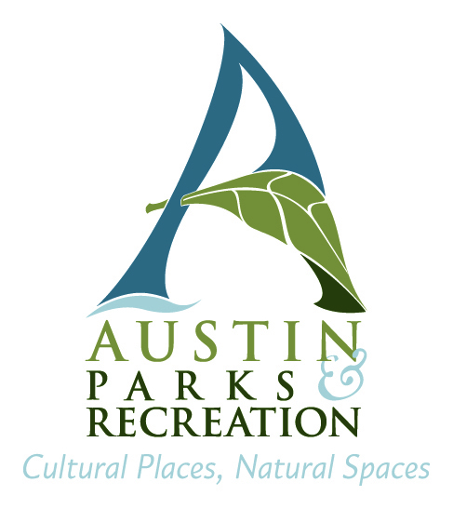
2018 City of Austin Employee
Youth Camp Scholarship Program

The 2018 Youth Camp Scholarship Program is open to all regular City of Austin employees with dependent children ages 5 through 12, and older children with special needs. If you plan to apply for a scholarship for an older student with special needs, please notify the PARD Inclusion Office by phone (512) 974-3914 or email inclusion@austintexas.gov. Employees can receive up to $50 per child, per week reduction in the cost of spring and summer camp fees at City of Austin Parks and Recreation Department (PARD) camps. Payments are only made for attendance at week-long, all-day camps.

You must apply for this program by the following deadlines to be approved for funding:

Spring Break - 5 p.m., February 5, 2018
Summer Break - 5 p.m., May 7, 2018

Only dependent children of regular City of Austin Employees are eligible for this program.
Eligible children include:

- Biological children, stepchildren, legally adopted children, children for whom you have obtained court-ordered guardianship or conservatorship, and qualified children placed pending adoption.
- Dependent grandchildren must meet the requirements stated above, and must qualify as a dependent, as defined by the IRS, on your or your spouse’s Federal income tax return at the time of enrollment.

Nieces, nephews, visiting grandchildren, friend’s children, etc., are not eligible.

For information on how to enroll your children in a Parks and Recreation Department program, contact a recreation, nature, arts, or cultural center near your home. Camp registration dates and information can be found at:

http://www.austintexas.gov/department/youth

For more information on PARD camps, call 512-974-6700.

Please send your completed application to:

US Mail: HRD/EBD Childcare Interoffice Mail HRD/EBD Childcare
PO Box 1088 or delivery: 6th Floor, One Texas Center
Austin, TX 78767 505 Barton Springs Rd.

List of Participating Parks and Recreation Centers
2018 Youth Camp Scholarship Program

Camp Name | Address and Austin ZIP Code | Phone Number
Asian American Resource Center | 8401 Cameron Road 78754 | 512-974-1700
Austin Nature & Science Center | 301 Nature Center Drive 78746 | 512-974-3888
Danny G. McBeth Recreation Center | 2401-A Columbus Drive 78746 | 512-974-9011
Delores Duffie Recreation Center | 1182 North Pleasant Valley Rd. 78702 | 512-978-2465
Dittmar Recreation Center | 1009 W. Dittmar Rd. 78745 | 512-974-6090
Dottie Jordan Recreation Center | 2803 Loyola Lane 78723 | 512-978-2380
Dougherty Arts Center | 1110 Barton Springs Road 78704 | 512-974-4040
Dove Springs Recreation Center | 5801 Ainez Drive 78744 | 512-974-3840
Elisabet Ney Museum | 304 East 44th Street 78751 | 512-974-1625
Emma S. Barrientos Mexican American Cultural Center | 600 River Street 78701 | 512-974-3785
George Washington Carver Museum and Cultural Center | 1165 Angelina Street 78702 | 512-974-4926
Givens Recreation Center | 3811 East 12th Street 78721 | 512-974-2430
Gustavo “Gus” L. Garcia Recreation Center | 1201 E. Rundberg Ln. 78753 | 512-978-2525
Hancock Recreation Center | 811 East 41st Street 78751 | 512-978-2335
Lorraine “Grandma” Camacho Center | 35 Robert Martinez Jr. Street 78702 | 512-978-2420
Metz Recreation Center | 2407 Canterbury Street 78702 | 512-978-2399
Montopolis Recreation Center | 1200 Montopolis Drive 78741 | 512-978-2300
Northwest Recreation Center | 2913 Northland Drive 78757 | 512-974-6972
Oswaldo A.B. Cantu/Pan Am Recreation Center | 2100 East 3rd Street 78702 | 512-978-2425
Parque Zaragoza Recreation Center | 2608 E. Gonzales 78702 | 512-978-2460
Pickfair Community Center | 10904 Pickfair Dr. 78750 | 512-974-1320
South Austin Recreation Center | 1100 Cumberland Rd. 78704 | 512-978-2440
Turner Roberts Recreation Center | 7201 Colony Loop Dr. 78724 | 512-978-2690
Virginia L. Brown Recreation Center | 7500 Blessing Ave. 78752 | 512-974-7865
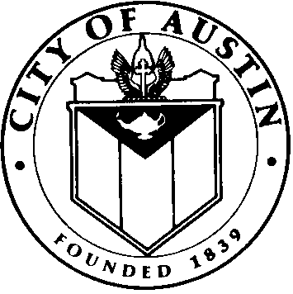

City of Austin

Youth Camp Scholarship Program - 2018 Application Form

1. Employee Information

Employee First Name | Employee Last Name | Employee I.D. Number
Street Address | City, State, ZIP Code | Telephone # (Cell or Home)
Department | Physical Work Location | Work Phone #

- Information on Child(ren):

Name (Last, First, Middle Initial) | Custody of Child Yes/No | Date of Birth | Social Security Number

By applying for the City of Austin Youth Camp Scholarship Program, I certify that:

- I understand that Youth Camp scholarships are awarded only to regular City of Austin employees who have dependent children who have enrolled and attended all-day, weeklong City of Austin Parks and Recreation Department programs,
- The above identified children meet the definition of dependent as stated below:
- Biological children, stepchildren, legally adopted children, children for whom I have obtained court-ordered guardianship or conservatorship, and qualified children placed pending adoption.
- Dependent grandchildren must meet the requirements stated above, and must qualify as a dependent, as defined by the IRS, on my or my spouse’s Federal income tax return at the time of enrollment.
  - The IRS has determined that certain employees may receive favorable tax treatment on funds up to $5,000 per year in dependent care assistance programs established by their employer. This $5,000 limit includes the combined funds applied to the following programs: the City of Austin Childcare Assistance Voucher Program, the City of Austin Youth Camp Scholarship Assistance Program, and FLEXTRA Dependent Care Accounts. For most employees, only the combined funding received from these programs during the calendar year which exceeds the $5,000 IRS limit will be reported to the IRS as taxable income and taxes will be withheld.

SIGNATURE: _____________________________________________________ DATE: _________________

Deadline for Spring Break - 5 p.m., February 5, 2018
Deadline for Summer Break - 5 p.m., May 7, 2018

