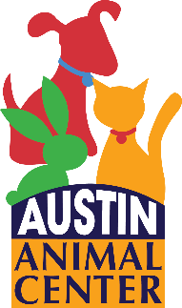
Visitor Profile
Are you interested in adopting a  Dog/puppy  Cat/kitten
❐ Rabbit  Other small animal

Name ______________________________________________________Date __________________
Home#_____________________________ Cell#_______________________________
E-mail Address _____________________________________________________________________
Address _________________________________________________Apt/Unit #_____________________
City _______________________________ State _______________ Zip Code ____________________
DOB ________________________ DL or ID # __________________________

Do you currently have any pets in your household?  Yes  No
If yes, how many __________________________________________________________________
What kind? ______________________________________________________________________
Number of People in the Household: Adults ______ Children ______ Ages of Children _______________

Please check any topics you’d like more information on:
❐ Feeding your pet   Introducing your new pet to other pets |   Challenging behaviors   What to do if your pet is lost
❐ Where to keep your pet during the day, at night, or while at work   House training | ❐ Grooming/Training   Behavior issues   Other: ________________________________
Is there any other information you wish to share? _____________________________________________________________________________________________________________________________________________________________________________________________________________________________________________________________________
I certify that all information provided is true and understand that false information may nullify this application and authorize Austin Animal Center to verify the above information.

Applicant Signature: ____________________________ Date:_______________________

