ATTACHMENT 1. Submitting Offers online using eResponse.
- Create a Response. Find the Solicitation you wish to respond to in Austin Finance Online (AFO), located at: https://www.austintexas.gov/financeonline/finance/. If the Solicitation includes the “eResponse” function, it will have a “My Response” section in the Solicitation’s Detail page. Click on “Create Response” to start a Response (Fig. 1).
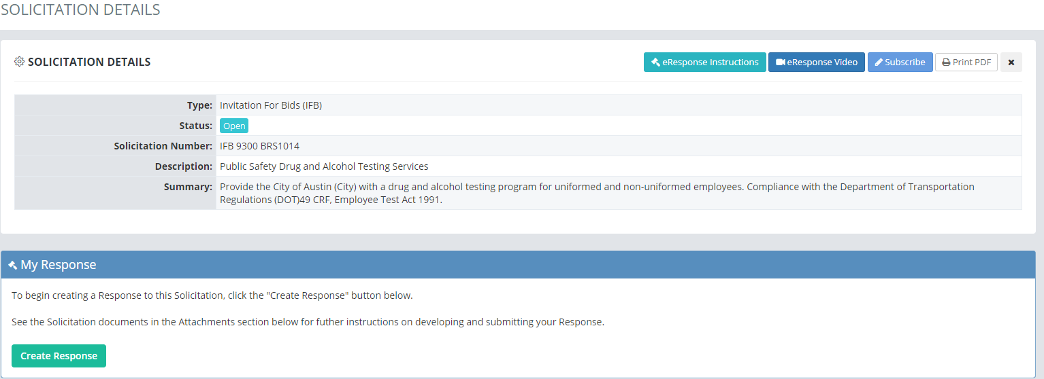
(Fig. 1)
  - Offerors must be logged into AFO in order to create, edit or submit a Response.

  - If you click on “Create Response” but you have not yet logged into AFO, the system will redirect you to a login screen (Fig. 2). Once you have logged into AFO, the system will take you back to the Solicitation.
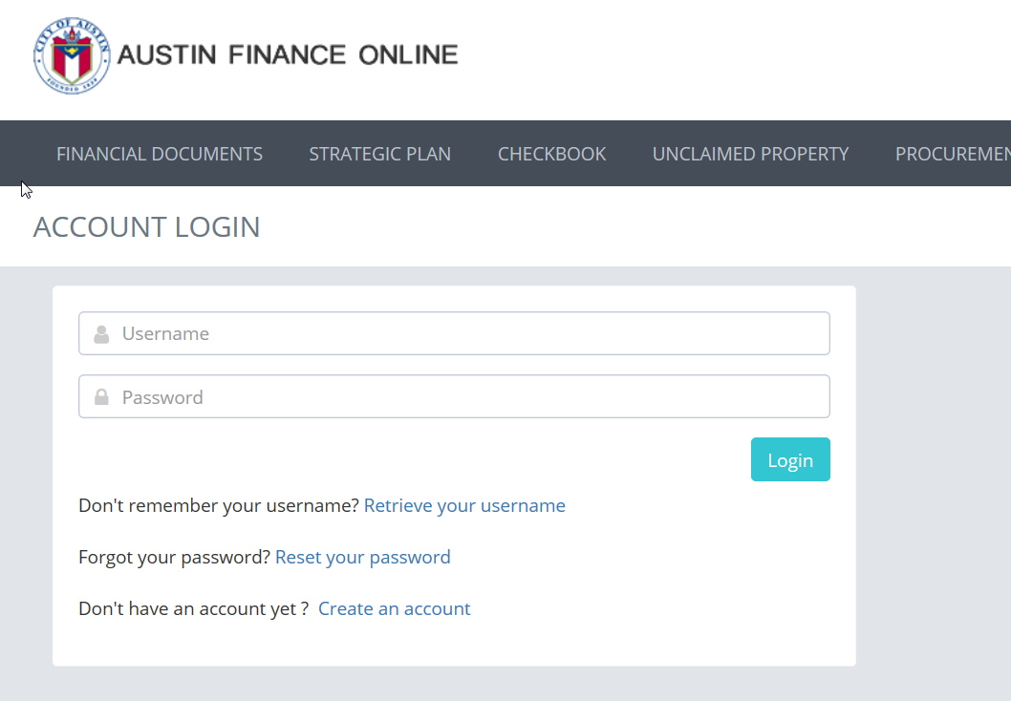
(Fig. 2)
  - Once you click “Create Response”, you will now see a Response ID, Vendor Name, the date that you Created your Response, the date and time you Last Revised your Response and the Status of your Response, which should be “DRAFT” initially (Fig. 3).

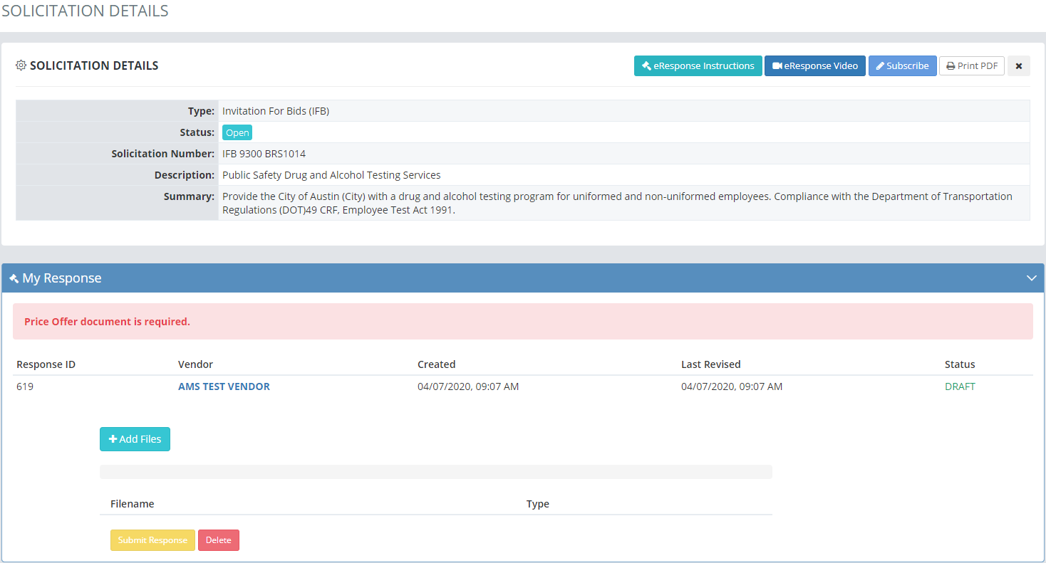
(Fig. 3)
- Adding Files to Your Response. To upload files to your Response click on the blue “+ Add Files” button (Fig. 4).

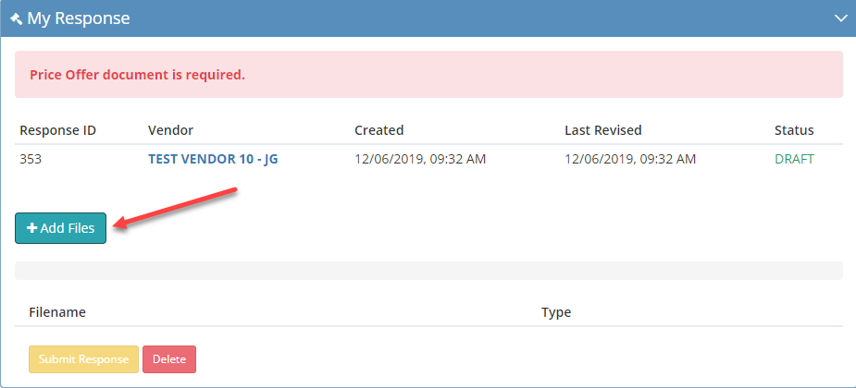
(Fig. 4)
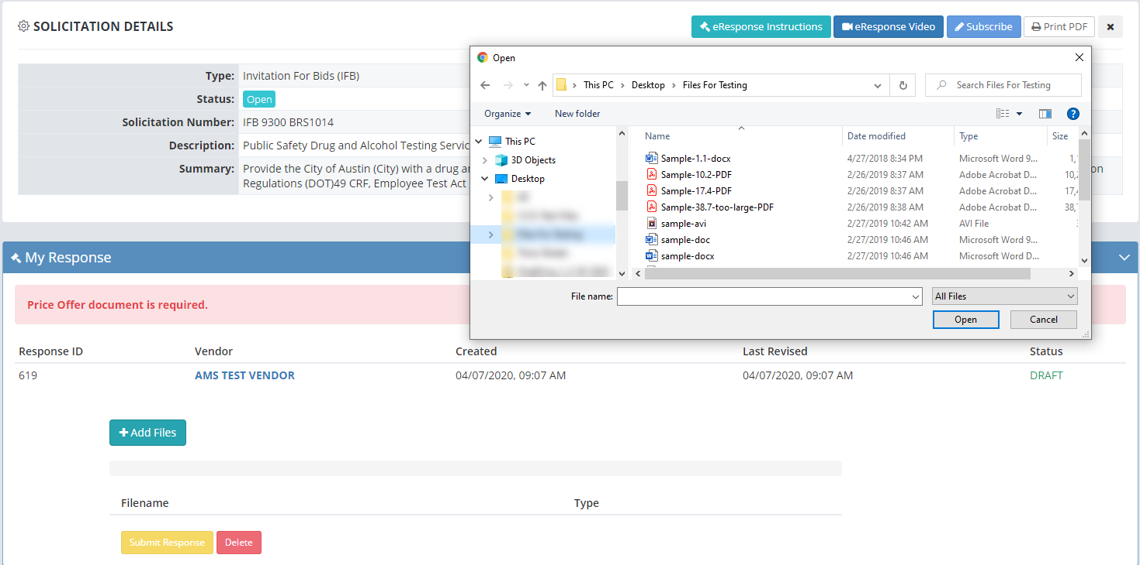
(Fig. 5)
- After clicking the “+ Add Files” button, a pop-up window will open displaying files on your computer (Fig. 5).

- Navigate on your computer to where your files are located. Select the file you wish to upload and click “Open”. The blue indicator bar moving from left to right will show your file being uploaded (Fig. 6)

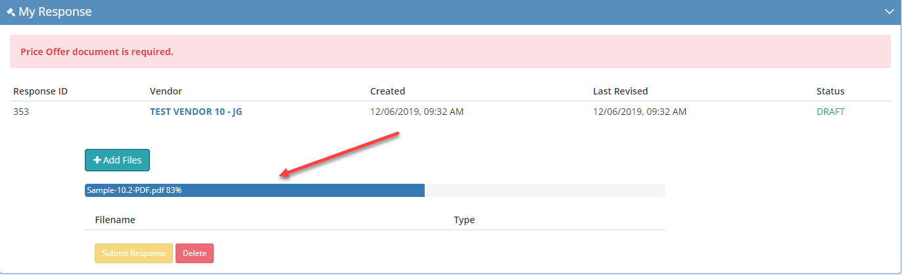
(Fig. 6)
- Repeat this step to add additional files to your Response.

- File Types Accepted. The eResponse functionality in AFO supports (accepts) the following electronic file types (Fig. 7).
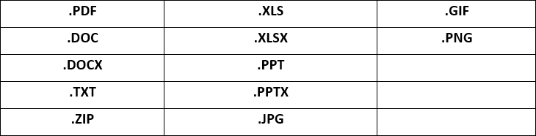
(Fig. 7)
- Number and Size of Files Allowable. The eResponse functionality in AFO supports (accepts) no more than ten (15) files in a Response. eResponse will not accept a single file greater than 40 MB.

- eResponse Only Accepts One Submission per Vendor per Solicitation. If alternate offers are being accepted, you will need to submit those along with your primary submission. Alternates can be multiple pages in a single “Price Offer” file or uploaded as a separate document by selecting the “Technical Offer” from the drop down.

- Identify Your Files. As you add files, you will see a dropdown menu to the right of the Filename, under “Type”. Use this dropdown menu to select the appropriate file types (Fig. 8).

  - For Requests for Qualifications Statements (RFQS), the following files must be included:
- Select the “Offer and Certifications” type for the file which contains your signed Offer Sheet and all the certifications in that attachment which require completion and signature. You can only identify one (1) file as your “Offer and Certifications.”

- If required, select “Compliance Plan” type to identify the file that includes your compliance plan. You can identify multiple files as “Compliance Plan” types.

- Select the “Technical Offer” type for any files that contain any information required as part of the qualifications submittal requirements in the instructions section. You can identify multiple files as “Technical Offer” types.

- You will not be able to submit your Response if you have not identified at least one file as “Offer and Certification”. Once you do, the red warning bar across the top of the My Response box will disappear.
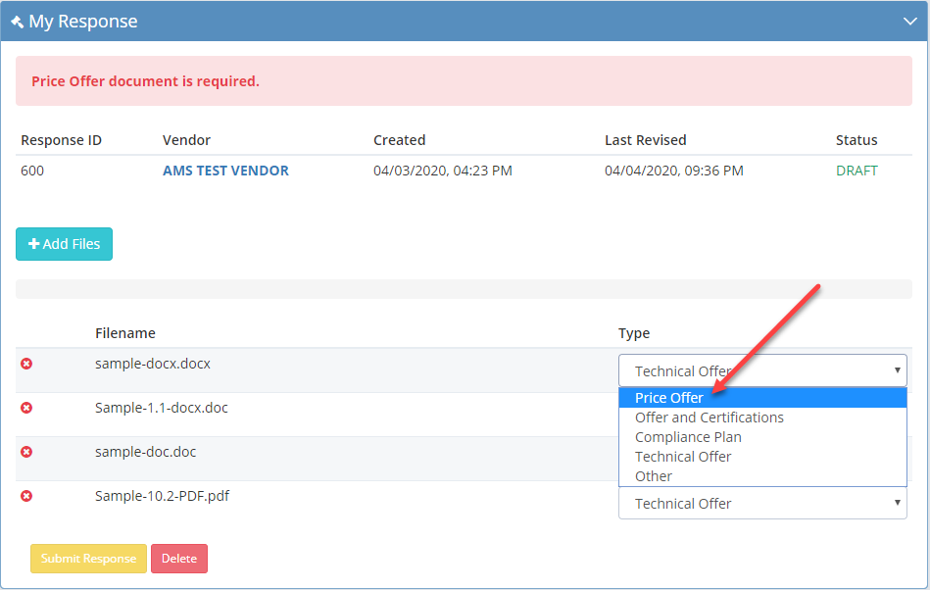
(Fig. 8)

- Submitting your response. Once you have uploaded and identified the types of all the files you need to for your Response, click the “Submit Response” button (Fig. 9).

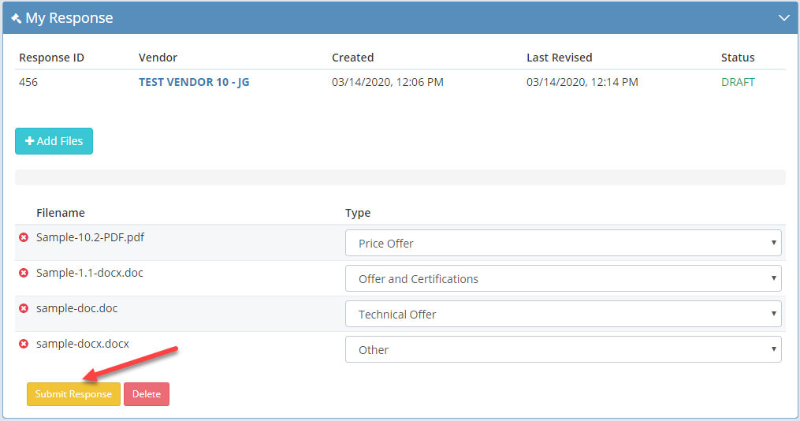
(Fig. 9)
  - After you click the “Submit” button, you will be redirected to the Response History Page of your User Dashboard (Fig. 10). You will be automatically Subscribed to the solicitation when you submit your Response.

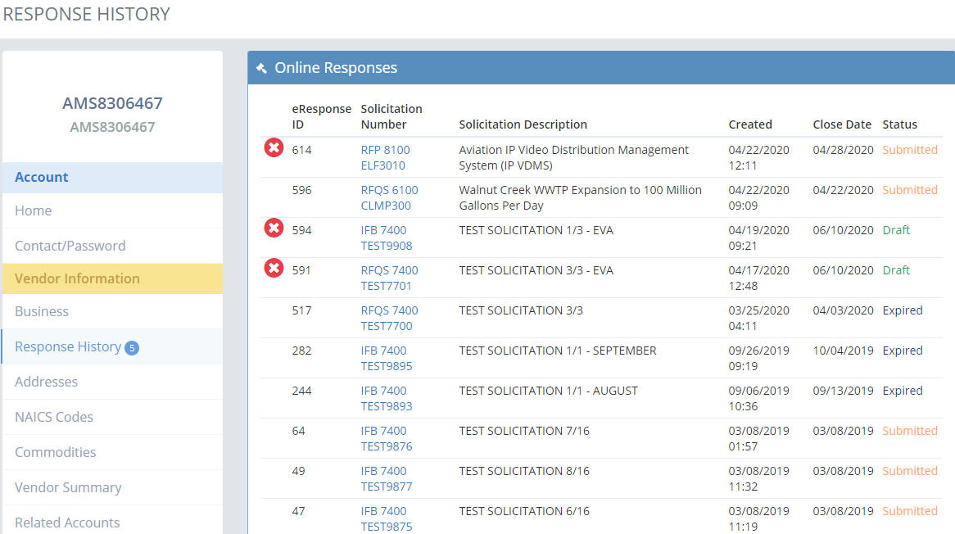
(Fig. 10)
  - You can return to the Solicitation or your Response through the Response History page, or by navigating directly to the Solicitation in AFO. When you return to the Solicitation, you will notice that your Status (upper right corner of the My Response section) will state “SUBMITTED”. Your Last Revised date and time will update to the date and time you clicked on the “Submit” button.

  - If you start a response and don’t click “Submit Response”, your response will stay in “DRAFT” status. Before the Solicitation’s Due Date and Time, you can navigate back to your draft Response and complete it.

  - Responses that are still in “DRAFT” status by the Solicitation’s Due Date and Time will not be received by the City.

- Withdrawing or Changing a Response After it has been Submitted. Prior to the Solicitation’s Due Date and Time, you may withdraw or modify your Response. You can delete the entire Response or individual files. To Withdraw or Change your Response, navigate back to the Solicitation. You will see your Response and files in the “My Response” section.

  - To delete the entire Response, click the red “Delete” button at the bottom of the “My Response” section. You will receive an “Are You Sure” message to confirm your intent to delete your Response including all files within it. Click on Yes, to proceed with the deletion.

  - To delete individual files within a Response, click the red circle with the white “X” to the left of the file you wish to delete.

