How to Identify Block Numbers In Google Maps

Example: 6th Street from Congress Avenue to Guadalupe Street

1. Go to web address www.google.com/maps
2. Type the intersection into search box & Search

Note: A map will load and a bubble will indicate the intersection at this time.

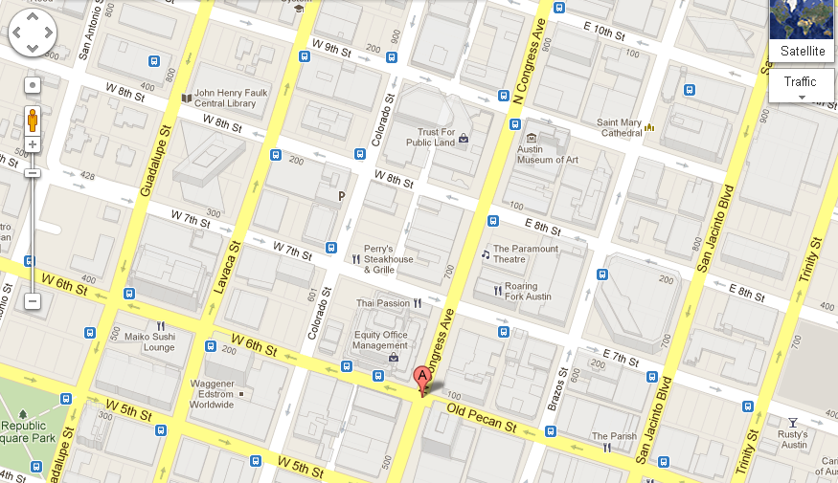

3. Zoom into the intersection as close as you can (without going into street view). You will see tiny font populate, almost transparent on the streets that you may have never noticed before! These are block number indicators! Now you know that 6th Street at Congress is the 100 Block of 6th.

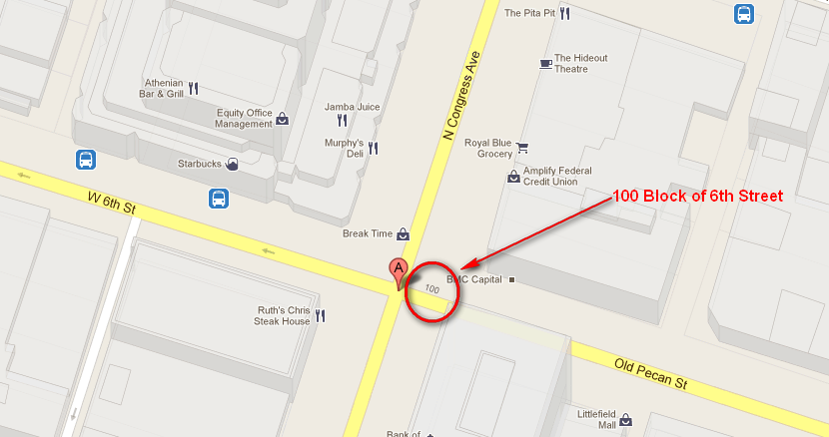

4. You will now pan the map towards Guadalupe Street.

Note: If you aren’t sure which direction Guadalupe is in, you can zoom out until you find it. You could also just start the process over and search 6th Street at Guadalupe.

Note: To Pan the map, click the map, hold the button and move the mouse in any direction. The map will move with the mouse.

5. Zoom in on your next intersection. Below is 6th Street at Guadalupe. In this example, the block number for this segment of 6th is not populated. This is something that occurs often in Google maps. It is the 300 block of W 6th Street. See map below for the easiest way of determining the block number when it does not auto populate.
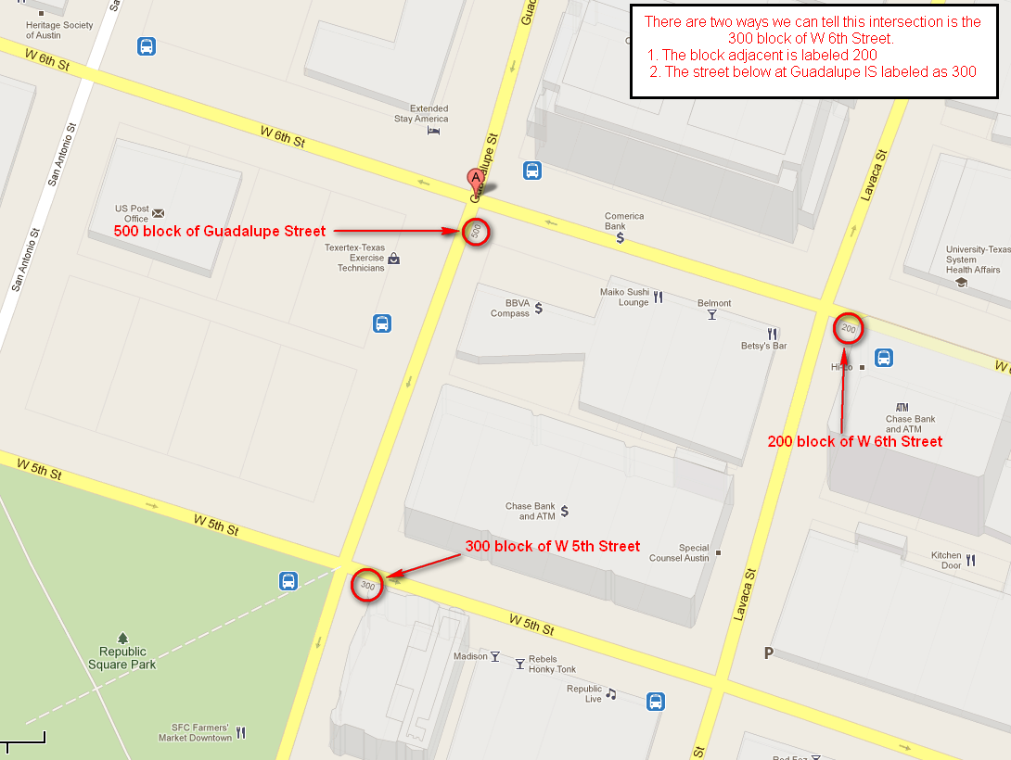

After using Google Maps, you now know that 6th Street between Congress and Guadalupe is actually the 100-300 blocks of W 6th Street!

