Community Youth Development Program
Strengths and Needs Assessment
FY 2016

February 1, 2016

City of Austin
Health and Human Services Department
Community Service Unit

Executive Summary

78744 Dove Springs Community Strengths and Needs Assessment, FY 2016(CSNA) is an annual report prepared for the Texas Department of Family and Protective Services (TDFPS), Division of Prevention and Early Intervention. The Youth of Promise Initiative is funded through the Community Youth Development (CYD) Grant; a grant awarded by TDFPS to fifteen communities throughout the state of Texas that exhibit high referral rates to the juvenile justice system. The 78744 Dove Springs zip code CYD program is administered by the City of Austin-Health and Human Services Department. This annual SNA profiles the target area and its strengths and needs regarding resources and services available to help resident youth avoid involvement with the juvenile justice system. The report serves as a platform for identifying and procuring ongoing and additional services, as well as improving or expanding current services.

The assessment is based on several data sources:
- The Community Strengths and Needs Assessment Survey (see Appendix A) reflects adult and youth perceptions of protective factors within the 78744 Dove Springs community as well as gaps in programming that respondents felt would help to reduce juvenile crime. Respondents completed 553 total surveys: 386 Youth surveys and 167 Adult surveys.
- Research conducted by a variety of organizations working in the 78744 Dove Springs area.
- Community Strengths and Needs Assessment (SNA) Surveys and SNA Reports from previous years.
- Interviews conducted with CCC members and CYD service providers.
- Focus group conducted with YAC members.
- Statistical evidence of juvenile criminal behavior within the 78744 Dove Springs community.

The report presents details indicating that, among other findings:
- Between FY 2006 and FY 2015, juvenile referral rates in the target zip code have decreased each year except FY 2010, dropping a total of 37.3%.
- Juvenile arrest rates vary each year, but the average arrest rate between 2008 and 2015 is lower than previous years.
- Burglary of a residence and Theft were the crimes most frequently committed by juveniles in the 78744 Dove Springs zip code. For FY 2014 however, Possession of Marijuana was the second more crime committed after Burglary of residence.
- CYD programs are providing important services that address risk factors though CYD grant constraints limit the ability to fund programs that would have a noticeable effect on target CYD Internal Assets.
- The 78744 Dove Springs community faces unique structural challenges such as lower-than-average incomes, larger household sizes, a high percentage of foreign-born and non-English speaking immigrants, and a small number of community organizations filling a leadership capacity.

The report may be utilized by TDFPS, CCC, YAC and the Fiscal Agent as a “launch pad” in determining funding priorities for the next RFP.

Table of Contents

Executive Summary 1
SECTION I
Introduction of CYD Program, Youth of Promise Initiative 3
Methodology of SNA report 4
SECTION II
Description of Service Area 5
General Descriptors 5
Community Challenges/Risk Factors 8
Community Assets 20

SECTION III
FY 2016 SNA Survey 26
SECTION IV
Concluding Observations 39
Appendices
A. 2016 Youth and Adult Surveys, Spanish and English 41

B. 2016 SNA SURVEY LOCATIONS…………………………………………………….43

C.2016 SNA LETTERS OF SUPPORT………………………………………………………..48

SECTION I

Introduction

78744 Dove Springs Community Strengths and Needs Assessment, FY 2016 (SNA) is an annual report that is a required component of the Community Youth Development (CYD) Grant (Contract #24186674), administered by the City of Austin-Health and Human Services Department (COA-HHSD). The report is prepared for the Texas Department of Family and Protective Services (TDFPS), Division of Prevention and Early Intervention (PEI). TDFPS awards the grant to communities throughout the state that exhibit high referral rates to the juvenile justice system. This annual SNA profiles the strengths and needs in the target area, focusing on resources and services that are available to help resident youth avoid entanglement with the juvenile justice system. The report serves as a platform for identifying gaps in youth services and for identifying pre-existing strengths in the community so as to avoid CYD duplication of services. The SNA Report is a product of specific research tasks and ongoing community involvement with CYD programs throughout the year.

The City of Austin, Health and Human Services Department (COA-HHSD), the fiscal agent for the grant, retains a portion of the funding for administration and direct services. The remaining funds are awarded to local entities for direct services to youth and families in the community. The service delivery area is the 78744 Dove Springs zip code in southeast Austin, Texas. The fifteen communities throughout Texas who receive CYD funding were chosen based on statistical evidence indicating significantly high levels of juvenile probation referrals.

The underlying purpose of the CYD Program is to provide substantive services and to “plug the gaps” in community services that help local youth make positive choices in life and avoid involvement in the juvenile justice system. The CYD Program emphasizes prevention services by funding programs aimed at assisting youth before they become involved in the juvenile justice system. The CYD Program aims to continuously improve the quality of the services provided under the grant and to strengthen collaborative links with providers of ancillary services not directly funded by the grant.

The CYD Program is characterized by both a high degree of community involvement and a strong emphasis on synergy of CYD programs with other services. The primary structures for community participation are the Community Collaborative Committee (CCC) and the Youth Advisory Committee (YAC).

Community Collaborative Committee (CCC) is comprised of 78744 Dove Springs residents, YAC members, and service providers. The FY 2016 CCC has 16 members. The CCC assists with SNA survey development and distribution. A copy of the SNA is shared with the CCC members annually.

The YAC is comprised of 11-17 year old youth who reside or attend school in the 78744 Dove Springs area. The FY 2016 YAC group has 10 members and has participated in a wide variety of outreach activities including the annual Christmas tree recycling held at the Zilker Park, volunteer Blue Santa with Austin Police Department at the blue Santa warehouse, and distributing SNA surveys at various locations including the Dove Springs Recreation Center. The group meets two times a month, usually on Wednesdays and sometimes on Saturdays, for Youth Leadership Development events, averaging at least one leadership development activity a month.

A fundamental aspect of the CYD Program is its emphasis on cross-program collaboration. Wherever possible, the CYD Program seeks to fill gaps in services and to work with previously existent service providers in a shared effort to achieve a significant change in juvenile probation referrals in the 78744 Dove Springs zip code. The CYD program is limited in scope to preventative services which increases the need for synergy of servicing in order to attain a real and visible impact on youth in the target region. The CYD Coordinator and YAC Coordinator attend other community meetings, such as the monthly Citizen Advisory Committees at different 78744 Dove Springs school campuses to create links for cross-communication and to attain a broader understanding of programs that are available to youth in the community. Information about the Youth of Promise Initiative/CYD Program is provided at community-based public events and places like local libraries, recreation centers, and schools. Information is disseminated by YAC members, CCC members, and COA-HHSD staff with the purpose of gaining community support and involvement in CYD Program activities.

Methodology

The Strengths and Needs Assessment is the product of an integrated quantitative and qualitative research approach comprised of several data collection methods:

- The Community Strengths and Needs Assessment Survey (see Appendix A) reflects adult and youth perceptions of protective factors within the 78744 Dove Springs community as well as gaps in programming that respondents felt would help to reduce juvenile crime. Respondents completed 553 total surveys: 386 Youth surveys, 167 Adult surveys.
- Research conducted by a variety of organizations working in the 78744 Dove Springs area.
- Community Strengths and Needs Assessment (SNA) Surveys and SNA Reports from previous years.
- Previous paper interviews conducted with CCC members and CYD service providers.
- Previous focus group conducted with YAC members.
- Statistical evidence of juvenile criminal behavior within the 78744 Dove Springs community.

YAC and CCC members, CYD Service Providers and COA-HHSD staff members distributed approximately 553 SNA surveys. The questionnaire was circulated in both English and Spanish to adults and youth throughout the 78744 Dove Springs zip code primarily during the fall of 2015. Participation was based on respondent convenience and was completely voluntary. The surveys were distributed at the Austin Power House Church, local public schools serving the 78744 Dove Springs zip code, community events, service providers’ sites, and other locations convenient for capturing community participation. A map of the 78744 Dove Springs schools surveyed can be found in Appendix B of this report. Residents and stakeholders completed a total of 553 total surveys: 386 Youth surveys and 167 Adult surveys.

SECTION II

Description of Service Area

The 78744 Dove Springs zip code is located in southeast Austin, Texas. Although the neighborhood commonly referred to as Dove Springs makes up a large percentage of the resident population, the entire 78744 Dove Springs zip code has experienced a population boom in the last two decades which has brought new housing developments, schools, and businesses located outside of the Dove Springs neighborhood. The 78744 Dove Springs community is a vibrant, diverse neighborhood with a wide variety of assets and challenges which include lower-than-average incomes and education levels, high percentages of first generation and non-English speaking populations, and high rates of juvenile crime and overall crime including gang participation. Community assets include high levels of community participation, a generally positive opinion of the neighborhood by residents, and a strong core group of community programs.

+General Descriptors

LARGE GROWTH RATES

Since 1990, the 78744 Dove Springs zip code has experienced a significant amount of growth. Between 1990 and 2015, the population grew from 23,418 residents to 43,452 residents and various estimates put the 2007 population between 37,677 and 40,000 residents. In 2010, the population reached 42,820 residents. Rapid growth in the entire 78744 Dove Springs zip code, especially among the undocumented immigrant population makes it difficult to estimate population sizes.

RACIALLY DIVERSE COMMUNITY

The area has a large percentage of Latino residents. According to the 2010 U.S. Census, 76% of the 78744 Dove Springs population was Latino, 15% were White, and 7% were Black/African American. The 78744 Dove Springs zip code has more total Latinos and the second highest concentration of Latinos by comparison with any other Travis County zip code. Over half of the population speaks Spanish at home. The Greater Dove Springs area is one of the three fastest growing Hispanic population centers in Austin according to the City of Austin. In 1990, Dove Springs had a Latino population of about 45%. By 2015, this number had nearly doubled to almost 80%.

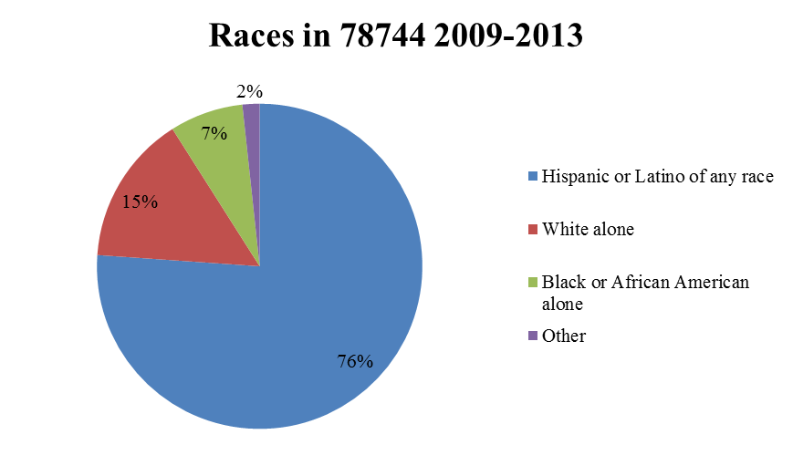

YOUNG POPULATION

Dove Springs has a notably younger population than the rest of Texas. The median resident age among 78744 Dove Springs residents is 27.6 years while the median age for Texas is 31.1 years. Latino and Black residents tend to be younger than their White counterparts in the community. In Dove Springs, for example, the median age for Latinos is 22 years old; the median age for Black residents is 24 years old while the median age for White residents is 40 years old.

LARGE FAMILIES

The 78744 Dove Springs community is characterized by large family and household sizes. The average household size in the 78744 Dove Springs zip code is 3.4 people while the average household size for the entire state of Texas is 2.7 people and the average for Travis County is even lower at 2.47 people. As can be seen from Chart 2 and Chart 3 (below), the 78744 Dove Springs community has significantly larger household sizes than other zip codes in Travis County. Data taken from the 2000 U.S. Census shows that in the two randomly-chosen Travis County comparison zip-codes (78751 and 78745), one-person households were most common and the number of households fell at a steady rate as the number of household members increased by units of one household member. In the 78744 Dove Springs zip code, however, the number of one-person household members was only slightly higher than two-person household members and there was a 7.6% increase between the numbers of three person households to the number of four person households. There were also increases between the numbers of households with six and seven household members.

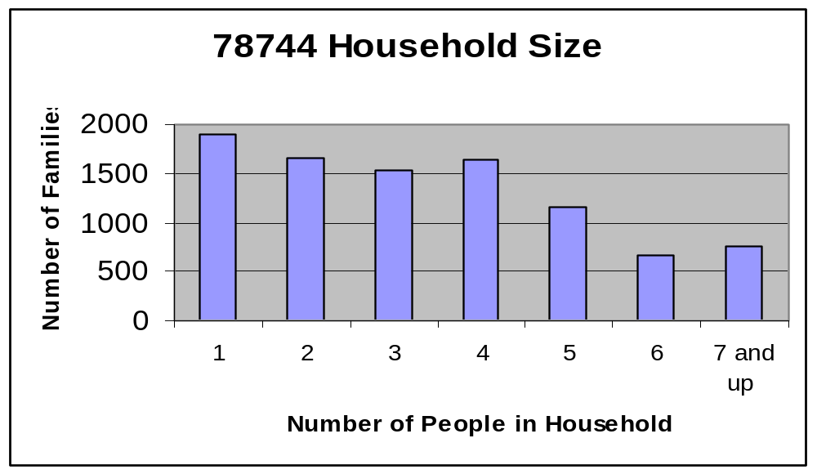
Figure 2
source: onboard informatics, LLC

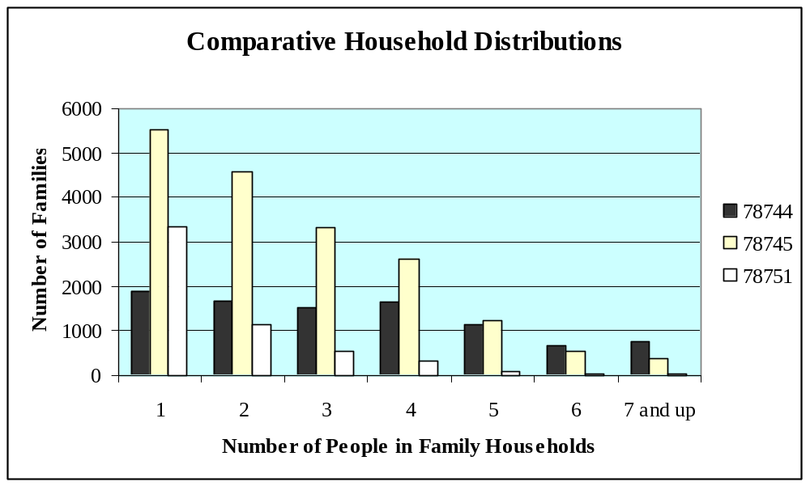
Figure 3
source: onboard informatics, LLC

Risk Factors in 78744 Dove Springs

LOW SOCIO-ECONOMIC STRATA

Individual incomes in the 78744 Dove Springs zip code are nearly half that of the rest of Texas. Based on taxes filed for the 2004 tax year, the average Adjusted Gross Income (AGI) for 78744 Dove Springs was $26,498 while the average AGI for the entire state was $47,881. In 2008, 21.4% of 78744 Dove Springs residents were living below the poverty level. The estimated median household income for 78744 Dove Springs households in 2008 was $46,037 while the estimated median household income for all of Austin was $59,221. These incomes are stretched even thinner by large household sizes in the area.

LARGE IMMIGRANT POPULATION

The foreign-born population makes up 24.1% of 78744 Dove Springs residents with the vast majority (84%) coming from Mexico. Within the Dove Springs community in particular, 35% of the Latino population is foreign born and 80% of immigrants are not citizens. Area residents who lack legal status face additional challenges to living and working in the U.S. including increased vulnerability to exploitation and victimization, difficulty accessing services and lack of rights and protections and/or knowledge of them.

GANG ACTIVITY

Gang activity remains a challenge for the 78744 Dove Springs community. During the 2006-2007 school year, thirty-six percent of AISD secondary students reported having a friend who was part of a gang and 43% stated there was regular gang activity at their campus. According to the Austin Independent School District (AISD), students at Akins High School and Travis High School were notably more likely to have friends who belonged to a gang than students at other AISD district high schools. Forty-one percent of students at Akins and 45% of students at Travis reported having friends who were gang members. Nearly one in every three gang members referred to Juvenile Probation in 1999 lived in the 78744 Dove Springs, 78723, or the 78702 zip codes. Eleven percent of all gang members referred to Travis County Juvenile Probation in 1999 came from the 78744 Dove Springs zip code.
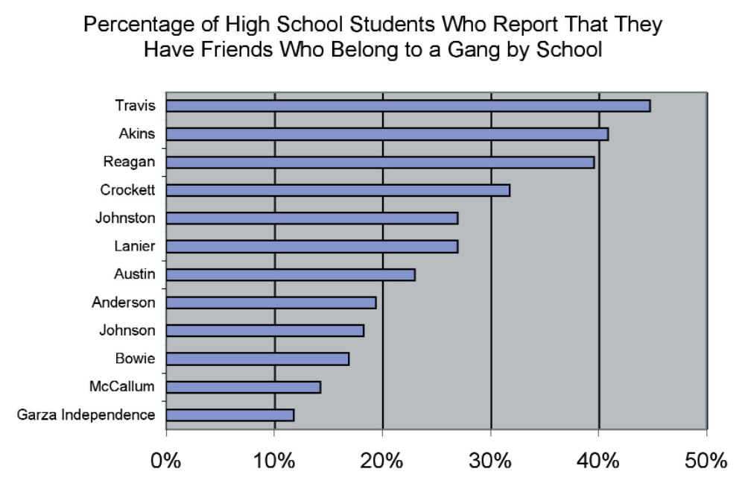
Figure 4
Source: 2004 TCADA Survey and 2005 AISD SSUSS

While these statistics and interviews seem to indicate a prevalence of gang activity in the area, the 78744 Dove Springs community’s perception of gang activity is mixed. Of the 70.7% of respondents to the 2008 SNA survey who felt youth crime was a concern in 78744 Dove Springs, 76.3% marked “gang violence” as the criminal activity occurring “most frequently” in their neighborhood. In the 2009 SNA survey, respondents were asked to mark whether gang activity affected specific aspects of their daily routine. Thirty-eight percent indicated it affected their ability to “play in the park” and 36% said gang activity affected their ability to “walk to and from school.” A majority of respondents felt gang activity did not affect these aspects of their daily lives. The Wesley Center for Family and Neighborhood Development, a non-profit, faith-based organization operating within the Dove Springs neighborhood, conducted a door-to-door survey in Dove Springs in 2009. When residents were asked to describe specific issues in the community as a “major problem”, “some problem” or “no problem,” two of the top five listed issues described as being “no problem” had to do with gang activity. Seventy-five percent of respondents indicated the issue of “Friends involved in gangs” posed no problem to the community and 67% felt “Gangs in the Community” were “no problem” as well. However, during a 2012 SNA interview, CCC member Officer Anthony Valderas noted that there is a large gang influence in the neighborhood. “People need to take ownership of the neighborhood,” he said. “Crime is pretty prevalent. We were able to cut it down once and there’s no reason why we can’t cut it down again.” More recently, in a 2013 SNA interview, one member of the CCC said, “I know that gang activity is around and that youth are affected by this.” This sentiment was reiterated by the YAC during a 2013 focus group. Nearly all members said they closely knew someone who was in a gang. Several members mentioned gangs as a challenge to their community in the paper questionnaire, and the group largely agreed during the focus group.

EDUCATIONAL CHALLENGES

Youth in the 78744 Dove Springs zip code face discernible educational challenges. The Texas Education Agency reports higher rates of “at-risk” status among students who are economically disadvantaged. The Texas Education Agency reports that between 82% and 95% of elementary students in the Dove Springs area are economically disadvantaged and between 56% and 69% of students are considered academically at-risk. United Way for Greater Austin reports that 96% of students at Mendez Middle School (a middle school located in the 78744 Dove Springs area) were economically disadvantaged during the 2011-2012 school year. United Way also found that 67% of students at Mendez had factors that put them at-risk for dropping out of high school and that only 37% of 8th graders at Mendez passed all of their standardized tests. According to an AISD report, Mendez Middle School had the worst attendance in the entire district. During the 2006-2007 school year, 53% of the student population at Mendez was “in violation of Texas’ State School Compulsory Attendance Laws”.

The recent Wesley Center survey asked students how they felt about the school they attended and how they felt about their educational opportunities. Eighty-five percent of students said they felt “Very Happy/Happy” about the school they attended and 69% said getting along with classmates was “no problem.” However, 30% indicated they were “Not so happy/Not at all happy” with their chances of going to college. “Paying for education after high school” and “Deciding what to do after high school” were the two highest ranked “major problems” for 78744 Dove Springs youth.

JUVENILE CRIMINAL ACTIVITY IN 78744 Dove Springs

The overall juvenile crime referral rates for all of Travis County have dropped over the last decade, however in 2010 referral rates rose in the 78744 Dove Springs. Between FY 2006 and FY 2009 the number of juvenile referrals dropped from a total 652 referrals to 579 referrals: an 11.2% decrease over the four year period. As can be seen in Chart 5, the largest decrease occurred between FY 2011 and 2012; there was no significant decrease in the number of juvenile referrals between FY 2008 and 2009. Between FY 2009 and FY 2010 the number of juvenile referrals increased from a total 579 to 591 referrals: a 2.1% increase in a one year period. This number increased for the first time since 2006. Between FY 2010 and FY 2011 the number of juvenile referrals dropped from a total 591 referrals to 529 referrals: a 10.5% decrease within the one year period. Between FY 2011 and FY 2012, the number of juvenile referrals dropped from 529 to 437 referrals. This represents a 17.4% decrease: the largest drop in any year since 2006. Lastly, between FY 2012 and FY 2013, the number of juvenile referrals dropped further from 437 to 409. This exhibits a 6.4% decrease in juvenile referrals.
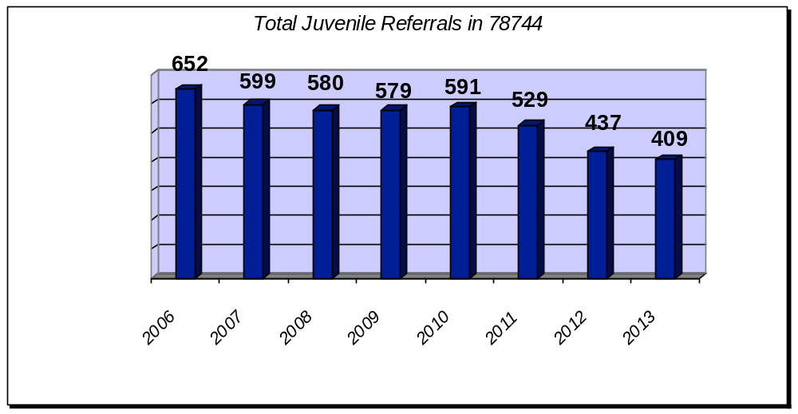

Figure 5
source: travis county juvenile probation department

These numbers of juvenile probation referrals from the 78744 Dove Springs zip code correlate much stronger than the numbers of juvenile arrests. Statistics from the Austin Police Department show the variation in juvenile arrests. In 2010, there were 396 juvenile arrests/suspects in January through September 30th. In 2011, arrests/suspects rose to 405, a 2.3% increase. In 2012, arrests/suspects dropped to 353, representing a 12.8% decrease. In 2013, arrests/suspects dropped further to 293, representing a 17% decrease. In 2014, arrests/suspects rose to 321, representing a 9.6% increase. Finally, in 2015, 275 cases, a 14.3% decrease from 2014, were reported from Jan. 1st, 2015- Sept. 12th, 2015. Figure 7 shows a decreasing juvenile crime rate trend between 2011 and 2015, with just a slight peak in 2014.

Table 1: Juvenile Crimes 2003-2015
Count of GO Primary Key | Person GO Role Desc
GO Occurred Date Year | JUV-ARRESTE | JUV-SUSPECT | Grand Total
2003 | 285 | 246 | 531
2004 | 285 | 213 | 498
2005 | 274 | 158 | 432
2006 | 304 | 190 | 494
2007 | 299 | 203 | 502
2008 | 309 | 164 | 473
2009 | 227 | 168 | 395
2010 | 230 | 166 | 396
2011 | 241 | 164 | 405
2012 | 200 | 153 | 353
2013 | 161 | 132 | 293
2014 | 187 | 134 | 321
2015 | 146 | 129 | 275
Grand Total | 3148 | 2220 | 5368
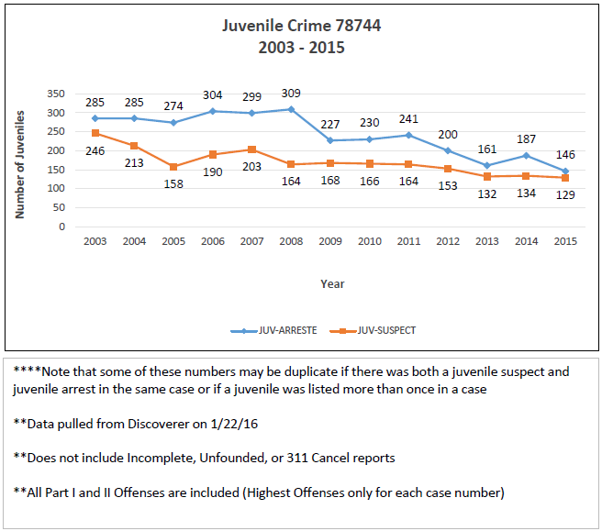

Figure 6 Juvenile Crime in 78744 from 2003 to 2015
source: austin police department

Table 2: Juvenile Arrests/Suspects 78744
2011-2015
Count of GO Primary Key
GO Occured Date Year | Total
2011 | 405
2012 | 353
2013 | 293
2014 | 321
2015 | 275
Grand Total | 1647
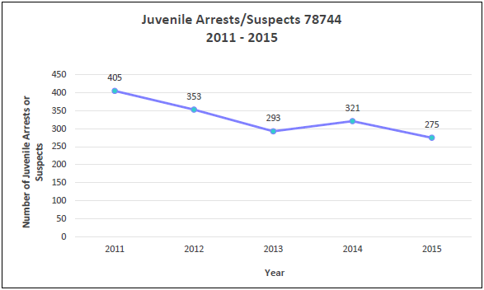
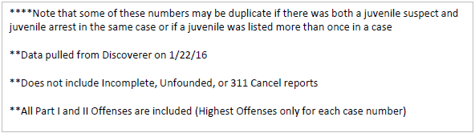
Figure 7
source: austin police department

Offense Types
While the total number of referrals in 78744 Dove Springs decreased between FY 2010 and FY 2015, the annual percentages of crime categories remained relatively constant. Chart 8 shows the four main juvenile referral offense categories. There was little change over the five year period in referral percentage totals per category. Referrals for misdemeanors made up roughly 40% of referrals each year. Violation of probation referrals made up about 20% of total referrals. Felony referrals made up around 15% of total referrals, and status or CINS referrals made up around 25% of total referrals each year.

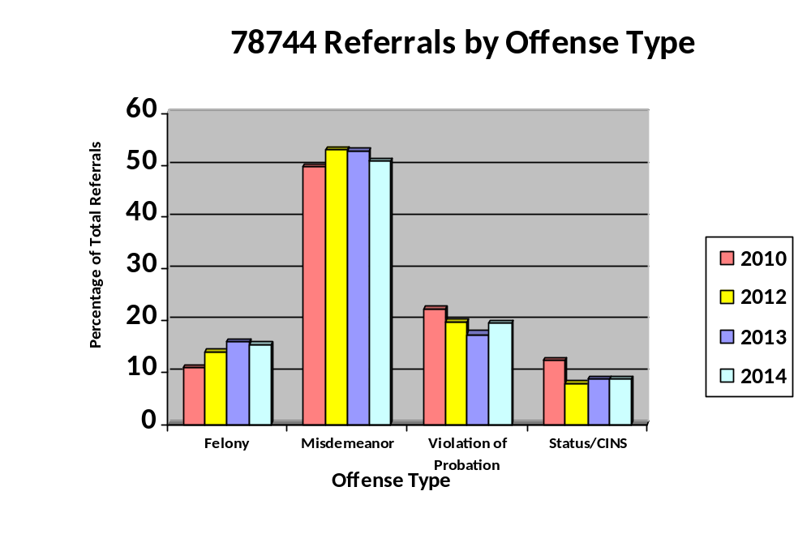

Figure 8
source: travis country juvenile probation department

The main offense categories of Felony Offenses and Misdemeanor Offenses are broken down into four subcategories: Violent, Property, Drug, and Other. The percentages of juvenile offenses within Misdemeanor and felony subcategories saw significant changes over the three years. Chart 9 displays these changes in juvenile Felony offense type. The smaller of the two pie charts, representing the main categories of juvenile criminal offenses, shows very little change between 2010 and 2014 while the larger pie chart, representing Felony subcategories, shows more notable change within the four year period.

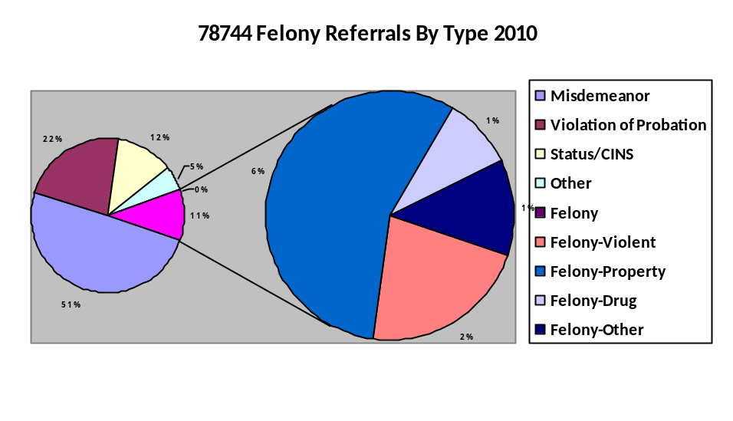
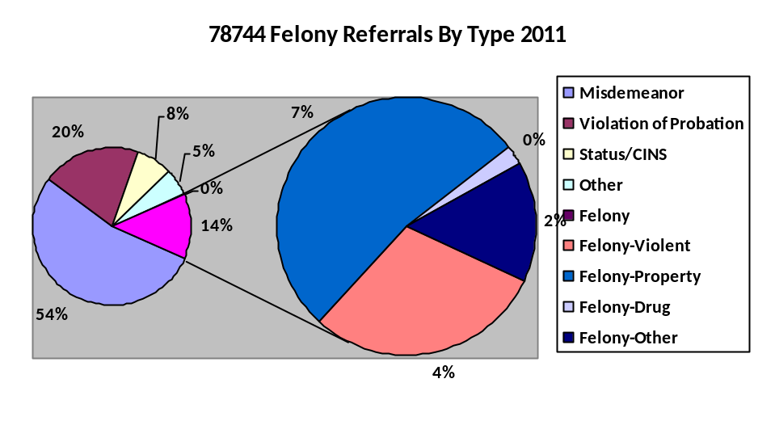
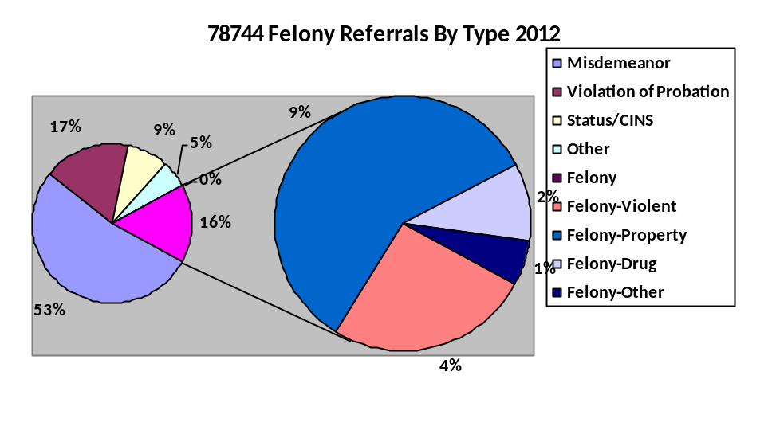

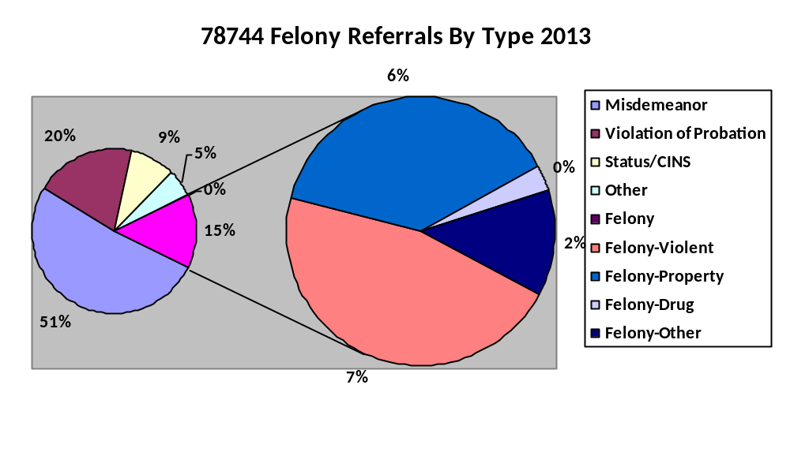

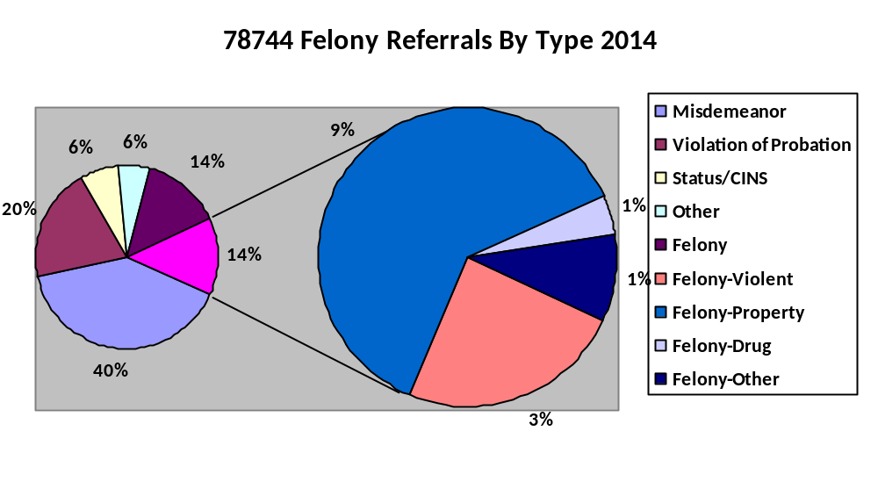

Figure 9
source: travis country juvenile probation department

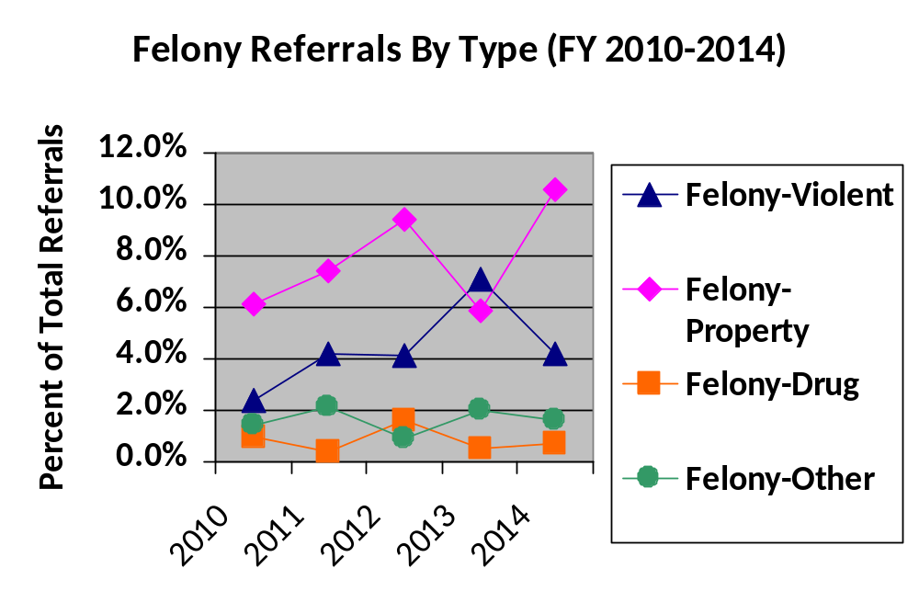

Figure 10
source: travis country juvenile probation department

As seen in Charts 9 and 10, while felonies continue to make up about 15% of all juvenile referrals in the 78744 Dove Springs zip code, there have been changes each year to the composition of referrals by type of offense. Felony property crimes have risen each year during the four year period, making up the majority of felony referrals, except for the year 2013 when they dropped. Violent felony crimes rose between FY 2010 and FY 2011, then remained nearly the same between FY 2011 and FY 2012, and then again rose from 2012 to 2013, and then dropped in 2014. Property felony crimes surpassed violent felony crimes in 2014. Felony drug crimes dropped between FY 2010 and FY 2011, rose to its highest of the three years in FY 2012, dropped in 2013, and rose slightly in 2014. Other felony crimes dropped in 2011, but rose to its highest amount in 2012. These changes do not provide a clear trend in juvenile referral types. Felony property crimes demonstrated an increasing trend until 2013 when they dropped drastically and then rose again in 2014. The continued increase from 2010- 2012 in the relative amount of property crimes as a percentage of total referrals was consistent with previous years’ SNA reports that showed the same trend.

Misdemeanor crimes also saw changes in the composition of crime type committed over this time period. Notable trends include violent and other misdemeanors remaining high each of the four years. Drug related misdemeanors fell in FY 2011, but rose again to high levels in FY 2012 and FY 2013 and then fell again in FY 2014. Property related misdemeanors were the lowest percentage misdemeanor category in FY 2010 and FY 2011, but rose to third highest in FY 2011, 2012, 2013, and 2014.

Timing of Criminal Activity

Figure 11 shows the timing of cases involving a juvenile arrest or suspect by month. The overall number of cases has been decreasing from 2011 to 2015, with the exception of 2014, where there was a 9.6% increase in total cases reported from 2013. The figure shows a small trend in arrest/suspect activity that may correlate with school sessions. Three months have the highest number of arrests in this time period: April, May, and October for 2011-2013. Other months vary more each year, but March and April generally had the lowest number of juvenile arrests/suspects until the year 2013. In 2013 and 2014, March and August showed the highest number of arrests. In 2015, July showed the highest number of arrests (39 cases), with the rest of the year ranging from 13 cases to 26 cases.

Table 3: Juvenile Suspects/Arrests 78744 by Month for 2011-2015
Count of GO Primary Key |  |  |  | Date Year
GO Occurred Date Month | 2011 | 2012 | 2013 |  | 2014 | 2015 | Grand Total
JAN | 35 | 31 | 18 |  | 19 | 24 | 127
FEB | 36 | 27 | 23 |  | 25 | 21 | 132
MAR | 38 | 9 | 26 |  | 45 | 22 | 140
APR | 39 | 31 | 28 |  | 27 | 26 | 151
MAY | 42 | 33 | 28 |  | 37 | 24 | 164
JUN | 22 | 23 | 23 |  | 21 | 25 | 114
JUL | 28 | 33 | 22 |  | 27 | 39 | 149
AUG | 27 | 33 | 30 |  | 20 | 24 | 134
SEP | 39 | 33 | 19 |  | 22 | 15 | 128
OCT | 35 | 32 | 30 |  | 26 | 25 | 148
NOV | 33 | 40 | 21 |  | 23 | 13 | 130
DEC | 31 | 28 | 25 |  | 29 | 17 | 130
Grand Total | 405 | 353 | 293 |  | 321 | 275 | 1647
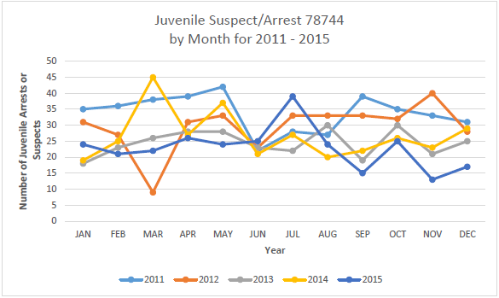

Figure 11 24
source: austin police department

Crime Rates in Austin and the Southeast Region

The above graphs and figures display positive trends in overall criminal activity among the juvenile population in the 78744 Dove Springs community. These decreasing trends are accentuated when compared with the growing total juvenile population in the area and the surrounding criminal environment. While juvenile criminal involvement in the 78744 Dove Springs area decreased, total violent crimes in the entire Southeast Region increased. Between FY 2008 and 2009, total Part I violent crimes increased by 12.6% in the Southeast Region while violent crimes in the entire Austin area rose by only 3.1% over the same time period. Between FY 2008 and FY 2009, the Southeast Region saw a significant increase in homicide, rape, robbery, and aggravated assault crime. Such general increases in overall crime, however, did not increase the juvenile crime rate in the 78744 Dove Springs zip code.

COMMUNITY LEADERSHIP

The 78744 Dove Springs community and the Dove Springs neighborhood in particular, have a history of community involvement and grassroots organizing.

Southeast Corner Alliance of Neighbors (SCAN) was established in the early 1980’s to respond to growing crime and gang problems in Dove Springs and was later transformed into an umbrella organization for smaller, more localized neighborhood groups. SCAN members were Diane Sanders and Bob Larson, the first Austin City Councilmember who resided in Dove Springs, held an active role in the area: throughout the 1990’s SCAN was a leader in the Self-Reliant Program, a citywide initiative, focusing on Southeast Austin and aimed at engaging neighborhood associations to take an active role through education and partnering with the City of Austin and Travis County to address crime, health, transportation, and park conditions in their neighborhood. Throughout the years SCAN has participated in community events and has been instrumental in bringing many key structural assets to the 78744 Dove Springs neighborhood such as the Dove Springs Recreation Center. SCAN became inactive in the late 90s, but a Dove Springs Neighborhood Association emerged in 2013 under the leadership of President Edward Reyes and Vice President Casey Ramos, who both grew up and are longtime residents. Edward has been instrumental in coordinating City of Austin resources such as Code Compliance to address resident concerns. On October 31, 2013, a flash flood occurred in Dove Springs and over 800 homes were flooded in over twelve feet of water. During this flood, water levels rose the quickest and highest in over 100 years and broke the city record. Edward and the Neighborhood Association and the Dove Springs Recreation Advisory Board were the first community responders to provide food, water, and cleaning supplies to residents affected by the flood with their tents and headquarters located at Quicksilver and South Pleasant Valley. In addition to the Neighborhood Association, the Dove Springs Recreation Advisory Board under the leadership of President George Morales III, who grew up and is a longtime resident has also been influential to host community wide Thanksgiving dinners, Christmas toy drives, Back to School supplies, Easter, and Halloween events to build community relationships and support the youth of Dove Springs. The Dove Springs Recreation Advisory Board is the longest active volunteer board within 78744 Dove Springs starting in 1995.

In 2011, a Southeast Neighborhood Contact Team was formed to voice property owners, business owners and resident concerns regarding housing in the area to Austin City Council as they serve as the Advisory Board. Ms. Ofelia Zapata, Chair and resident, Vice Chair Frances Acuna and others have joined the group in order to inform city government of neighborhood plan issues in the 78744 Dove Springs area.

Community Assets

The 78744 Dove Springs community has a wide variety of assets that help youth lead positive lifestyles and avoid criminal involvement. The area has a history of community involvement with several community organizations that still function in a leadership capacity. Residents display strong values for education and place an emphasis on the importance of family support for youth. 78744 Dove Springs community residents also seem to value their neighborhood and neighbors.

The 2009 Dove Springs Community Assets Audit found that Dove Springs has a wide array of resources and organizational assets including twelve public schools, nineteen churches, and twenty-two community based organizations32. The Assets Audit conducted a windshield survey, a type of survey conducted by driving through a neighborhood and making visual observations. Of 4,996 Dove Springs area households, surveyors ranked 56% of the houses, 83% of the apartments, and 79% of the streets as being in “good condition”. 33

In the entire 78744 Dove Springs region, there are eighteen public schools either operating in the 78744 Dove Springs zip code or serving a large percentage of students from the 78744 Dove Springs zip code. CYD Service Providers work in sixteen of these schools34. CYD also works at the Southeast Branch Library, the Dove Springs Recreation Center, and River City Youth Foundation. The CYD Program Director, Poetrell Stewart collaborates with Parent Support Specialists and Community Liaisons.

32 Dove Springs Community Assets Audit Wesley Center for Family and Neighborhood Development. January 2009.
33 A ranking of “good”, “some deterioration” and “run down/deteriorating” was determined based on the overall average of the condition of lawns, housing, litter, and street condition.
34 The one school where CYD Service Providers neither recruit nor operate is located outside of the 78744 Dove Springs zip code and only 28% of the student body comes from the 78744 Dove Springs zip code.

The organizations that currently provide services to youth and families in the 78744 Dove Springs community through the Youth of Promise Initiative are:

- City of Austin, Health and Human Services
- Mexic-Arte Museum
- Creative Action
- Workers Assistance Program

City of Austin, Health and Human Services offers the Youth Advisory Committee (YAC), a teen leadership group comprised of youth from the 78744 Dove Springs area between the ages of 11-17. The YAC serves an important role in the CYD program because they are the youth voices of the 78744 Dove Springs area. Youth build leadership skills and are actively involved in the community.

Mexic-Arte Museum receives CYD funding for their Art Outreach “Screen It” Program. The program brings local artists into schools to explore the printmaking process with students. Students learn about Mexican and Latino art and culture and engage in art-making activities while investigating the theme of respect in all artworks. At the completion of the class, students are invited to the Museum for a guided tour of a printmaking exhibit.

Creative Action receives CYD funding for three programs, The Courage to Stand/Courage In Action, Crossing the Line and Summer Program.

Courage to Stand/ Courage In Action are a 5-6 session, classroom-based series focusing on the role of the courageous bystander. Creative Action leads students in examining the choices, risks, and consequences of intervening to assist a person being bullied while drawing on real-life examples from history.

Crossing the Line is a multi-day, interactive performance in which Creative Action’s actor-teachers help middle school students devise solutions to the everyday problems they face. Over the course of the program, students learn concrete conflict resolution skills, which focus on articulating their feelings, controlling anger, and identifying personal goals.

Summer Program is at various elementary and middle schools in the 78744 Dove Springs zip code during the summer. The Summer Program is a dynamic and engaging blend of creative arts and education for PreK-12th grade youth. Creative Action placed trained “Artists-in-Residence” at sites in the 78744 Dove Springs community to implement an arts-based curriculum that is designed to prepare students to be active, creative and positive members of their community. Activities include theatre, visual arts, puppet and mask making, dance, drumming, team building, creative writing, music and filmmaking.

Workers Assistance Program offers programing through CYD: Group Mentoring and Youth Leadership Development.

The Group Mentoring program is an after school group-mentoring program for 4th through 8th grade youth. The mentoring program uses a model which focuses on building relationships between young people and caring adults who serve as role models and life coaches. The mentors help youth develop character, learn and develop leadership and communication skills, and build their self-esteem, self-control, resiliency and understanding of positive ways to resolve conflicts.

Youth Leadership Development Program is offered in conjunction with the Group Mentoring Program. This program provides services to 20 youth between the ages of 10 and 14. The Youth Leadership program will work with these 20 youth to provide additional programming in the area of leadership. The program has eleven-session which will be offered monthly to these youth. The program allows participants the opportunity to develop strong and effective leadership skills. The ultimate goal of the program is to use skill building activities to promote self-esteem, empowerment, conflict resolution, communication skills, goal settings and academic skills.

Other organizations that provide additional services to the 78744 Dove Springs community are:

4-H Capital offers the SPARKS program at three community schools providing extra-curricular educational opportunities in science and technology to students in low-income areas of Austin.

A.I.S.D Victory Program provides tutoring services to help students with homework at the Southeast Austin Public Library.

American Youthworks (AYW) is a comprehensive human investment organization that
transforms young people into self-sufficient adults through education, job training and community service. AYW works with AmeriCorps programs has a charter high school for those needing a high school diploma, and offers counseling, health care, career placement services and college preparation.

Austin Area Urban League offers a Youth Empowerment program offering academic support, homework assistance, tutoring, community service projects, field trips, and a variety of other services to youth who are referred to the AAUL program through the Municipal Court system.

AVANCE trains parents as advocates, teachers, and role models and provides early childhood development services and activities.

Big Brothers/Big Sisters of Central Texas offers community-based mentoring program that matches youth ages 6-14 years old with a caring adult for long-term one-on-one mentoring.

CommUnityCare offers comprehensive primary care for the whole family including pediatrics, behavioral health services, and dental care. There is a CommUnityCare clinic in the 78744 Dove Springs zip code.

Communities in Schools works in four 78744 Dove Springs area schools, offering an array of campus-based dropout prevention programs including mentoring and tutoring opportunities.

Dove Springs Recreation Center offers a wide variety of community-based programs including after-school care for students from three elementary schools, free afternoon meals for the community, martial arts, gymnastics and sports programs, art and dance classes and a variety of community social events.

Girl Start provides learning-by-doing opportunities in mathematics, science, and technology.

River City Youth Foundation provides services to youth and families in the Dove Springs neighborhood including youth development, family counseling, mentoring, violence and substance abuse prevention, and technology training programs.

Skill Point Alliance offers free technology classes at Travis High School and South Austin Community College Campus including keyboarding, basic internet and e-mail and other computer skills.

Southeast Austin Community Branch Library serves 12,000-20,000 people monthly. The library offers 5 programs currently including family programming, youth tutoring through AISD Victory Program (listed above), ESL classes and Story Time for children.

The Seedling Foundation offers community beautification, College Admissions Mentor Program and mentoring to children of incarcerated parents in A.I.S.D.

The WIC program provides supplemental food, health care referrals, and nutrition education to women, infants, and children. There is a WIC location in the 78744 Dove Springs zip code.

Worksource Career Center is an employment and training resource center administered by the Greater Austin Area Workforce Board.

The Latino Healthcare Forum (LHCF) is an Austin, Texas based non profit organization concerned with reducing racial and ethnic health disparities. The LHCF's original core competency has been to train members of the community to become Health Care Workers or as we call them "Promotoras" through a 160 hour course certified by the Texas Department of State Health Services.

GO! Austin / VAMOS! Austin (GAVA) is a coalition of residents, community leaders and nonprofits that share a common interest in improving the health of the Dove Springs and 78745 communities through increased access to and participation in physical activity and improved nutrition. GAVA supporters have agreed to align their resources and expertise for greater positive impact, especially as it relates to the health of children.

The Austin Project Family Resource Center (FRC) has taken root and has engaged hundreds of new community partners, along with thousands of dollars of in-kind support that benefits families and youth. The FRC now provide struggling families with case management services and connection to critically needed resources. The FRCs assist families to access affordable housing, health insurance, access to a medical home, emergency health care, employment services, legal aid, financial assistance, adult education, and connection to community through local faith-based organizations, neighborhood associations, and community events.

ACE/21st Century After School Programs serves as a supplementary program to enhance local reform efforts. The program assists students in meeting academic standards in core subjects (math, reading, science, social studies) by providing out-of-school time services to students and their families through community learning centers that offer an array of enrichment activities to complement regular academic programs.

Boys and Girls Club (BGCAA) assists youth in improving their educational and social skills, physical health and fitness and emotional well-being. BGCAA strives to create a foundation for a positive peer culture that value learning skills and contribute to society. Programs are compelling enough to appeal to kids as an alternative to unsupervised, “hanging out” time after school.

Young Life believes in the power of presence. Kids’ lives are dramatically impacted when caring adults come alongside them, sharing God’s love with them. Because their leader believes in them, they begin to see that their lives have great worth, meaning and purpose.

Apart from non-profit resources within the 78744 Dove Springs zip code, the community has other assets including positive relationships among neighbors, strong structural assets, and a high-level of community participation.

POSITIVE RELATIONSHIPS

There seem to be positive relationships in the 78744 Dove Springs community both among family members and between neighbors. In a 2009 Wesley Center survey, 91% of youth said they were “very happy/happy” about their family and in the 2009 SNA survey, 65.3% of the 294 residents who responded agreed with the statement, “I live in a neighborhood where people know and like each other.” Seventy-two percent of respondents felt people “are willing to help their neighbors” and an equally high percentage, 73.2%, agreed people “generally get along with each other.” Eighty-six percent of youth in the Wesley Center survey said they were “very happy/happy” with community members’ respect for different races. At the 2009 78744 Dove Springs Community Meeting hosted by COA-HHSD, the majority of the community strengths mentioned by attendees involved neighborhood unity and positive relationships between neighbors. On the 2010 SNA Survey, 71 respondents wrote that positive relations among neighbors were what they liked most about their community. In the 2012 SNA Survey, this response increased to 119 respondents. Again during the 2013 YAC focus group, most members claimed their neighbors and the people in the community among their biggest assets.

STRONG STRUCTURAL ASSETS

The 78744 Dove Springs zip code has a variety of public facilities located within the community known as Dove Springs. The Dove Springs Recreation Center and the Southeast Branch Library are located right across the street from an elementary and middle school. The Recreation Center and the middle school provide space for organized and informal community and youth sports and evening recreational events while the library has its own after-school program. The library and the recreation center also serve as foci for distributing services to the community and hosting community events, such as the annual Thanksgiving Dinner. CYD programs often hold events at these locations as do other programs in the area.

During an informal SNA interview in 2009, a police officer who had been working in the area for four years and was a volunteer mentor at a 78744 Dove Springs elementary school said the biggest strength in the community was the strong base of organizations and programs although these resources were, in her opinion, underutilized by youth. The officer, who wished to remain anonymous, listed the River City Youth Foundation, the Southeast Branch Library, the Dove Springs Recreation Center and the supportive work of school-based Parent Support Specialists as examples of such community resources. The Southeast Branch Library was again mentioned in the 2013 YAC focus group, where two members claimed it as one of the biggest assets in their community.

COMMUNITY UNITY

Despite its limited structured leadership and programs, the 78744 Dove Springs has a strong desire to improve its community. In 2013 SNA interviews, several respondents said that an important asset to the community was its desire for change. These included: “willingness of the community to create a change”, “willingness to come together to work on a common goal”, “The willingness and desire of the residents in building a safe, healthy environment”, and that residents “are eager to improve their family relationship”.

Residents of 78744 Dove Springs are described as being participatory in community events and social gatherings. During the free response portion of the 2010, 2011 and 2012 SNA survey, several adults indicated a need for more social opportunities in order to connect with other parents in the community. Suggestions were varied and included everything from community service events to neighborhood cultural performances to youth sports tournaments (see Section III: Community Ideas for Youth Programming). Community unity and participation was repeatedly cited as one of the community’s strongest assets along with a supportive and dedicated group of non-profit and school-based employees.

An employee of the Dove Springs Recreation Center thought unity was the most important issue to community residents. A childhood resident herself, she mentioned that the community used to have more community walks and events than are currently provided. She believes this is a result of a lack of leadership more than a lack of interest, citing the large turnout at every recreation center event. At the annual Thanksgiving Dinner held at the Dove Springs Recreation Center, around 300 community members usually attend. One of the main challenges to activity participation is publicizing events as many residents do not use e-mail, some do not have phones, and a large percentage does not speak English.

SECTION III

2016 CSNA Survey:

Perceptions of Crime and Neighborhood

The 2016 Community Strengths and Needs Assessment Survey collected data from youth residents, adult residents, and stakeholders including CYD Service Providers and members of the 78744 Dove Springs community. Respondents returned a total of 553 total surveys: 386 Youth (Under 17 years of age) and 167 Adult (18 years of age and older).

The survey investigated respondent’s perceptions of 78744 Dove Springs community strengths and needs with a focus on youth programming needs in the community. The survey asked participants to choose six program categories they felt would best serve the community and help to reduce the juvenile crime rate in 78744 Dove Springs. They were also provided with a write-in box in which they were asked to offer their own thoughts and ideas on 78744 Dove Springs community needs. This section presents the results of the 2016 SNA survey.

Survey Demographics
Age
- 553 total surveys: 386 Youth and 167 Adult

78744 Dove Springs Affiliation
- 69.08% of survey respondents live in the 78744 Dove Springs zip code and 30.92% do not live in the 78744 Dove Springs zip code, but attends school, has children who attend school, or work in the 78744 Dove Springs area. All respondents live, work, or go to school in the 78744 Dove Springs zip code or CYD affiliated school.

Community Strengths
The survey gave a list of eighteen types of community strengths or programs (and an option of “other”). Respondents were asked to choose the top five they thought were most helpful in their neighborhood. The figures below shows the responses divided by youth and adults in 2016 and 2015 SNA surveys.
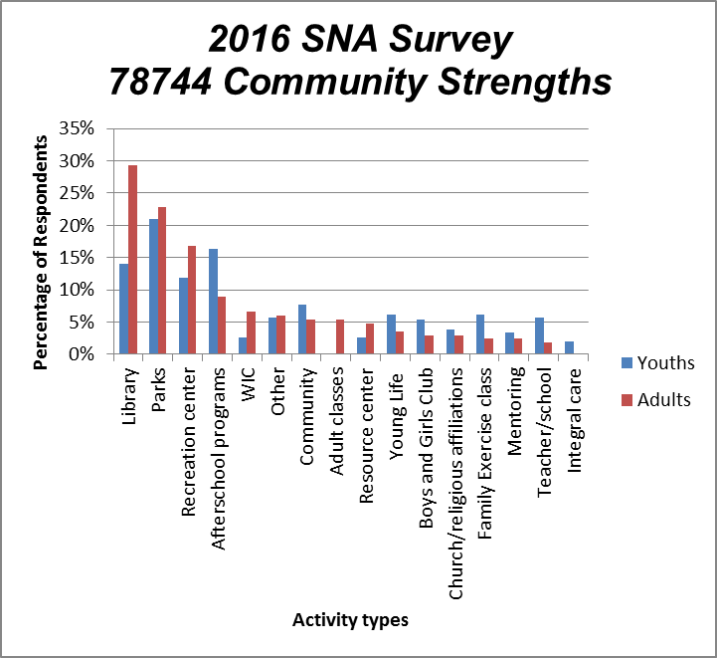
Figure 12 Ranking distribution of community strengths in 78744 for youth and for adults by percentage in 2016 SNA survey
Margin of Error = +/- 2

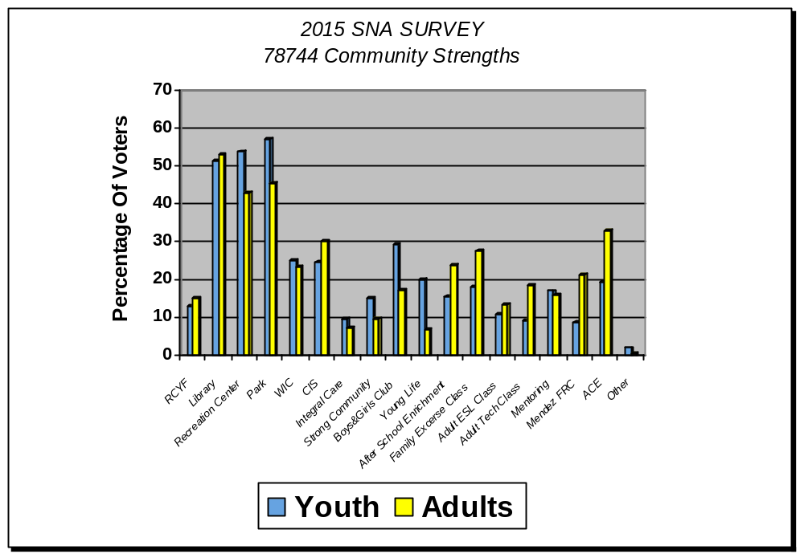

Figure 13 Ranking distribution of community strengths in 78744 for youth and for adults by percentage in 2015 SNA survey
Margin of Error = +/- 2

Table 3 Ranking distribution of the top 5 community strengths in 78744 by percentage as rated by youths and by adults for 2015 and 2016 SNA Survey
 | Youth |  | Adult
Ranking | 2016 | 2015 | 2016 | 2015
1 | Park | Park | Library | Library
2 | Afterschool programs | Recreation center | Park | Park
3 | Library | Library | Recreation center | Recreation center
4 | Recreation center | Boys and Girls Club | Afterschool programs | ACE
5 | Community | WIC | WIC | CIS

Notable observations include:

- The top community strength chosen by youths and by adults remained the same in 2016 SNA survey results. Park and library, chosen by youths and adults, respectively, remained the top community strength in FY 2015 (Table 3).
- These community strength rankings are similar to those in FY 2014 and FY 2015 SNA survey results. The top three choices for adults did not change. The top three choices for youths changed only slightly, with the second choice recreation center in FY 2014 replaced with afterschool programs in FY 2015.
- New additions in the top five programs in FY 2015 for youths are afterschool programs and community, which replaced Boys and Girls Club and WIC (the fourth and the fifth ranked community strengths in FY 2014). The new additions seem to reveal the youths’ increased level of comfort and confidence in their community and the success of the afterschool programs in 78744 in FY 2015.

Perceptions of Crime Comparison
The following are the results of those participants who did respond when asked: “Do you think crime in 78744 Dove Springs has gone (within the last year): Up, Down, Stayed the same”

2016 SNA Results
- 49 (29.3%) Adults thought crime went up while 24 (14.4%) thought crime went down and 94 (56.3%) adults thought crime had stayed the same within the last year
- 74 (19.2%) Youth thought crime went up while 84 (21.8%) thought crime went down and 228 (59%) youths thought crime had stayed the same within the last year

2015 SNA Results
- 43 (26.2%) Adults thought crime went up while 42 (25.6%) thought crime went down and 62 (37.8%) adults thought crime had stayed the same within the last year
- 124 (17.6%) Youth though crime went up while 179 (25.4%)thought crime went down and 325 (46.2%) youth thought crime had stayed the same within the last year

2014 SNA Results
- 64 (24.6%) Adults thought crime went up while 45 (17.3%) thought crime went down and 118 (45.4%) adults thought crime had stayed the same within the last year
- 107 (19.1%) Youth thought crime went up while 165 (29.5%) thought crime went down and 244 (43.6%) youth thought crime had stayed the same within the last year

2013 SNA Results
- 126 (37.5%) Adults thought crime went up while 69 (20.5%) thought crime went down and 99 (29.5%) adults thought crime had stayed the same within the last year
- 54 (31.4%) Youth thought crime went up while 46 (26.7%) thought crime went down and 59 (34.3%) youth thought crime had stayed the same within the last year

2012 SNA Results
- 51 Adults thought crime went down while 16 thought crime went up within the last year
- 259 Youth thought crime went down while 181 thought crime went up within the last year

These results indicate that a higher proportion of adults in the 78744 Dove Springs zip code believe crime increased in 2015 than youth. A larger percentage of adults and youth believed crime had stayed the same. Compared to the 2015 results, the percentage of youths that believe crime has gone up increased while the percentage that believe crime has stayed the same also increased. In FY 2015, over half of youths and adults who live, work, or go to school at Dove Springs believe that crime had stayed the same within the last year.

While the majority of the respondents believe that the crime trend had stayed the same within the last year, it is generally still considered an issue in the community. As one Youth Advisory Committee member stated in a 2012 interview:
“Crime is a big issue that has affected everyone in the 78744 Dove Springs zip code area including me. It is a really big deal because every day I always see cops roaming around at night to keep the neighborhood safe. There is too much burglary, violence, and more stuff going on in this neighborhood. Our house has been robbed for almost four times already. My dad has trouble with his job because people steal his tools that are worth hundreds of dollars. I have been witness of how men enter the Valero store and run out with beer without even paying for it. Even the employers call it a ‘Beer Run’, it happens daily.”

During the 2013 YAC focus group, crime was still considered a major problem in the members’ community. Fighting and drug use were frequently mentioned as specific problems prevalent in the area. The majority of the group agreed that property crimes and theft were the most common types of crimes committed, whereas violent crimes and assaults were not common. Most of the members, however, also agreed that crime was going down in the community; some members answered that crime was not a major issue in their community.

Community Programming Preferences
The survey gave a list of eleven types of programs and asked respondents to choose the top six programs they thought were most needed in their neighborhood to reduce the juvenile crime in 78744. The figures below show results of the program rankings divided by youth and adult responses.

Figure 14 Ranking of programs most needed in 78744 to reduce juvenile crime as perceived by youth and adult respondents in 2016 SNA Survey

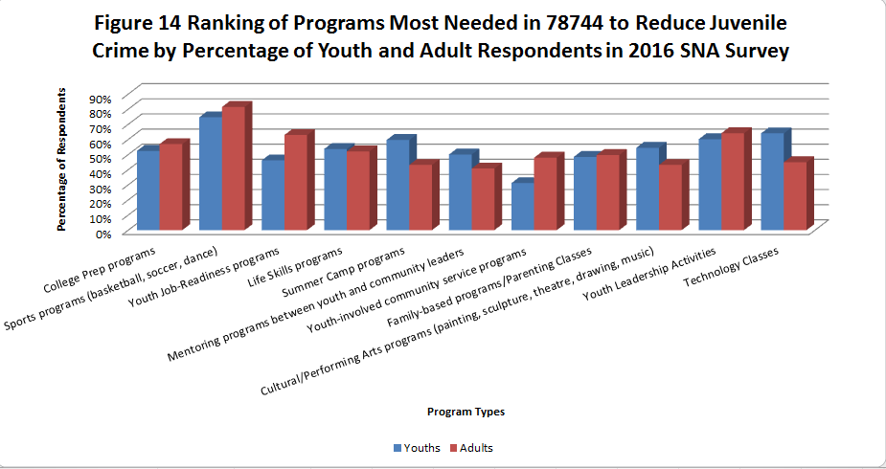
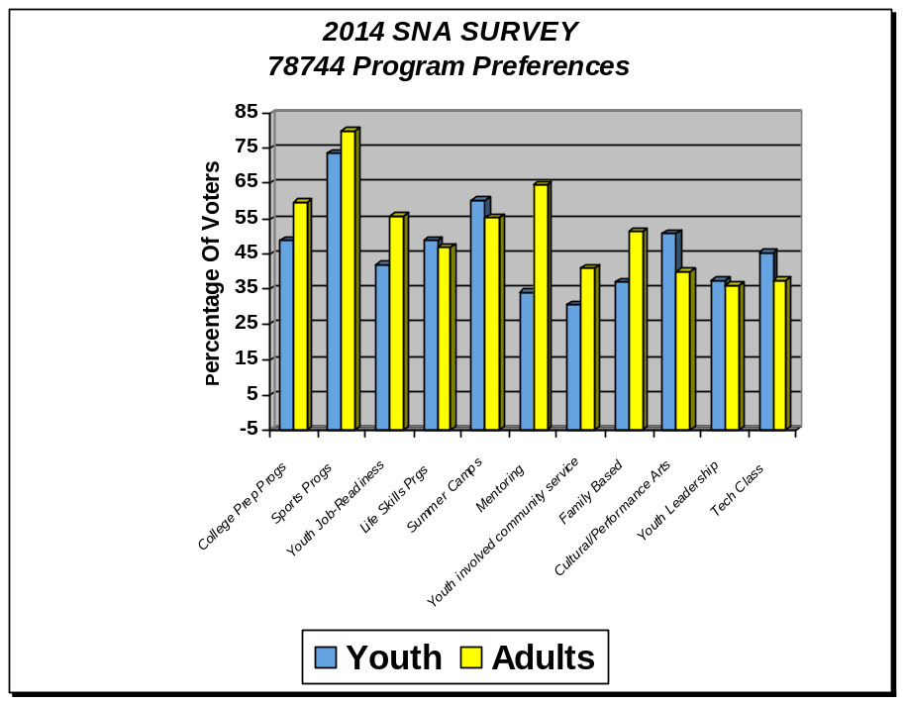Figure 15
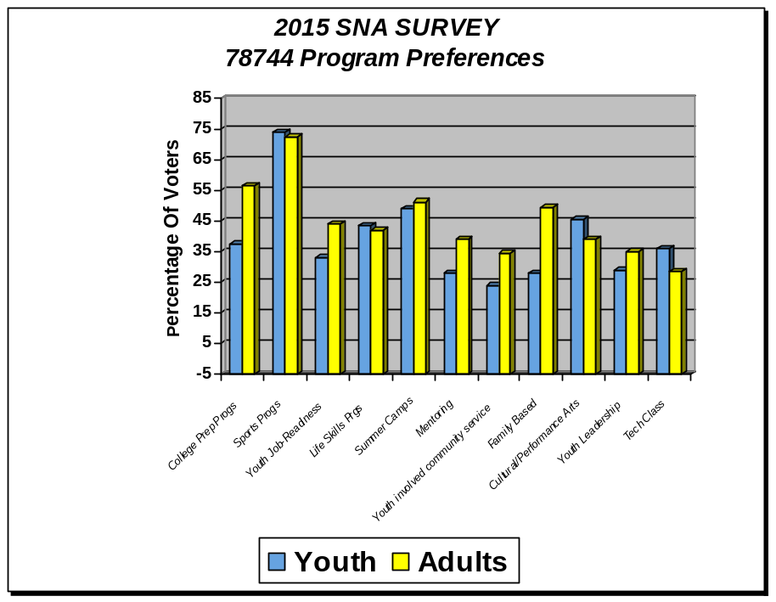
Margin of Error = +/- 2%

The figures above portray the distribution of effective program rankings for Youth and Adults. The programs listed in the section below are listed in the order they were ranked when youth and adult responses are compared.

Table 4 Ranking distribution of the top programs needed to reduce juvenile crime in 78744 by percentage in 2016 SNA Survey
 | Youth |  | Adult
Ranking | 2016 | 2015 | 2016 | 2015
1 | Sports programs | Sports programs | Sports programs | Sports programs
2 | Technology classes | Summer camp programs | Youth leadership activities | College prep programs
3 | Summer camp programs & Youth leadership activities | Cultural/performing arts programs | Youth job-readiness programs | Summer camp programs
4 | Life skill programs & Cultural/performing arts programs | Life skill programs | College prep programs | Family-based programs
5 | College prep programs | College prep programs | Life skill programs | Youth job readiness programs
6 | Mentoring programs between youth and community leaders | Technology classes | Family-based programs/parenting classes | Technology classes

Notable observations include:

- Youth and Adult respondents consistently ranked Sports programs as their top choice for 2016, 2015, 2014 and 2013 surveys.
- For youths, the top six programs that were present in 2015 all remained in the top six programs in 2016. Furthermore, two additional programs were selected into the top programs: youth leadership activities that tied with summer camp programs in third place and cultural/performing arts programs that tied with life skill programs in fourth place.
- Going from 2015 to 2016, there is a jump in the perceived importance of technology classes by youths as it jumped from sixth most needed programs to the second most needed programs in 78744. Interestingly, technology classes dropped from the top six most needed programs in adult responses.
- There is a shift of preference for youth leadership activities and youth job-readiness programs in adult respondents as these two programs ranked as the second and third most needed programs in 78744.
- Family-based programs/parenting classes showed up as the sixth most needed programs in adult survey responses in 2016.
- Over the last six years the community has consistently expressed a need for programming in areas that are not currently funded by CYD, namely Sports Programs, Summer Youth Employment Programs and College Prep Programs.

Table 5 Ranking distribution of the top programs currently helping to stop or reduce youth crime in 78744 by percentage in 2016 SNA Survey
Ranking | Youths | Adults
1 | Sports programs | Sports programs
2 | Youth leadership activities | Youth job-readiness programs
3 | Family-based programs/parenting classes | Youth leadership activities
4 | Summer camp programs & technology classes | College prep programs
5 | Life skill programs | Family-based programs/parenting classes
6 | Cultural/performing arts programs | Life skills programs, mentoring programs between youth and community leaders, & youth-involved community service programs
Table 5 shows the youth and the adult respondents’ perceived effectiveness of the programs that are currently helping to stop or reduce youth crime by percentage. Sports programs are ranked as the top program for currently helping to stop or reduce youth crime in 78744 by both youths and adults.

Sports programs, youth leadership activities, family-based programs/parenting classes, and life skill programs appeared on both the youths’ and the adults’ selection of top 6 programs that are currently helping to stop or reduce youth crime in 78744 in 2016 SNA Survey.

Youths served and satisfaction rate
Grant Year September 1, 2013 thru August 31, 2014

- 1658 unduplicated youth served from 6-17 years old
- 100% not did Not Engage in Delinquent Behavior
- 907 Satisfaction Surveys completed – 93% Satisfaction Rate

Grant Year September 1, 2012 thru August 31, 2013

- 1211 unduplicated youth served from 6-17 years old
- 100% not did Not Engage in Delinquent Behavior
- 907 Satisfaction Surveys completed – 96% Satisfaction Rate

Grant Year September 1, 2011 thru August 31, 2012
- 1136 unduplicated youth served from 6-17 years old
- 100% not did Not Engage in Delinquent Behavior
- 896 Satisfaction Surveys completed – 89% Satisfaction Rate

Grant Year September 1, 2010 thru August 31, 2011
- 1630 unduplicated youth served from 6-17 years old
- 100% not did Not Engage in Delinquent Behavior
- 1365 Satisfaction Surveys completed – 93% Satisfaction Rate

***Total number of Target Youth with a validated incident is the number of program target youth participants with a documented date of referral from the Texas Juvenile Probation Commission database that is during the period services are being received, which is defined as after a youth's registration date for the PEI program and before the date during the last month of receiving services.

Note: Grant requires only 80% satisfaction rate and only 95% rate of youth not involved in delinquent behavior.

Notable observations include:
- Of all the people involved in a CYD program, zero participants were involved in crime. This provides evidence that the CYD programs are effective in reducing the incidence of crime in the 78744 Dove Springs zip code.
- The most recent satisfaction report shows that 96% of the participants are satisfied with the CYD program they attend.
- Despite these evidences, State funding for CYD was reduced by 36% during Grant year 2010- 2011 to Grant year 2011- 2012. As a consequence, lower number of youth could be served.

CYD Participation Rate in 78744 in 2016 SNA Survey

165 respondents answered the question “Are you currently attending any of the services provided by the following CYD Programs? (If you are a parent, does your child/teen attend?). Of the 165 responses, only 17 (10.3%) answered yes, that they or their child/teen are currently attending one of the services provided by CYD programs listed.

Figure 16 Distribution of respondents involved in CYD programs in 78744 in 2016
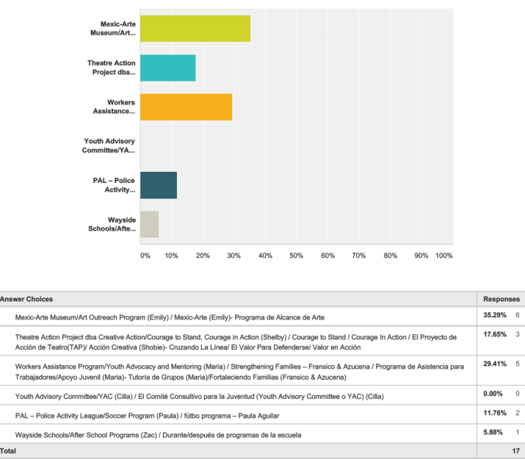

CYD Suggestions

The 2015 and 2014 SNA survey included a free response question asking: “What ways do you think CYD could be better?” The results are summarized below along with original quotes:

- 128 CYD-affiliated respondents answered this free-response question in 2014 and 109 CYD-affiliated respondents answered this free-response question in 2015. Forty-five respondents answered this free-response question in 2016.
- The most common suggestion was increasing the diversity of the programs offered, extend the current programs, include sports programs and technology programs, and recruit more participants by spreading awareness.

- Although not considered as CYD-affiliated responses, many non-CYD respondents claimed that the CYD could improve by telling people what is available, since they did not know what these programs were. This was also a concern for the 2015 survey.

- Some original responses to this questions present in the 2015 survey were:

  - “providing more funding for more programs”
  - “Advertise more to allow more residents to know about these programs”
  - “More technology”
  - “If these programs could help the youth connect with professionals in those fields that could help mentor them it could provide the youth with an avenue on how to not only develop those skills but also have someone they can go to find out how to become or use those skills in the real world.”

- Some original responses to this questions present in the 2014 survey were:

  - “by providing more after school programs”
  - “Have more people and should be longer”
  - “Making people more aware of these programs, example using local radio or TV commercials to broadcast the presence in the are.”
  - “more technology”
  - “to have more programs”

- Some original responses to this questions from the 2013 survey were:
  - “Stats to show progress”
  - “More money for services & programs”
  - “Get more people involved. The program should go around the neighborhood to promote.”
  - “Get parents involved and let them know what they are doing.”
  - “I think CYD could improve in having programs that have teach self esteem. that teach value. the culture. We need to teach our children to become men with great respect for others. men that value what they have, what they believe in, men that honor they culture. I think if we can teach they that we can have a better future, they can be the next president, the next city official.”

Conversations and Assessments

In the 2013 SNA, four community members participated in informal, emailed questionnaire interviews in which they were asked about their perceptions of neighborhood crime, issues of importance to residents, community strengths, and gaps in servicing for youth and families in the community. CYD-contracted Service Providers also provided input on community strengths, needs, and ways in which CYD can become even more effective in the future. Comments from these informal interviews are outlined below.

The summer months are important times to address youth programs.

Angel Alvarez, a local elementary teacher, believed that improvements could be made to CYD programming during the summer. He believes that “the children should have more opportunities with better accessibility to the multiple programs during the summer time as they have during the fall and spring time”, as during the summer his students “mostly watch TV because they were unable to go outside to play with their friend.”Paola Ferate-Soto, from the Southeast Branch Library, agreed that CYD programs could improve during the summer months. She believed that strides could be made “by reaching out to more students and providing extracurricular activities in the summer months when most kids are unsupervised because parents can’t afford summer care.”

The 78744 Dove Springs community needs to take control of its programs and education.

- In one interview, an Austin Police Officer noted the role community residents should have in their own success: “We need parents to become more involved in understanding the importance of education. We need more parents to understand that discipline is a good thing and benefits everyone in the family and the community. We need a more thorough process in identifying “street-level” leaders, those people who actually live in the neighborhoods and are willing recruit other leaders, network with other community organizers, and maintain contact to ensure observable results in their rebuilding efforts.” Kimberly Royal, a local principal, noted that the community also needs to take “ownership in education.”

CYD Service Providers note internal regulatory and policy constraints to CYD Program effectiveness and efficiencies:

- The food stipulation requirements are a challenge to attracting community involvement at CYD sponsored events.
- Limitations on serving unduplicated youth are a challenge.
- Frequency of CYD report submissions are time-consuming and reduce the amount of time for recruitment efforts and group preparation.
- Reduction of the paper work will lessen the burden and can be a great improvement for grant guidelines and requirements.

SECTION IV

Concluding Observations:

“Filling the Gaps”

CYD-GOALS vs. PROGRAMMING REQUIREMENTS

The largest gap seems to be within the CYD grant itself. According to the FY 2005 CYD Guidelines, the CYD Target Internal Assets (meaning internal goals for CYD target youth) include developing self-esteem, helping youth feel confident about their abilities, helping youth feel empowered to make a difference, helping youth establish positive peer relationships, ensuring youth feel supported by adults in their lives through staff members, mentors, and family members, and helping youth develop a positive view of their personal future. However, CYD target output requirements provided by TDFPS are disenabling for programs which might have such long-term impacts on youth. In order to meet their output requirements for unduplicated youth served, CYD programs must reach a large target audience over a short time span, minimizing service provider’s ability to provide intensive, in-depth service to youth. CYD Service Providers must re-direct their resources towards programs that reach a larger number of youth at the expense of more intensive programming.

In addition, the inadequate grant received from the State makes it difficult for the CYD teams to implement the suggestions given by the community. For September 1st 2013 to August 31st 2014, the State provided $386,769.67. This amount is used to pay for a multitude of things including: staff (3 members) salaries, retirement, health insurance, training, program supplies, van rentals, youth ceremony, and food for the youth. This amount is also for the 10 free programs which serve over 900 youth each year in the 78744 Dove Springs zip code.

FREE SPORTS PROGRAMS

Organized sports programs are a valued commodity in Dove Springs. There are evening pick-up soccer games on school fields, youth sports games bring a high family turn-out, and the Dove Springs Recreation Center’s evening karate classes and soccer games provide an opportunity for parents and guardians to connect with each other. Sports are clearly enjoyed by the 78744 Dove Springs community and there has, over the last five years, been a clear and frequently expressed desire for more affordable sports programs. On the 2014 and 2015 SNA survey, youth ranked Sports Programs as the most needed youth program. During the free response section, community members reiterated the need for the youth to have a safe place to go, not just to keep out of trouble but also to spend their time and energy productively and to maintain a healthy lifestyle. During a 2012 SNA interview, Officer Valderas noted that, “More physical fitness opportunities are important if we want to keep the youth out of gangs and out of their rooms where they just sit and play video games. They need to know that there are other opportunities out there, starting with physical activity.” These comments have been consistent over the years. During the YAC Focus Group for the 2009 SNA, students explained that school-based sports programs limited participation by grade point average requirements and sports offered at the nearby recreation center were cost-prohibitive for many area youth. YAC students pointed out that students who do not have high grades and whose families cannot afford fees for sports are those who are most at-risk for gang and crime related activities. Finding a service provider for sports programs has proven to be a challenge for the CYD program. Indeed, though sports programs were a priority on the 2011 RFA (Requests for Application) and notice was sent out to over thirty different non-profits via email; no qualifying sports programs applied for CYD funding.

AFTER-SCHOOL PROGRAMS

Texas, in general, and the 78744 Dove Springs zip code, in particular, suffers from a shortage of affordable after-school programs. According to the Central Texas Afterschool Network, only 10% of Texas’ K-12 youth are able to participate in afterschool programs and one fourth of children are unsupervised afterschool. Ms. Meyers, a neighborhood social worker, cited affordable after-school care and child care as the biggest problem the community faces. When asked to list affordable after-school programs in the area, she could list only four programs, including the Southeast Branch library which, due to lack of supervision, allows only children age 13 and up to attend. None of the programs offer transportation to the facility which she cited as a constant issue for working parents.

Respondents to the 2010 SNA survey and attendees at the 2010 78744 Dove Springs Community Meeting ranked After-School Programs as the most needed youth program in the community. While all current CYD Service Providers offer an after-school component and several provide semester-long after-school activities, none of them are based on providing daily, after-school care throughout the school year.

In addition, research indicates that the after- school hours between 3- 6 p.m. are the peak hours for juvenile crime and peak hours for experimentation with drugs, alcohol, cigarettes, and sex. According to the Texas Partnership for Out of School Time (TXPOST), which is a statewide network of nonprofit, public, and private sector partners in Texas with a goal of increasing accessibility of out of school time programs for Texans, high- quality out of school time programs promote:
1) Engaged learning by providing a variety of activities for youth that go beyond ‘babysitting,’
2) Safe communities by providing supervision for youth and
3) Strong workforce by decreasing the number of work days missed by parents due to anxiety over their children’s afterschool care.
Because After- School Programs provide both supervision and quality programs, the youth benefit by staying engaged with productive activities and the community benefits by seeing a decrease in juvenile delinquency rate.

SUMMER PROGRAMS

Summer programs, whether summer employment programs for older teens or summer camp programs for younger youth, are repeatedly cited by community members as a need. SNA survey results for the last five fiscal years have ranked Youth Employment Programs among the top five funding priorities. On the 2013, 2014, and 2015 SNA, Youth respondents chose Summer Camp programs, as the second most needed program.

During a previous YAC Focus Group, one member cited the importance of employment in creating a sense of responsibility and personal ownership among youth. She said, “Once they start working towards something for themselves, making money and buying their own things they will be more considerate and act responsibly.” Youth Employment Programs also foster connections between youth and local businesses which help unify the community and provide positive role models for teens. Results from the Wesley Center’s 2009 door-to-door survey reported that two of the top five “major problems” for youth have to do with opportunities after high school. Exposing youth to the work force in a structured, programmatic way can help provide a forum in which teens are exposed to careers and ideas for paths they might be interested in exploring after high-school.

Summer youth employment programs and summer camp programs provide structured, positive environments for youth who might otherwise be unsupervised during the summer months.

COLLEGE PREPARATION

The 2013 SNA survey and YAC focus group suggest a strong need for college preparation programs in the 78744 Dove Springs zip code. In the 2013 survey, Adults and Youth chose College Prep Programs as second and fourth most needed programs, respectively. This sentiment was strongly expressed in the 2013 YAC focus group. YAC members displayed a strong desire to attend college, but wanted more programs to teach them what they needed to do to get there. As youth in this area become more expectant of attending college, they need information and tools in order to prepare themselves to meet these goals.

LONG-TERM MENTORING PROGRAMS

There are an insufficient number of programs offering long-term mentoring in the 78744 Dove Springs zip code. According to a report on gang activity by the office of the Attorney General of Texas, “to compete successfully with gangs, recreational programs must offer excitement and close, supportive relationships. Mentoring programs may be combined with after-school and summer activities.” A local area social worker cited mentoring programs as a need. Adults chose Mentoring Programs as their 4th most needed program in the 2013 SNA survey. CYD programs could help fill this gap in long-term mentoring if, as mentioned above, number requirements were lowered.

PARENTING CLASSES

When asked to create a youth program that would help decrease youth crime, a previous YAC member explained that what community youth really needed was a counseling center for adults because “adults influence kids a lot”. A police officer who has worked in the area for four years previously listed parenting classes as the greatest need for the 78744 Dove Springs community. In an informal interview she said that, in her opinion, the main problem with youth violence and crime in the area is that parents are young and do not have an understanding of good parenting tools. During the free response portion of the 2011, 2012 and 2013 SNA survey, adults asked for parenting “orientations” on how to communicate with their children about issues like sex, drugs, alcohol, higher education, gangs, and a wide-variety of other sensitive topics. A large number of parents asking for these sorts of classes were Spanish-speakers, perhaps indicating a lack of these types of services for the Spanish-speaking population. On the 2012 SNA survey, Family Based Programs were ranked by youth as the fifth most-needed program. One of the responses to the reason why a youth ranked Family Based Programs high was to “spend more time with mom and dad”. A CYD Service Provider is one of the few programs currently offering parenting classes in the area and most of their group sessions cater to a Spanish-speaking population. Similar programs that work with parents and youth in addressing juvenile crime are needed in the community.

COMMUNITY COLLABORATION

During a number of 2012 SNA interviews, community members emphasized the importance of different community groups communicating and working on their policies together. For instance, the policies of Austin ISD and the police department directly affect the neighborhood’s assets such as the Southeast Branch Community Library. Because students are not allowed to stay on school grounds after school hours, as dictated by the police department and school district, students flock to the library where librarians are left to deal with any issues. This result in a number of problems that the library’s staff is not always equipped to handle. The community as a whole should have the opportunity to give input and help determine what rules and regulations should apply in their community, instead of being made by only sections of the community. This of course would require dedicated time and effort from all parts of the 78744 Dove Springs zip code.

CRIME PERCEPTIONS VERSUS REALITY

The 2013 SNA survey showed that the 78744 Dove Springs community has an extremely varied view of its crime profile. When asked if crime has gone up, down or stayed the same within the last year, nearly one-third of youth chose each answer. Adults also had a large percentage select each response. However, 37% of adults believed crime had gone up compared to 20% who believed it had gone down. The survey results show that adults are more likely to believe crime has gone up than youth. In reality, as this report has shown, juvenile crime in the 78744 Dove Springs zip code has gone down substantially within the last year, and even more over the past decade. When asked about crime in the 2013 YAC focus group, answers were just as varied as survey responses. Some members claimed that crime was a major problem, whereas others said that it was no worse than other areas. More YAC members believed that crime had gone down lately, however, than survey respondents. These results indicate that the 78744 Dove Springs community is largely unaware of the recent decreases in criminal activity, and that more could be done to show them the progress the community is making as it combats crime.

GREATER FOCUS ON THE LATINO YOUTH

According to the 2010 U.S. Census Bureau, the majority of the population in the 78744 Dove Springs zip code (76.35%) is Hispanic/Latino. According to the Hispanic/Latino Quality of Life Initiative, which reports the quality of life issues for Hispanic/Latinos in Austin and provides recommendations to amend them to the City of Austin, one of the issues regarding the services for Hispanic/Latino youth in the Austin area includes the fact that “Hispanic/Latino youth make up a large proportion of the juvenile justices system.” The majority of the youth is also unemployed and/or underemployed; most lack the basic skills to help them secure work once they are adults. In addition, activities that promote youth development, such as organized sports, are also lacking.

Since the 78744 Dove Springs zip code has a majority of Hispanic/Latino youth, programs that specifically target these youth would be helpful to the community. Some of the suggestions (as taken directly from the report) by the Hispanic/Latino Quality of Life Initiative include:

- Creating and/or enhancing youth art, music, writing, theater, dance and performing classes at recreation centers and look into offering music production and business workshops as means for youth development
- Work to incorporate more co-ed sports into current program offerings
- Expand the number of computer labs at recreation centers and offer more classes like the Connected Youth program at the Austin Public Library that teach basic skills that can help youth secure gainful employment.

Most of these suggestions can be implemented as After- School programs through CYD, provided there is sufficient funding and staffing.

Next Steps

City of Austin-Health and Human Services Department Community Youth Development Program will disseminate the 78744 Dove Springs Community Strengths and Needs Assessment among CCC members, YAC members, subcontractors and the interested public as a formative document for approaching discussions regarding FY 2016 program funding. The program priority ranking and funding suggestions outlined in this document will be taken into consideration when creating the FY 2016 CYD Requests for Application (RFA) along with other considerations such as CCC and YAC member input, TDFPS requirements, and programming availability.

This document was created by Katie Noriega for the City of Austin, Health and Human Services Department.

Appendices

A. 2016 SNA Youth and Adult Surveys, English and Spanish 45

B. 2016 SNA SURVEY LOCATIONS……………………………………………………………………………47

C. 2015 SNA LETTERS OF SUPPORT……………………………………………………….48
Appendix A
2016 Community Survey Needs Assessment Youth and Adult Surveys


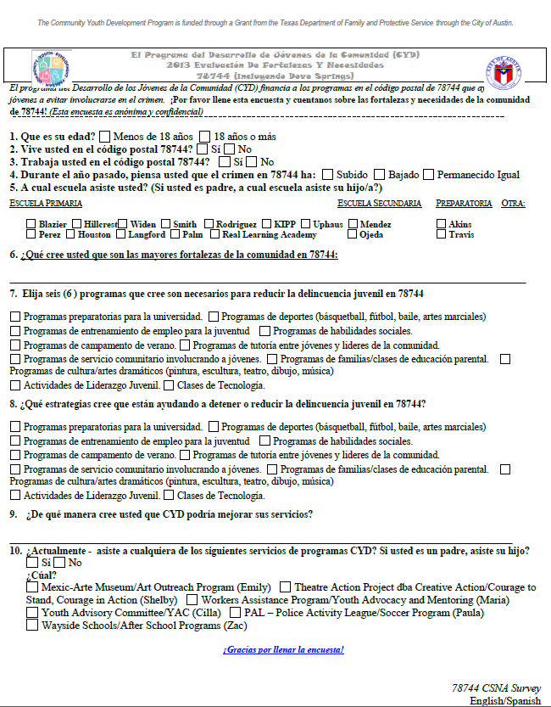

2015 SNA SURVEY LOCATIONS
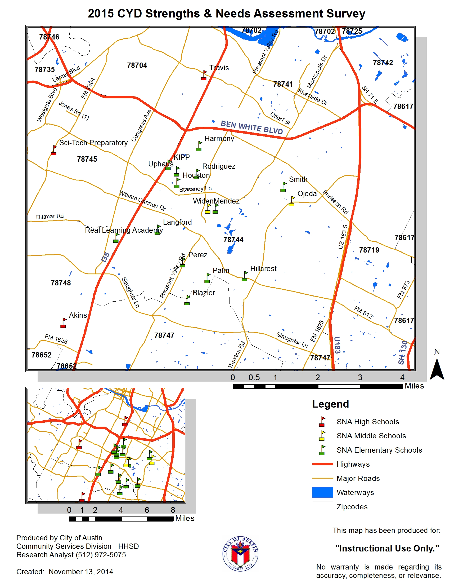
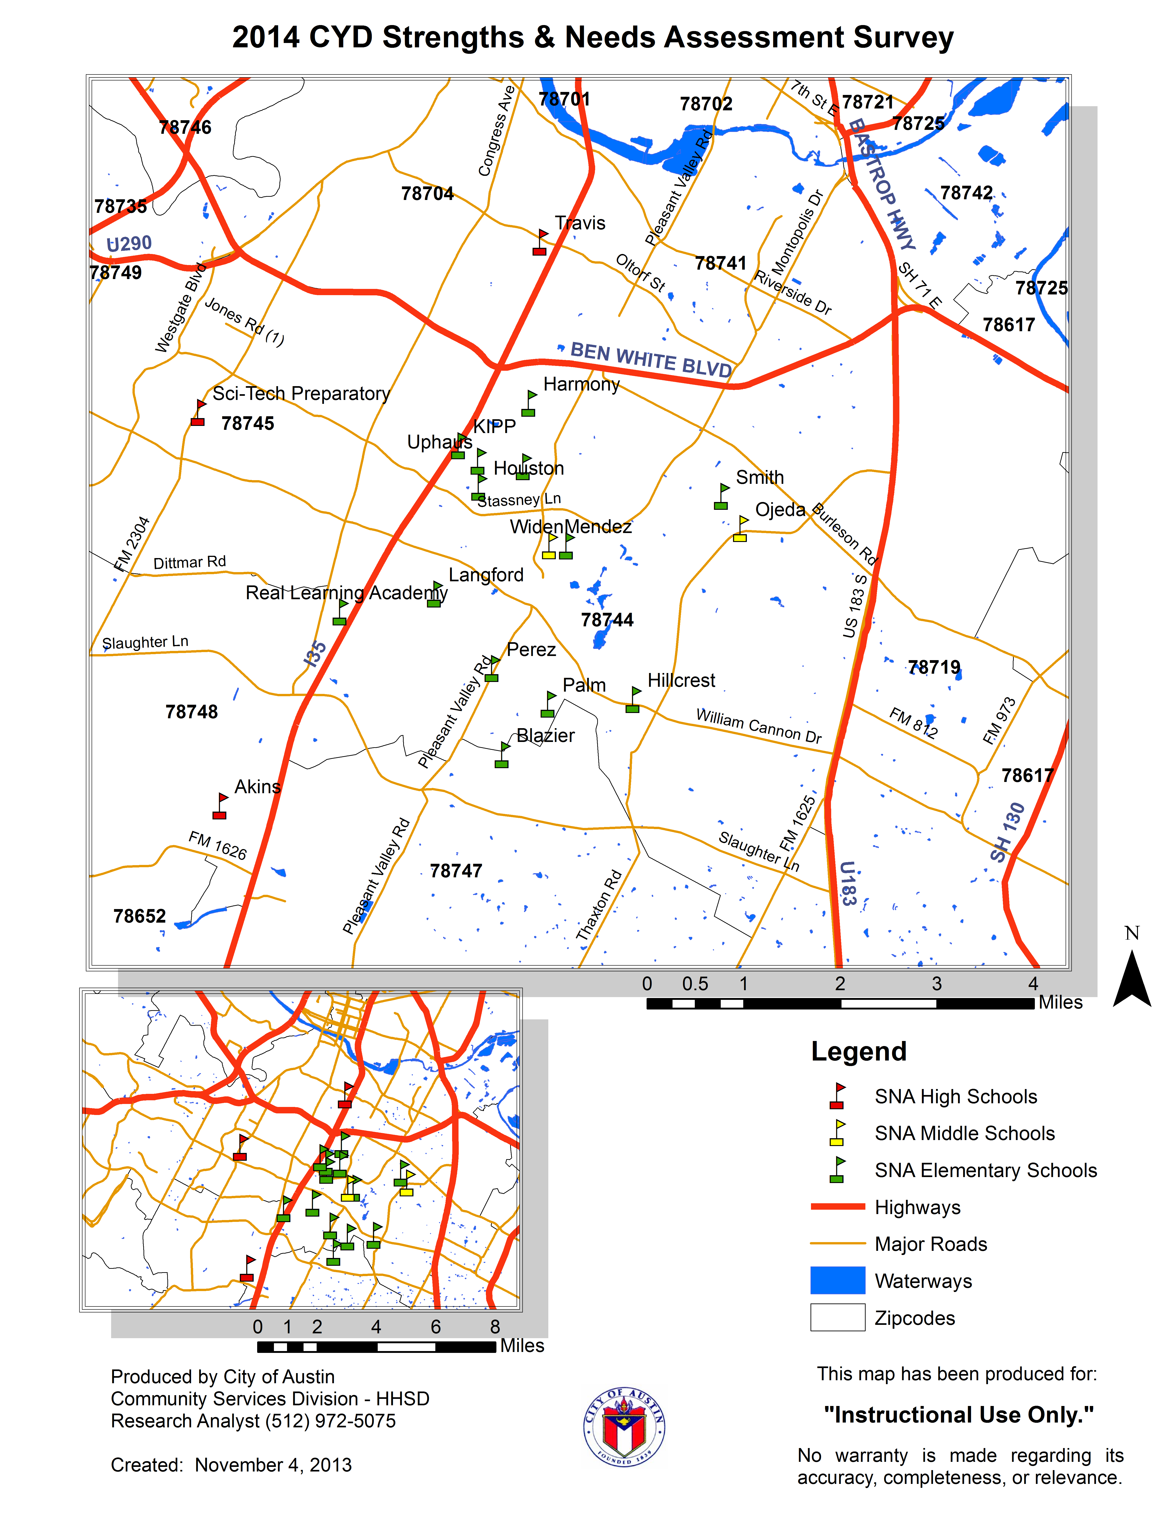

CYD Grants are authorized under Title IV of the Social Security Act, which is administered by the U.S. Department of Health and Human Services. The Administration for Public Services, Office of Human Development Services, administers social services under Title IV, Part B, which includes CYD.
The Wesley Center of Austin estimates that the population of the Dove Springs neighborhood alone is around 40,000 residents with just over 70% Latino residents while Onboard Informatics places the population of all of 78744 Dove Springs, including Dove Springs, at 37,677 residents.
Onboard Informatics, LLC compiles information from thousands of data sources to create up-to-date community information. Their sources include the U.S. Census, FBI and Bureau of Labor Statistics, National Center for Education Statistics and local entities such as Assessor, Clerk and the Chamber of Commerce. The information that was used in compiling this Description of the Service Area was gathered from the city-data website.
Robinson, Ryan. “The Top Ten Big Demographic Trends in Austin, Texas.” City of Austin. http://www.ci.austin.tx.us/demographics/downloads/top_ten_trends4.doc https://www.austintexas.gov/page/demographic-data
Onboard Informatics, LLC.
State of Dove Springs Wesley Center 2007.
2000 U.S. Census
Onboard Informatics, LLC.
The Austin Chamber of Commerce
Onboard Informatics, LLC.
Dove Springs is one of several communities in the 78744 Dove Springs zip code.
State of Dove Springs Wesley Center, 2007.
FY07 Travis County Immigrant Assessment (Travis County Health and Human Services & Veterans Service, Austin, Texas, 2007)
“AISD-Safe Schools/Healthy Students Logic Model ACCESS.”
Akins and Travis High Schools are the two high schools that serve the 78744 Dove Springs community.
“State of Dove Springs” Wesley Center, 12.
Travis County Juvenile Probation records from CY1999 as found on Community Action Network’s Public Safety Assessment 2000.
Results from the Wesley Center of Austin survey are yet to be published.
These statistics are based on a 2006 report by the Wesley Center. Of the seven elementary schools Wesley Center considered to be within Dove Springs, two schools were too recently established to provide data.
TEA defines “economically disadvantaged” as the sum of the students coded as eligible for free or reduced price lunch or eligible for other public assistance. “At-risk” factors include not performing satisfactorily on recognized assessment tests during the school year; not maintaining an average equivalent to 70 in two or more subjects during the previous or current semester or current school year; a student of limited English proficiency; or has failed a grade (State of Dove Springs p.16)
Statistics were provided by United Way for Greater Austin in the 2012 Target Graduation End-of-Year Results report.
“Safe Schools and Healthy Student’s Initiative: Austin Community Collaboration Ensuring Student Success.” Austin Independent School District. http://www.austin.isd.tenet.edu/community/access/docs/ACCESS_Proposal.pdf
Travis County Juvenile Probation. Statistics prepared by Research Unit on May 6, 2009 and October 9, 2009.
Statistics provided by the Austin Police Department on May 19, 2010. “The data provided is for informational use only and is not considered official APD crime data as in official Texas DPS or FBI crime reports.”
General offense categories are Felonies, Misdemeanors, Violation of Probation, and Status/CINS. Felonies and Misdemeanors have subcategories: Violent, Property, Drug, Other.
Travis County Juvenile Probation
Violent Felonies include Homicide, Sexual Assault, Robbery, and Aggravated Assault.
The Other Felony category includes over 800 different crimes including some types of graffiti crimes, evading arrest, forgery, and illegal weapons crimes.
Violent Crimes listing includes Murder, Rape, Robbery, and Aggravated Assault (APD) ³¹ Information taken from the SCAN website. http://www.neighborsaustin.com.
Neither the 2009, 2010 SNA survey nor the 78744 Dove Springs Community Meeting defined After-School Program. After-School Programs range from once-a-week programs for a few hours after-school to daily programming that runs throughout the school year between the hours of 3 p.m. and 6 p.m. It is inconclusive which types of after-school programming survey respondents felt were most necessary.

