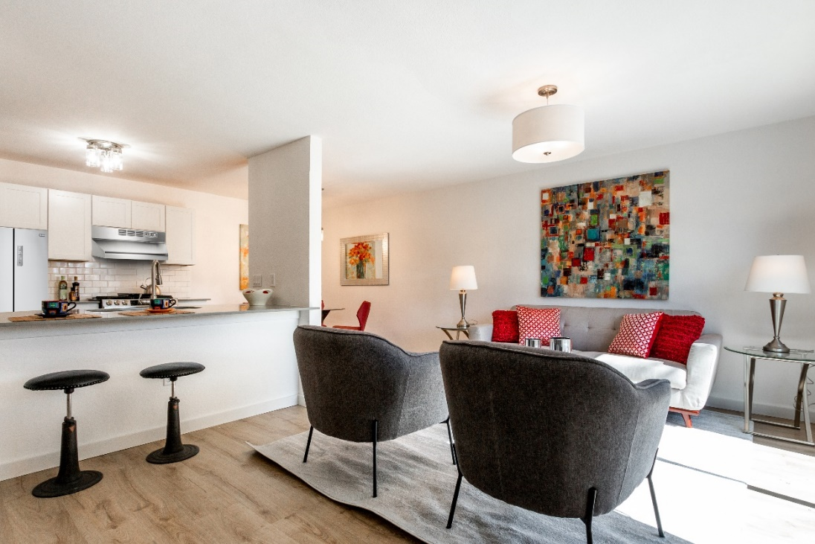
For Sale
Stop throwing away rent.
Save an hour commuting.
Own in Austin near downtown.

Households earning $39,000 - $75,000, may be eligible to buy at affordable pricing with no or low money down.

- Remodeled homes
- Washer/Dryer In Unit
- White Shaker Kitchen
- Stainless Steel Appliances
- Renovated Bathrooms
- Off Street Parking
Croslin Court Condominiums

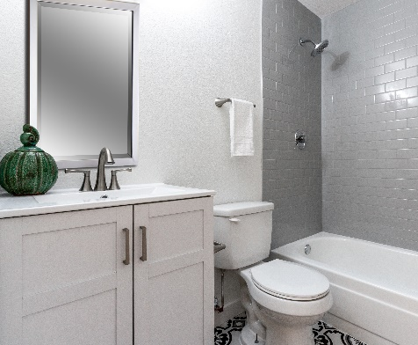
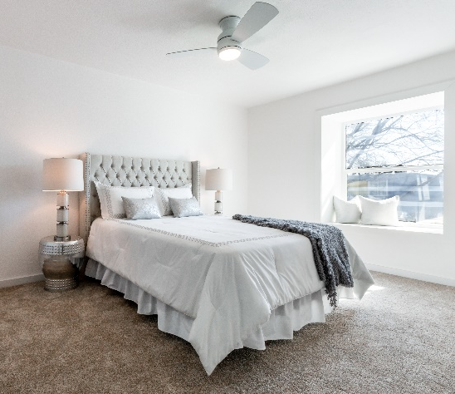
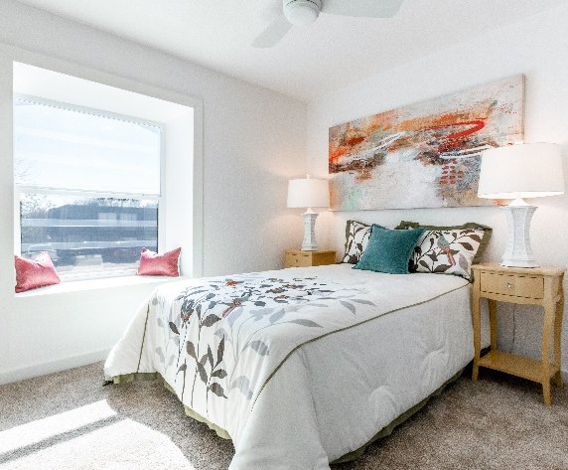
300 East Croslin St
Austin, TX 78752

Now Available Starting in the $140s
3 Bedrooms with 2.5 Bathrooms,
2 Bedroom with 1.5 Bathrooms, and
1 Bedroom with 1 Bathroom Units

Low to
Open Book Real Estate is a licensed Texas Real Estate Brokerage that fully supports the Fair Housing Act and the Equal Opportunity Act. All material presented herein is intended for informational purposes only. Information is compiled from sources deemed reliable but is subject to errors, omissions, changes in price, condition, sale, or withdrawal without notice. Materials selected for individual units are subject to change without notice. All measurements and square footage are approximate. Exact dimensions can be obtained by retaining the services of an architect or engineer. All information necessary for a buyer to make a purchasing decision must be verified at the buyer’s expense using the buyer’s experts only. No reliance on information provided by the broker or owner should be used for purchasing decisions. This is not intended to solicit property already listed. Nothing herein shall be construed as legal, accounting, or other professional advice outside of the realm of real estate brokerage.

Open House Sunday 2-4 PM Now
Open Book Real Estate Russell Artman, Broker
(512) 688-6444 www.OpenBookRealEstate.com
Stylishly updated condominium offered for sale for the first time. All units are currently being renovated.
Act now for the lowest prices.

Open-concept kitchen with white Shaker-style cabinets, stainless steel appliances, breakfast bar, and stone countertops create an expansive space for the whole family. Flowing living room and dining room offers options for living. Powder room has been updated with a new sink and toilet. Upstairs features new carpeting for both bedrooms. Designer tile throughout the spacious full bathroom. Includes washer/dryer hookup plus new energy-efficient windows and doors. Pictures include some optional upgrades.

Croslin Court Amenities
  - 300 East Croslin St
  - Austin, TX 7852

Driving Distance
- Downtown Austin (5.9 mi)
- Texas Capitol (5.6 mi)
- UT Campus (4.9 mi)
- The Domain (6.7 mi)

Public Transportation
- Bus Routes
  - 300 (<0.25 mi)
  - 1, 7, 300, 324, 350, 481
- Train Station
  - Crestview Train Station (<1 mi)

Highways & Main Roads
- US 183
- I-35
- US 290
- North Lamar Blvd
- Airport Blvd

Public Schools
- Austin ISD
- Brown Elementary School
- Webb Middle School
- Lanier High School

Grocery Stores
- H. E. B. (<3.5 mi)
- Central Market (3.5 mi)
- Butcher Shop (<2 mi)
- 99 Ranch Market (<1 mi)
- 10 Other Grocery Stores (<2 mi)

Shopping Centers
- The Crescent (1.0 mi)
- Highland Village (1.1 mi)
- Interpoint Shopping Center (1.3 mi)
- Centercross Plaza (1 mi)
- The Triangle (3.5 mi)

Parks
- Meadowview Triangle (0.4 mi)
- Highland Neighborhood (0.5 mi)
- St. John Park (0.8 mi)
- T. A. Brown School Park (0.9 mi)
- Buttermilk Branch Greenbelt (1.0 mi)

Music/Entertainment
- Threadgill’s (1.3 mi)
- Central Market Café (3.5 mi)
- Red Velvet Events (0.9 mi)
- Peached Social House (1.4 mi)
- Austin Chamber Music Center (<3 mi)
- AISD Performing Arts Center (<3 mi)

Restaurants
- Stiles Switch BBQ (1.2 mi)
- Chosun Galbi Korean BBQ (0.7 mi)
- Threadgill’s (1.3 mi)
- Texture (1.5 mi)
- Nervous Charlie’s Bagel Shop (2 mi)
- Applebee’s (0.5 mi)
- Vivo’s Tex Mex (1 mi)

Coffee Shops
- Fat Cats (0.8 mi)
- Barrett’s Coffee (0.8 mi)
- Fat Cats (1.0 mi)
- 850 Bakery Café (1 mi)

Churches
- Iglesia Evangelica Vida Nueva De Austin (0.25 mi)
- Gateway Baptist Church (<1 mi)

Other Shopping
- Modo Yoga (<1 mi)
- Tyler’s Outlet (<1 mi)
- Walgreens (1 mi)

As a contractor of the City of Austin / Austin Housing Finance Corporation is committed to compliance with the Americans with Disabilities Act (ADA) and Section 504 of the Rehabilitation Act of 1973, as amended. Reasonable modifications and equal access to communications will be provided upon request. Please call Relay Texas at 7-1-1 for assistance.

JESE Real Estate, LLC, the City of Austin, and the Austin Housing Finance Corporation do not discriminate on the basis of disability in the admission or access to, or treatment or employment in, its programs and activities. DAVID ONDICH has been designated as the City’s Section 504/ADA Coordinator. His office is located at 505 Barton Springs Road, Suite 600. If you have any questions or complaints regarding your Section 504/ADA rights, please call the Section 504/ADA Coordinator at (512) 974-3256 (voice) or 7-1-1. This publication is available in alternative formats.

Please call Relay Texas at 7-1-1 for assistance.

