
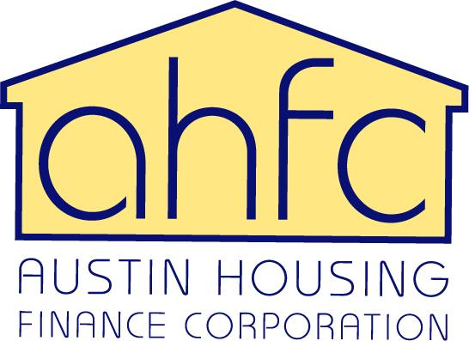

Frequently Asked Questions

DOWN PAYMENT ASSISTANCE (DPA)

Q. I need help with down payment assistance. Where do I start?
A. First step- Complete HousingSmarts home buyer education. Call 512-974-3100 or visit http://www.austintexas.gov/housingsmarts to register for class. Upon completion of the class you will receive a certificate of completion. Second step- You must be approved for a mortgage loan through a participating DPA lender listed on our website. The lender will submit a DPA application packet to the City of Austin on your behalf.
Q. How much money can I get towards my down payment and closing costs?
A. The amount of down payment assistance is based on need. The two options are (1) Standard DPA forgivable loan which is up to $14,999; or (2) a $15,000- $40,000 Shared Equity forgivable loan.
Q. How does Standard DPA work?
A. Standard DPA program assistance is a 0% interest rate, forgivable loan, with a 5 year affordability period and a 5 year loan term. No monthly payments are required. When the 5 year period has been met the loan will be totally forgiven.
Q. How does Shared Equity DPA work?
A. Shared equity DPA is an option if you need more than $14,999 towards down payment and closing costs. It is a 0% interest, forgivable loan with a 10 year affordability period and a 30 year loan term. No monthly payments are required. When the 10 year period has been met the loan will be totally forgiven; however, the shared equity will remain for a 30 year term.
For both programs, if you choose to sell or rent the house, transfer title, refinance with cash back, or draw an equity loan prior to the end of the affordability period the amount owed will become due and payable.
Q. What type of home can I buy?
A. You may use the assistance to purchase an existing or new construction single-family home, townhome, or condominium. Manufactured homes are also eligible if the manufactured home has a foundation which is permanently affixed to the land. Existing dwellings must pass our Housing Quality Standards (HQS) inspection. All newly constructed homes must meet City of Austin Accessibility and S.M.A.R.T. Housing standards.
Q. How long does the DPA application process take?
A. Thirty days from the date the lender submits a complete packet to the City requesting assistance.
Q. My credit score is not good. Can I still buy a house/qualify for DPA?
A. You may want to consider homebuyer counselling to learn how to eliminate debt, build your credit score, budget your finances and prepare yourself for homeownership. The DPA Program is not credit score driven; however, your lender may have credit score requirements.
Q. What is “first-time homebuyer?”
A. An Individual that has never owned a home or that has not owned a home in the last 3 years. The term also includes an individual who is a displaced homemaker or single parent, as defined by Housing and Urban Development. Individuals displaced by divorce may qualify. The DPA Program is for households that are purchasing the home to be used as their primary place of residence.
Q. Is there a limit on how much income I can have?
A. Yes. The total household income cannot exceed 80 percent of the Area Median Income (AMI). The income limits vary by the county in which you live and the number in your household.
Q. Is there a limit on the sales price of the house I can buy?
A. Yes. Click here to see the maximum sales price by locality.

