The City of Austin highly recommends the use of fabric face coverings in public spaces for adults and children over the age of 10. In child care settings, the City recommends that teachers, staff, children over the age of 10, and parents dropping off and picking up children from care wear face coverings. Cloth face coverings should not be placed on young children under age 2. The CDC has guidance on safely using and making cloth face coverings. Seeing others wearing masks or cloth face coverings can be scary, especially for young children. The following information may guide family and caregiver conversations to help children feel more comfortable with wearing masks/cloth coverings and seeing them on others.
Understand why masks/cloth coverings can be scary
Children under 6 identify people by individual facial features. Wearing a mask or cloth covering can make it hard or impossible for a child to identify people they know because their identifying facial features may be hidden. Children become better at identifying full faces between the ages of 6 to 14.

Explanations about why people are wearing masks/cloth coverings
The younger children are, the simpler the explanation should be.
- 2-3 years old: Masks/cloth coverings help us stay healthy.
- 4-6 year olds: Everyone has their own germs and sometimes those germs can make someone else sick. Masks/cloth coverings help us keep our coughs and sneezes from spraying onto other people. Masks/cloth coverings help us be health heroes just like washing our hands and staying 6 feet away from other people. Doing these things help us and others stay safe. You can link the hero idea to superheroes your child/ren admire(s).

Making masks/cloth coverings more comfortable for children
If you want young children in your care (over the age of two) to wear a face covering, these activities can help them feel more comfortable with the idea.
- Practice putting masks/cloth coverings on and off.
- Play peekaboo with a mask and let the child pull the mask/cloth covering on and off the adults or her/himself.
- Make and play with mask/cloth coverings for a doll or stuffed animal.
- Role play thanking the doll or stuffed animal for helping us stay safe.
- Encourage children to decorate their mask/cloth coverings.

What if children won't wear masks/cloth coverings?
The younger children are, the more challenging this may be. If children are too frightened of seeing others in masks/cloth coverings or cannot wear them themselves, children should not be in groups outside the home where 6 feet of distance between people cannot be constantly maintained.

Things to remember when wearing masks/cloth coverings
To be effective, masks/cloth coverings must cover noses and mouths and fit snugly on the face. Hands need to be washed if touching the mask/cloth coverings. The less the mask/cloth covering is touched, the better. If wearing the mask means children will be touching their face more often, they may not be ready to wear a mask. Below you can find some resources about children and masks.

Additional resources about face coverings and children

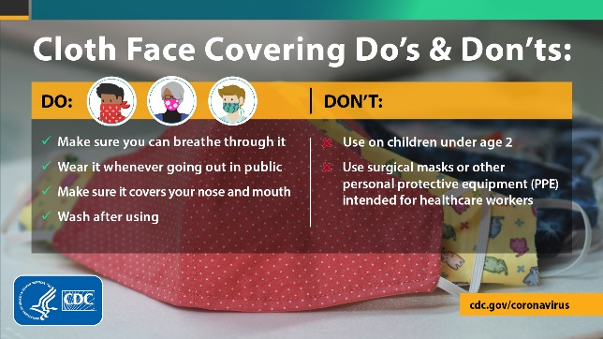

CDC guidance on the use of cloth face coverings to slow the spread of COVID-19

Children May Be Afraid of Masks. Here's How to Help.
Should Young Children Wear Masks?

Masks and Children During COVID-19
Masks Are Scary to Children - Good Parenting

