Austin 3-1-1 Smart Phone App Fact Sheet
The Austin 3-1-1 smart phone app makes it possible for residents to create service requests with their smart phones and attach photos related to their service request. Citizens can also track the status and location of their service requests. Last year Austin 3-1-1 completed more than 200,000 service requests, but with your help, and reporting Austin 3-1-1 can respond to even more. Our goal is 1st contact resolution of any concerns in our community.

- The Austin 3-1-1 smart phone app makes it possible for residents to create service requests with their smart phones and attach photos related to their service request.

- The Austin 3-1-1 smart phone app enables real-time collaboration between citizens and their city government, 24 hours a day, 7 days a week; allowing residents to become the eyes and ears of their communities.

- The app is available on Apple iPhone and Android devices and can be downloaded for free by searching for ‘Austin 311’ in the Apple iTunes App Store and/or the Google Play Store. Users with other mobile devices can enter service requests online at 311.austintexas.gov.

- Information sent from the smart phone app goes directly to the City department responsible for responding to the issue. This saves time and reduces errors.

- Users can submit requests anonymously; however, they are encouraged to enter their contact information so City departments can contact them if they have questions.

- Photos are not required, but if possible are encouraged. Users who don’t add photos must provide a description of the issue. Austin 3-1-1 mobile app will not share photos with the public.

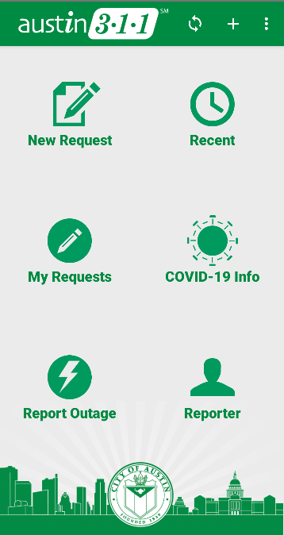

Main Menu Features:
- New Request: Submit a new service request.
- Recent: A list of recently submitted mobile app service requests.
- My Requests: Allows you to view the status of your requests.
- COVID-19 Info: Visit the COVID-19 in Austin website for current information.
- Report Outage: View and report energy service outages.
- Reporter: Allows you to save your information, to make future reports that much easier.
Service request types available on mobile app:

- AE - Street Light Issue - Address
- Austin Resource Recovery – Employee Behavior
- Austin Resource Recovery – Pet Search
- Austin Resource Recovery – Property Damage Report
- Austin Resource Recovery – Special Services
- Austin Resource Recovery – Spillage Trash/Fluids
- Channels/Creeks/Drainage Issues
- City of Austin Vehicle Report
- City Pool Maintenance
- City Pools & Lifeguard Issues
- Commercial Use of Parkland
- Community Engagement Project Feedback
- Concerns in Right of Way
- Construction Items in Right of Way
- Corridor Program – Construction Feedback
- COVID Vaccination Inquiry
- Dead Animal Collection
- Ditch/Driveway Pipe Services
- Drainage Pond Maintenance
- DSD – Follow-Up
- Electric Vehicle Station Issue
- Environmental Complaint
- Erosion
- Fireworks Complaint (seasonal)
- Flooding Current
- Flooding Past
- Food Complaint
- Found (Confined) Dog Assistance
- Found Pet Report
- Graffiti Removal – Public Property
- Grass/Weeds Over 12" Tall
- Harmful Algae
- Homeless - Violet Kiosk and Storage Carts
- Homelessness in City Parks
- Junked/Abandoned Vehicle
- Lady Bird Lake Debris Issues
- Lane/Road Closure Notification
- Loose Dog
- Lost Item in Storm Drainage System
- Manhole Issues
- Markings – Crosswalk Maintenance
- Neighborhood Home Programs
- New Sidewalk/Curb Ramp/Route
- Non Emergency Collision
- Non Emergency Evidence/Property
- Non Emergency Existing Police Report
- Non Emergency Family Protection/Child Custody
- Non Emergency Hands Free Violation
- Non Emergency Noise Complaint
- Non Emergency Officer Contact Request
- Non Emergency Vehicle Issues
- Other
- Outdoor Commercial Venue Music Complaint
- Park Graffiti Removal
- Parking Violation
- Parks Building A/C & Heating Issues
- Parks Building Electric Issues
- Parks Building Issues
- Parks Building Plumbing Issues
- Parks Cemeteries
- Parks Grounds Electrical
- Parks Grounds Maintenance
- Parks Grounds Plumbing
- Pay-by-Phone App
- Pet Resource Assistance
- Pothole Repair
- Rest Break Complaint
- Road Markings/Striping - New
- School Issues – Crossing Guard
- School Zone – New/Review/Changes
- School Zone Flasher – Maintenance
- Shared Micromobility
- Short-Term/Vacation Rentals
- Sidewalk Repair
- Sign – Parking Maintenance
- Sign - School Zone Sign Maintenance
- Sign – Street Name Maintenance
- Sign – Traffic Maintenance
- Special Event
- Speed Management
- Standing Water
- Street Sweeping
- Structural Conditions
- Telecommunication Complaint
- Traffic Sign New
- Trash/Debris on Property
- Vehicle Abatement Callback Request
- Water Conservation Violation
- Water Related Issues
- Water Theft Report
- Watershed Grow Zones
- Wildfire Education

