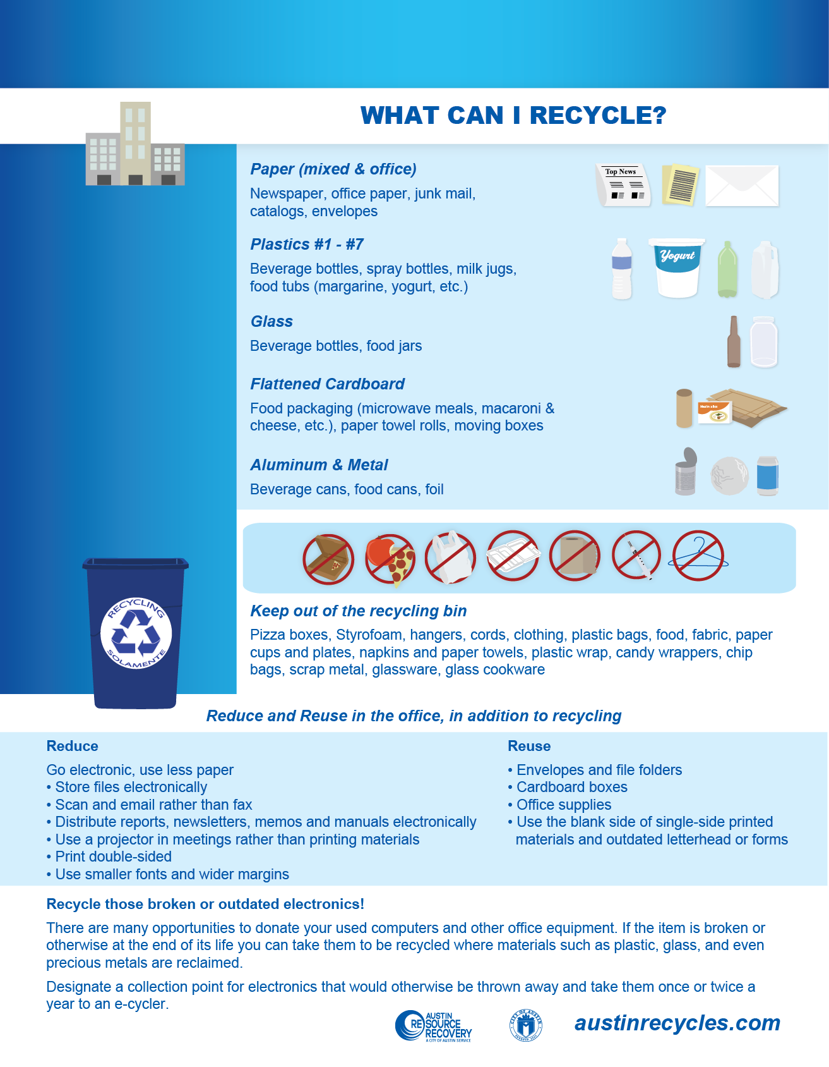

***Property specific,***

***customized text***

***goes here***

**Type your Property Name Here**

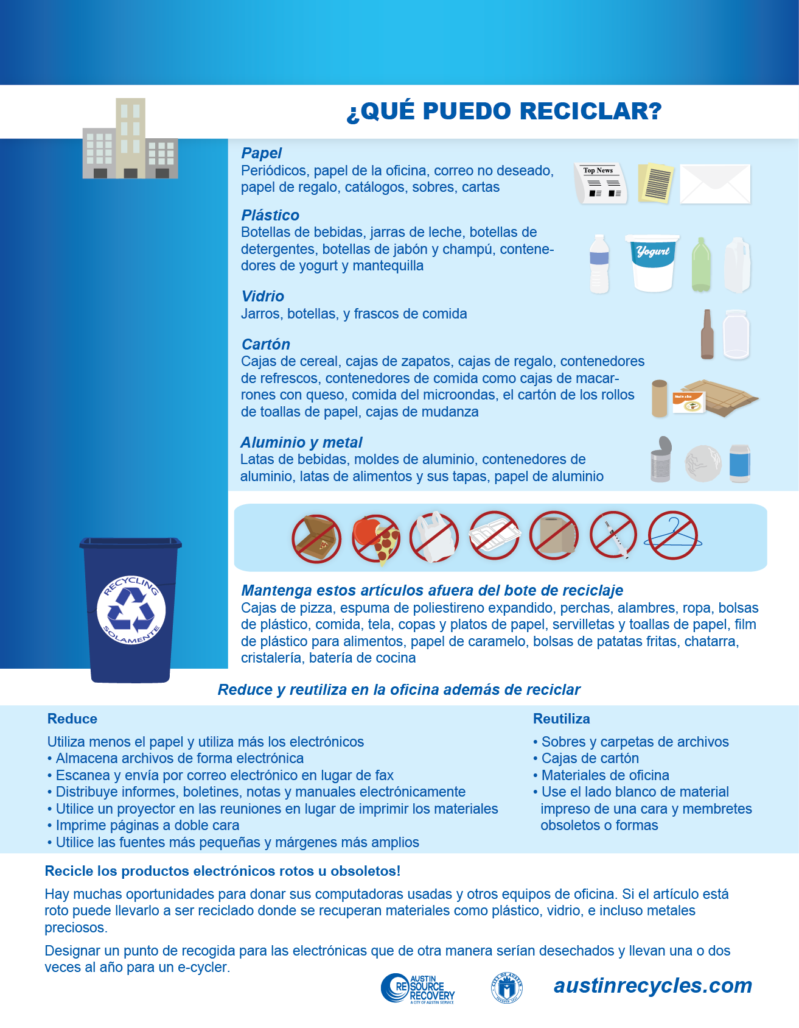

**Type your Property Name Here**

***Informacion***

***sobre la***

***propiedad***

***especifica aqui***