

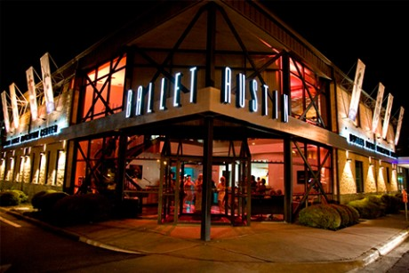


Reaching out to Customers with Disabilities
Quiz – FY16 Attachment #9

Reading Material:
Dept of Justice Online course Introduction & Lessons 1 & 2 at
http://www.ada.gov/reachingout/intro1.htm,
NEA ADA Tip Sheet and Cultural Contractor ADA Fact Sheet attached as PDFs.

Applicant Name
Sponsored Project (SP) Name (if applicable)
Contact (if an SP the contact person of SP)
Email
Phone


- Sally, wheelchair user, hears a radio announcement about your upcoming performance and the website is mentioned. She is excited to go online to get tickets for her and her friend Patty, who loves this artist. Tickets are on sale and Sally goes to the website. She finds out that, in order to obtain wheelchair accessible tickets, she is directed to call during limited business hours on specific days. Accessible seats are not available online! Sally is frustrated and ultimately decides to not go through the hassle.

There is an ADA obligation to provide tickets for accessible seating the same as everyone else. True or False?


- A family attends your puppet show. The parents are deaf. They show up to the event without notice, and request an American Sign Language Interpreter for the performance. You are not able to provide the services on such short notice, but the family decides to stay since the children are hearing and can still enjoy the show.

What could you have done to avoid this situation?
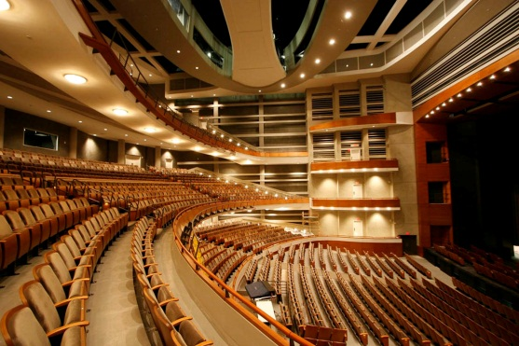

- If your theater has 151– 300 seats, how many wheelchair accessible seats are
required under the new ADA?

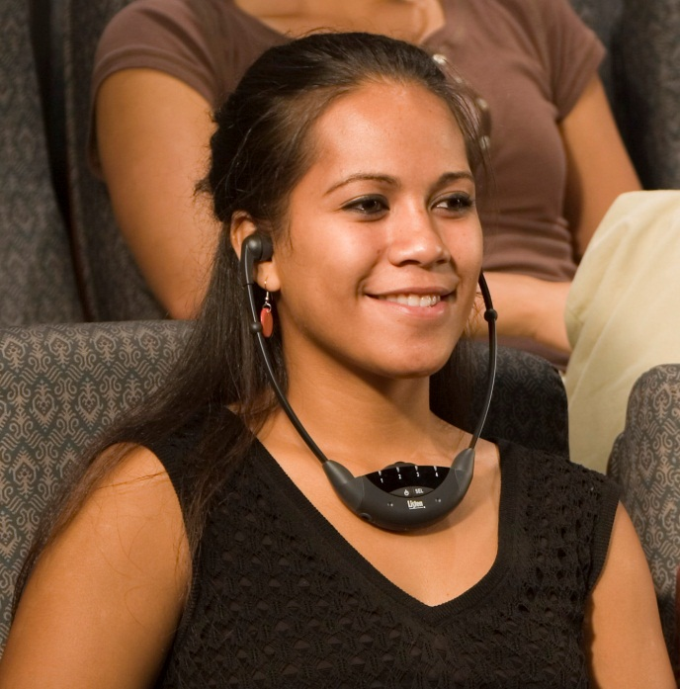
- You are hosting an acoustic guitar performance at a small venue (25- 50). A hard of hearing person requests an assistive listening device. Are you required to provide it?
Yes/No?

- A patron requests Audio Description for your performance, who do you contact locally to request that service?






Attachment #9

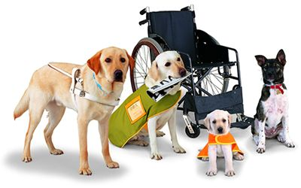

- A patron brings his service dog to your event, what questions can you ask to determine if you let the patron in with his service dog?
- Do you have a certification for your service dog?
- What is your disability?
- What a kind of tasks has your dog been trained to do for your disability?

- All of the above.

- Wheelchair accessibility does not need to be considered in an outdoor venue event. True or False?

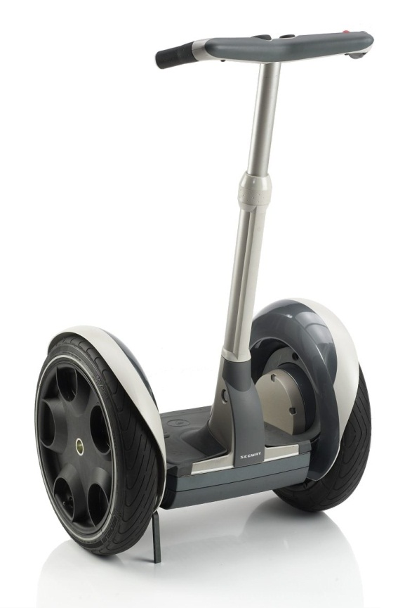
- Under the new ADA requirements, a Segway is not considered a mobility device. True or False?

- Your museum is hosting a traveling exhibition of mummies from ancient Egypt. The policy of the lending museum is that the artifacts may not be touched. You have a patron who is blind visit the exhibit. Would it be considered a “fundamental alteration” or a “reasonable modification” to let the visitor touch the art?

Once you have completed the quiz please include this answer sheet in your application under attachment #9.

