

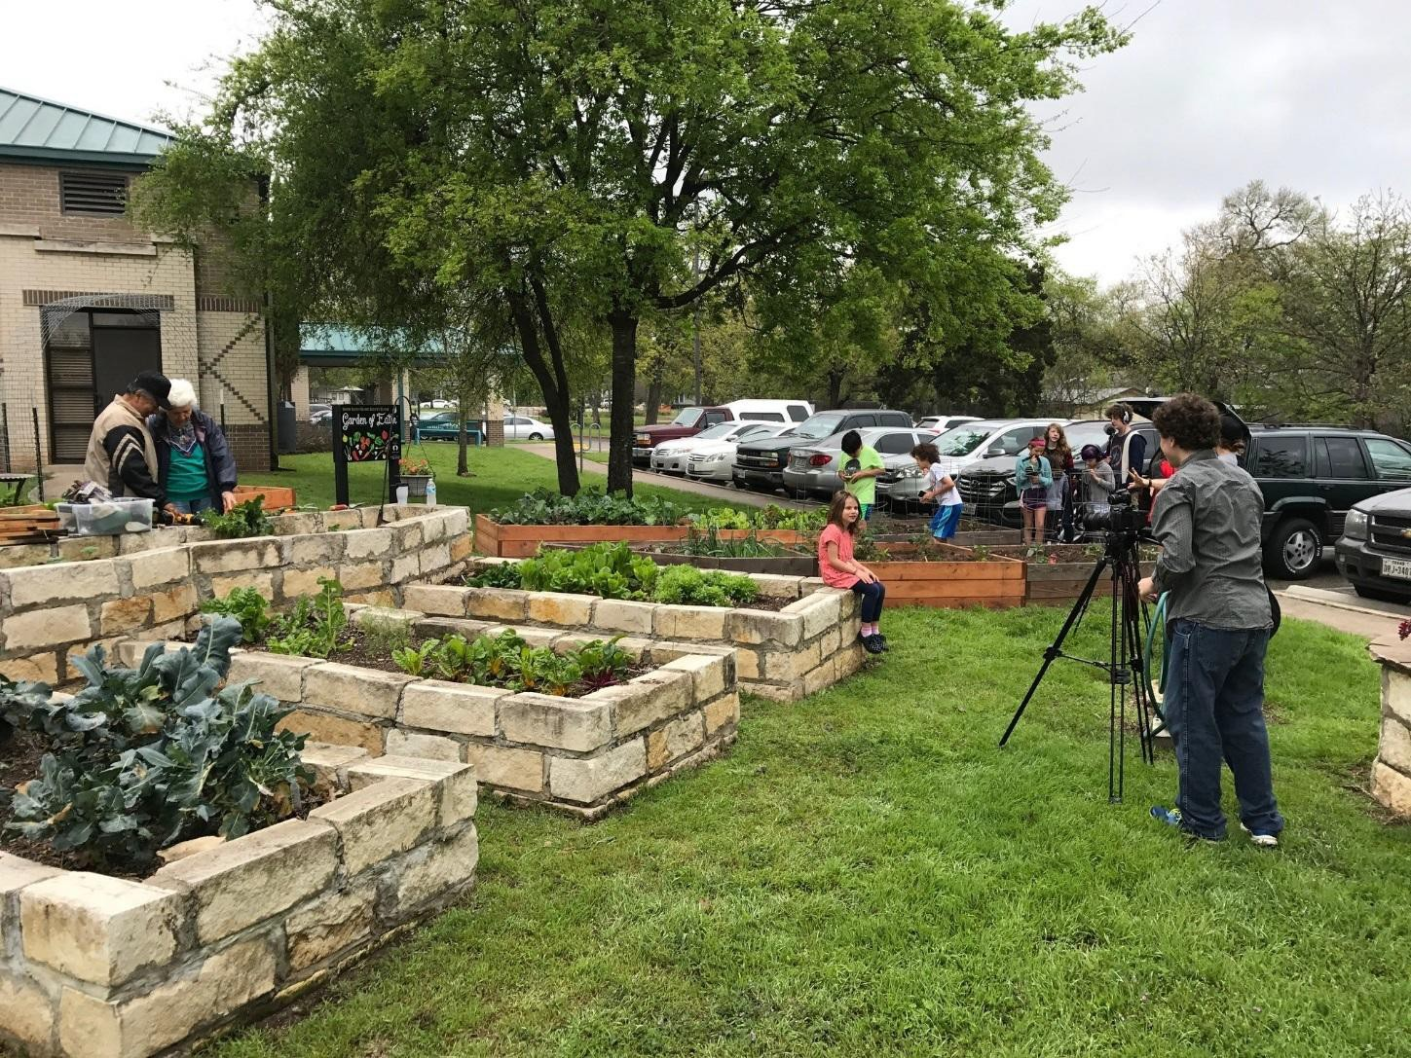
South Austin Senior Activity Center
User Guide and Rental Agreement
3911 Menchaca Rd, Austin, Texas 78704
512-978-2400
http://www.austintexas.gov/department/south-austin-senior-activity-center

Revised: 11/1/2025

South Austin Senior Activity Center
Normal Center Hours available for reservation Monday, Thursday, & Friday: 8:00am - 5:00 Tuesday: 8:00am - 9:00pm

Wednesday: 8:00am - 10:00pm
- During operation hours, 1 hour minimum rental is required.
- Before/after operation hours, IF approved, 4 hour rental minimum required.

Fees: See inserted fee listing for this property.

How to Reserve
Reservations must be made no less than 30 days prior to the date and no more than 6 months in advance to the date requested.
- Contact us: 512-978-2400
- Email: SouthAustinSeniorActivityCenter@austintexas.gov

Restrooms: 2 private bathrooms and large multi-stall restrooms are available with hot/cold water.
Parking Fee: There IS NOT a fee for parking.
Accessibility: The facility is wheelchair accessible. The City of Austin is committed to compliance with the Americans with Disabilities Act.

Electricity Available: Household style electrical outlets are available on site. Appropriate gauge cords should be used according to the device/appliance/item manufacturer guidelines used on site.

Water Available: Hot and Cold water is available in the kitchen.

FACILITY ROOM USER RATES
The time you request and book includes the total time allowed on site for: setup, take down, and
clean up.
REQUIRED FEES FOR ALL RENTALS
Security Deposit: $195 – (Rentals with No Alcohol; Refundable)
OR
$330 – (Rentals with Alcohol; Refundable)

Staff and Utilities Fee: $82.50 Per Hour (Per Hour Per Day)
ROOM OR AREA | COST/HOUR | ELECTRICITY IN ROOM?
Multipurpose Room  - 3,150 square feet | $105/hour | Yes
Annex  - 730 square feet | $70/hour | Yes
Arts and Crafts Room  - 480 square feet | $45/hour | Yes
Recreation Room  - 273 square feet | $25/hour | Yes
Commercial Kitchen with Rental  - For heating use only | $95/hour  Required $175 additional deposit (refundable) | Yes
Ice Machine with Rental | $22.50 flat fee | -
Building and Facility Rentals Cancellation Policy:
- If the City of Austin cancels, all deposits, and fees are returned to the renter.
- If the renter cancels more than 21 days before the rental begins, all deposits and fees are returned to the renter.
- If the renter cancels within 21 days before the rental begins, 50% of the rental fee and 100% of the deposit are returned to the renter.
- If the renter does not show up for the rental, no refund is given.

CONFIRMING RESERVATIONS, and MAKING PAYMENT(S)

Confirming Reservations
All reservations will be confirmed upon receipt of deposit, a signed rental agreement, and rental fees paid in full.

Payment Types Accepted
Cash, check, money order, or credit card payments are accepted. Payment in full is due 21 days or more from the permit/rental date.

Reservation Deposit
Payment of a deposit secures your reservations. Dates are not held without a reservation deposit. The balance of your reservation fee is due no later than 21 business days prior to your requested reservations. If the balance is not paid in full before that date, your request will be forfeited, and deposit refunded.

Damage Deposits
Deposit will be refunded in either part or whole upon inspection of the facility at the conclusion of the reservation. Deposit refunds are issued via check from the City of Austin and should be received within four to six weeks after the reservation. Deposits made by credit card will be refunded onto the same credit card. (NOTE) Any damage, usage not approved, extra time to depart, or maintenance required “out of the ordinary” after the reservation is completed, will be charged to you, and taken out of the damage deposit. If the deposit does not cover the cost, you will be billed for the balance. Failure to pay for additional costs within a 30-day period will result in a referral of accounts for legal collection. The City of Austin reserves the right to refuse to rent to groups or users who have a demonstrated history of being careless or reckless.

OVERVIEW of COMMON POLICIES, PARK RULES, and PERMITS
Park Rules and Conduct: The person or organization reserving City property is responsible for the enforcement of the Parks and Recreation Department Rules and City Code (City Code Chapter 8) during the reservation, and in addition, is responsible for the conduct and behavior of their guests. More information park rules can be found online. Violation or disregard for Park Rules and policies may result in the following consequences: ineligibility to make future reservations, removal, fine, arrest or legal action, cancellation of reservation, and/or forfeiture of all fees and deposit.

Miniature Trains, Petting Zoos, Carnival Rides, Water/splash slides, Water Balloons, Balloon Releases, and Bubble Soccer are NOT permitted at any time.

Wish Lanterns are NOT allowed as they pose severe fire risk.

Arrival/Departure
Reservations are arranged for a specific period of time, known as arrival/departure time. The arrival time is the time you have requested to begin the reservation. The reservation must end at the departure time previously arranged. Use of the site or facility beyond the hours paid for shall result in the assessment of additional charges.

Set Up and Take Down
Set up and take down of your rental must be completed in your approved reservation time.

Clean-Up
All decorations and trash must be picked up, bagged, and deposited in the cans provided. All tables and chairs used must be wiped clean and folded. Failure to complete any of these tasks will result in a partial and/or complete loss of the damage deposit. Cleaning equipment is available on site. The Parks and Recreation Department will not be responsible for any items left behind. The Program Supervisor has the final release on the condition of the park/facility.

No Alcohol (see also the “Permits” section)
According to City Code and Park Rules, it is not allowed to knowingly or willfully sell, possess with the intent to sell or consume any alcoholic beverage within any recreation center or on any outdoor area adjacent to and made a part of the center's facilities which shall include, but not be limited to, all fields and playgrounds, parking lots, play slabs and playscapes connected with the center without prior approval from the Director.
NOTE: If proposing PARD consideration of alcohol at a recreation facility or center, INQUIRE WITH THE FACILITY MANAGER immediately upon starting the reservation process.

No Tobacco, Smoking or Vaping
Per City Ordinance, § 12-5-3 Smoking is prohibited in all buildings, or portions thereof, owned and under the management and control of the city, or occupied by city officials and employees. A person commits an offense if they knowingly smoke within 15 feet of any pedestrian entrance of a public place. The use of such will result in the immediate cancellation of your event. Police will be notified, all guests will be escorted off the park premises, and legal action may be taken. Please take the time to notify your guests of this City Ordinance.
No Stopping, Standing or Parking on Parkland Per City Code, no person shall park any motor vehicle, motorcycle or other motor-driven device on any public park, or recreation center, which is owned, operated, or maintained by the city, except in parking areas designated for such purposes.

Decorations
NO nails, tacks, and staples/staple guns may be used on any surface. NO DUCT OR ELECTRICAL TAPE! Approved items to affix decorations include:

- Velcro (Velcro allows for quick decoration removal at the end of the event), zip ties, or high-quality non-marking tape (painters tape) ONLY!

Security
It shall be the responsibility of the person or organization making the reservation to provide the necessary security to ensure orderly behavior and protect property. A security plan with proof may be required and will need to be reviewed by the Program Supervisor fifteen (15) days in advance.
- Reservations will not be made to minors, eighteen (18) and under.
- All children and teen parties must have one (1) adult Chaperon per ten (10) minors.

Utilities
The building is heated/cooled by a computerized thermostat controlled off-site. The temperature cannot be adjusted immediately during your event. Alternative use of lighting, for example, battery operated candles, Christmas lights, and battery-operated lanterns must be approved by Program Supervisor.

Curfew
The park curfew is 10pm Sunday through Saturday. Police strictly enforce curfew hours and violators are subject to fines and/or arrest.

Endorsements
Rental of PARD facility does not constitute City of Austin or PARD endorsement of viewpoints expressed by participants in the program. Advertisements or announcements implying such endorsements, or that utilize City logos are not permitted.

Violations
The City of Austin Parks and Recreation Department reserves the right to cancel any event and has the authority to remove any person(s) from the facility if it is felt that any part(s) of this agreement are broken or that the facility is not being used for the purpose for which this agreement is intended. Facility user(s) not abiding by the City Ordinances and regulations contained herein may be suspended from use of the facility and all fees and deposits paid, forfeited. Future use of City facilities may also be denied.

INSURANCE
Minimally, Standard Insurance is required for all public events. Ticketed events, athletic events or tournaments, or a festival are all examples. Liquor liability is additionally required for all public events with alcohol on site.
Visit http://www.austintexas.gov/page/special-events-policies-procedures. The insurance document is located in the “policies and procedures section”.
PUBLIC EVENT: An event is considered public if any of the following apply: (A) there is NOT a finite and/or limited guest list; (B) a person of the public may purchase or acquire a ticket for entrance or participation; (C) a person of the public may attend the event; or (D) is advertised by website, email, print or radio media to the public.

PRIVATE EVENT: Events are considered private where a limited and finite count of guests is expected. An example would be a wedding, or birthday party, or private reception, which are NOT open to the public.

PERMITS
Permits are issued to and payable by the applicant or organization hosting the event.

Sound Permits

512-974-6797 for information, Office of Special Events.
Commercial/Advertising Purposes ($30), Private Party ($20), Public Interest, Political or Non-Profit ($10)
10 a.m. – 10 p.m. maximum per park curfew. When allowed, all amplified sound requires a sound permit. Examples of amplified sound include boom boxes, DJ’s, bands, speakers connected to cell phones, etc. By City Code, the parks sound ordinance is limited to 85 db, as measured at the lesser of 100 feet, or the boundary of the park in front of the source. Sound is NOT permitted within 100 feet of residentially zoned property. Restrictions apply to sound between 100 feet-600 feet of residential property: 8 p.m. limits Sunday through Thursday, and 10 p.m. limits Friday and Saturday. At all times possible, amplification devices/speakers should be oriented in a fashion as to direct sound away from adjacent reservations and area neighborhoods.

Permits are ONLY issued to confirmed (paid) reservations for the DIRECT RENTED SITE. We do not issue sound permits for vehicles in parks.

Moonwalk, Inflatables, and Rock Wall Permits - $10, water for dunking booths - $50: Permits for moonwalks, rock walls, and dunking booths are issued to PAID reservations at ALLOWABLE SITES. Please note your intent at the time the reservation is made. Companies must have on file or provide the City with required insurance and be inspected/certified by the State of Texas. Information is INCLUDED with picnic packets or find the list in the “policies” section online.). Vending without a permit subjects user and/or company to suspension from permitting eligibility. Miniature trains, petting zoos, carnival rides, water/splash slides, wish lanterns, water balloons, and balloon release are NOT permitted at any time.

PARD Alcohol Sales Permit Application Fee and State Issued TABC Permit ($30): Permits for any event requesting permission to sell alcohol require a TABC permit. Due at the time of submission of TABC permit application to the City for signature. With prior PARD approval, alcohol sales require hiring of licensed peace officers, liquor liability insurance and alcohol service in a building or fenced park site with monitored event doors/gates. In general, alcohol is considered a “sale” if funds are required for purchase, alcohol comes with a ticket required for admission, or where the price of “attending” includes alcohol.

- Alcohol Permitting Process
- Alcohol Service Standards
Health Catering and Concessions Permits: Must be approved by the Parks Department and is subject to approval and permitting by the Austin Travis County Health and Human Services Department.

Vending, Concessions, and/or Solicitation or Collection of Funds/Money: Solicitation, admission or other charges, money-raising activities, and/or sales are not allowed without the approval of PARD management. Such events are required to show proof of General Liability insurance. Additionally entities or vendors must be registered with the State of Texas and have a valid sales and use tax ID.

City Holidays

Observed Holidays - No Reservation Periods
On a limited number of Federal Holidays or Observances and other dates, the Parks and Recreation Department does not coordinate reservations for picnic sites or facilities due to the high volume of public use. On these dates, all picnic sites are first-come first-served. There may be Some variance based on calendar year.

City Holidays

Month | Holiday | Length of Observance | Type of Holiday
January | New Year’s Day | Day Only | Federal Holiday City Holiday
January | MLK Day  3rd Monday in January | Day Only | Federal Holiday City Holiday
February | President’s Day  3rd Monday in February | Day Only | Federal Holiday City Holiday
March / April | Easter weekend | Weekend of Holiday | Federal Holiday City Holiday
May | Mother’s Day Weekend 2nd Sunday in May | Weekend of Holiday | Federal Observance
May | Memorial Day Weekend last Monday in May | Weekend and Holiday | Federal Holiday City Holiday
June | Father’s Day Weekend 3rd Sunday in June | Weekend of Holiday | Federal Observance
July | Independence Day - July 4th | Day Only  Weekend of Holiday if Sat/Sun | Federal Holiday City Holiday
September | Labor Day Weekend 1st Monday in September | Weekend and Holiday | Federal Holiday City Holiday
November | Veteran’s Day | Day Only | City Holiday
November | Thanksgiving -  4th Thursday in November | Holidays and Day After | Federal Holiday City Holiday
December | Christmas Eve and Christmas Day  24th and 25th respectively | Holidays and Day After | Federal Holiday (25th)  City Holidays

This form must be completed by facility staff with the renter at the end of their rental reservation. In order to process a full refund all tasks included on this list must have be completed by the renter before the end of the allotted rental time.
Renter Name:

Checklist -
- Pick up litter from property, bag, and place it in appropriate areas/trash containers. If they have lids, close them.
- Remove all decorations and personal items brought on site (this includes TAPE, STRINGS, RIBBONS!) Do not leave displays or large props/items on the site.
- Floors – Sweep loose litter, sand and debris. Clean up large spills/food particles on ground.
- Return chairs and tables to their original location in an orderly fashion.
- Break down any boxes/recycling, and take home to your household recycling service.
- All rooms used for the rental have been checked for damages and found to be in as good condition as they were at the beginning of rental (no broken equipment, windows, tiles, décor taken down, etc.)
- Reservation ended, and cleaned up before the end of the use period.
  - Time event ended:

Notes:

Signature of Staff: Date:
Signature of Renter: Date:

Deposit Receipt Number: Refund Receipt Number:

FACILITY/PARK EVENT AGREEMENT
This Agreement is made and entered into by the City of Austin, a home rule municipal
corporation located in Hays, Travis and Williamson Counties, State of Texas (“City”), acting by
and through:

THE CITY OF AUSTIN, ( “the City”)  Jesus Aquirre MBA, CPRE, Department Director (or Designee)  Austin Parks and Recreation Department 200 South Lamar, Austin, Texas 78704  (512) 974-6797, (512) 974-6729 fax, and | REQUESTOR/ORGANIZER:  Name: Company/Organization: Address: City: State: Zip: Phone:

PARK LOCATION:
South Austin Senior Activity Center 3911 Menchaca Road
Austin, TX 78704
Upon the terms and conditions herein expressed and in consideration of the covenants and agreements herein expressed and of the faithful performance by the Requestor/Organizer of all such covenants and agreements, City grants Organizer the right to use and occupy the described space and premises. To be used for the purpose of producing, installing equipment, preparing the premises and equipment for use and for packing and removing equipment for the Event and for no other purpose without the written consent of the City.

AGREEMENT
This Agreement is effective upon execution by all parties and remains in effect until the obligations under this Agreement have been performed. I have thoroughly reviewed the event and site policies specific to the rented location. Upon execution of this agreement, the specialized site rules, policies and/or regulations are incorporated into the agreement. I am aware they may be found at: http://www.austintexas.gov/parkevents. I agree to comply with all Federal, State and City regulations, ordinances and resolutions, and to abide by and uphold City of Austin Park (PARD) Rules, Park Code, Chapter 8, and policies/procedures/rules related to the rented space(s). Specifically I am aware that glass, smoking and Styrofoam are prohibited in all parks. All City equipment provided or included is made available AS IS.

Austin Parks and Recreation Department (the City) reserves the right at any time to require Organizer to remove from the Property any participant, animals, furniture, fixtures, wiring, exhibits, or other thing in its sole discretion. Requestor shall pay the cost of repairing any and all

damage which may be done to the premises or any of the structures or plant life thereof by any act of Organizer or any of Organizer’s employees or agent or anyone visiting the premises upon the invitation of Organizer including the patrons of the attractions or function for which Organizer is renting the park site. It is expressly agreed the Parks and Recreation Department shall determine whether any such damage has been done, the amount thereof and the reasonable cost of repairing the same, and whether it is one for which, under the terms of this agreement, Requestor/Organizer is to be held responsible. The City shall have the sole right to collect, remove from grounds, and have custody of articles and personal property left on the premises past the Departure Time by Organizer or persons attending the Event. Organizer releases and discharges City from any and all liabilities for any loss, injury or damages to property abandoned or not.

REQUESTOR/ORGANIZER REPRESENTATIVE(s):
A representative(s) of REQUESTOR/ORGANIZER approved by the site manager or designee shall remain on the premises during the term, the Facility Sales Receipt, until event participants and the public have left the premises.

CANCELLATIONS:
If the City of Austin cancels, all deposits and fees are returned to the renter. If the renter cancels more than 21 days before the rental begins, all deposits and fees are returned to the renter. If the renter cancels within 21 days before the rental begins, 50% of the rental fee and 100% of the deposit are returned to the renter. If the renter does not show up for the rental, no refund is given.

AMENDMENT and ASSIGNMENT:
No amendment, change, or assignment to this Agreement will be effective unless made and agreed to in writing by the City and Requestor or Organization prior to the commencement of the scheduled Event.

FORCE MAJEURE
This Agreement will automatically terminate, and Organizer waives and releases any claim for damages or compensation from the City on account of termination if:
    - the Property, structures and/or improvements are wholly or partially destroyed or damaged by any cause, casualty, or unforeseen occurrence; or
    - local, state or federal imposed measures, travel restrictions, quarantines, or isolation in response to the outbreak of an infectious disease, epidemic or pandemic in the City that involves, includes or affects the Property, structures, improvements or staffing/employees, mass gatherings, public assembly or the Event; or
    - lightning, earthquakes, fires, storms, floods and landslides; or

    - threat or act of terrorism, strike, sabotage, civil disturbance, or disaster declaration; or
    - circumstances beyond City’s control, that materially impacts or renders City’s
performance impossible.

TERMINATION FOR BREACH:
The City shall have the right to immediately terminate this agreement in the event Requestor/Organizer is in breach of any material term of this agreement or of any of the permit requirements relating to the production staged. The City shall endeavor to give notice of breach, but it shall not be required to give notice in order to exercise its termination rights.

INDEMNIFICATION:
Requestor/Organizer and/or company agree to indemnify, save, and hold harmless the City, its officers, employees, agents, licensees, and invitees (collectively called "Indemnitees") against any and all liability, damages, losses, claims, demands, and actions of any nature, due to personal injury (including, without limitation, Workers' Compensation and death claims), or property loss or damage of any kind which arises or is claimed to arise out of or is in any manner connected with the use of the City property or with the presence on the City property of Contractor, its employees, agents, invitees, or volunteers. The undersigned warrants that he/she has the authority to bind the organization to this indemnification provision.

SIGNATURE
I certify that the information contained in my request is true and correct to the best of my knowledge. The undersigned declares he/she has the authority to bind the Contracting Organization, or Legal Event Owner for this indemnification.
I have read and full reviewed the applicable codes, policies and rules related to the rented space(s).
Requestor:

First Name Last Name Organization

Signature Date

RENTAL REQUEST FORM
Event Details

Requestor:
Address:
Email:
Day Time Phone:
Evening Phone:
Rental Date:
Rental Description:
Estimated
Attendance:
Rental Time:
Equipment Needs:
Special Requests:
Fees: |  | OFFICE USE ONLY
Security/Cleaning  Deposit: | Date: | Cash/CC or Check #: | Receipt #:
Staff & Utilities Fee: |  | Hours: | Sub Total:
Facility Space: |  | Hours: | Sub Total:
Facility Space: |  | Hours: | Sub Total:
Additional: |  | Hours: | Sub Total:
Additional: |  | Hours: | Sub Total:
Reservation Total: | Date Due: | Paid Date: | Receipt #:

Approvals:

Site Supervisor Program Manager (if required)

Division Manager (if required) Director (if required)

