Honorable Mayor Adler, Mayor Pro Tem Tovo, Council Members, Aides, Commissioners, Staff and Consultants,

As residents and business owners in the Judges Hill District (JHD) of the Downtown Austin Plan (DAP), and as members of the Judges Hill Neighborhood Association (JHNA), we offer our view of the September 15th CodeNEXT (CN) draft.

Most of our prior concerns and requests remain relevant and can be viewed in the document below (pages 4-13) as forwarded to you July 5th of this year. In it we request that CN honor the DAP for the JHD and the adjacent two blocks of the Northwest District (NWD). That was the basis for the “grand bargain” struck to preserve the unique character of this historic garden district while supporting massive density increments in adjacent, more central commercial areas with fewer historic treasures and old-growth trees.

The following corrections to oversights in the first CN draft make sense:

- Public land along our southwest border at the intersection of 15th and Lamar, a downtown gateway, are now appropriately designated Public (P).
- Some commercial properties previously called row houses, despite by-right 55-foot-tall “block forms,” now offer more appropriate heights of 40 feet next to homes, assuming the setbacks and stepbacks worked out in the DAP are maintained.

The current draft, though, ignores most of our concerns. Transects and nontransects alike are now lumped into new R designations that are, in essence, transects by another name. We again request nontransects based on existing lot sizes to preserve the community and its wooded, historic character, while stepping up rapidly to 400-foot heights just two blocks away in the Uptown/Capitol District (UCD), and heights as great as 220 feet in the University Neighborhood Overlay (UNO) across MLK.

When the UNO was first proposed we were invited to participate. But we felt that denser student housing along the western border of campus was appropriate if it respected the West University neighborhood. So those residents helped shape that plan. CN in its current form, though, would promote the razing of historic structures and mature tree canopy in our area to support dense student housing that should instead be adjacent to campus. The JHD already has a student co-op, condominiums and less expensive apartment complexes of a scale and number that don’t undermine the fabric of our community or its contribution to downtown’s character.

Other problems with the prior draft persist:

- Administrative “minor use permits” would bypass public input for zoning that includes bars and cocktail lounges
- ADUs that were added over our objections prior to CN are enlarged to 1,150 square feet in the current draft. They would destroy the area’s historic character by peppering it with “box houses” as the cheapest way to maximize square footage, thereby targeting mature live oaks. The DAP instead allowed garage apartments, a form of “missing middle” compatible our historic character and canopy.
- There is no mention of our Residential Parking Program (RPP), which let us support massive density nearby while maintaining livability and safety in this family neighborhood. We are told it’s a separate consideration, but suspect it is to be targeted later, though it was offered as reassurance to garner our DAP support.
- Side setbacks for commercial structures are still 5 feet, even if next to homes (see color diagram, page 16, Appendix A), with no compatibility setbacks.
- The CN commercial height definition still allows structures on slopes to tower over adjacent homes as demonstrated in the color diagrams in our prior position paper update (see Appendix C, page 18).
- Historic landmark offices in the JHD at 1806 Rio Grande, the Pope-Watson house, remain zoned Core Commercial-120-H as in the first draft:
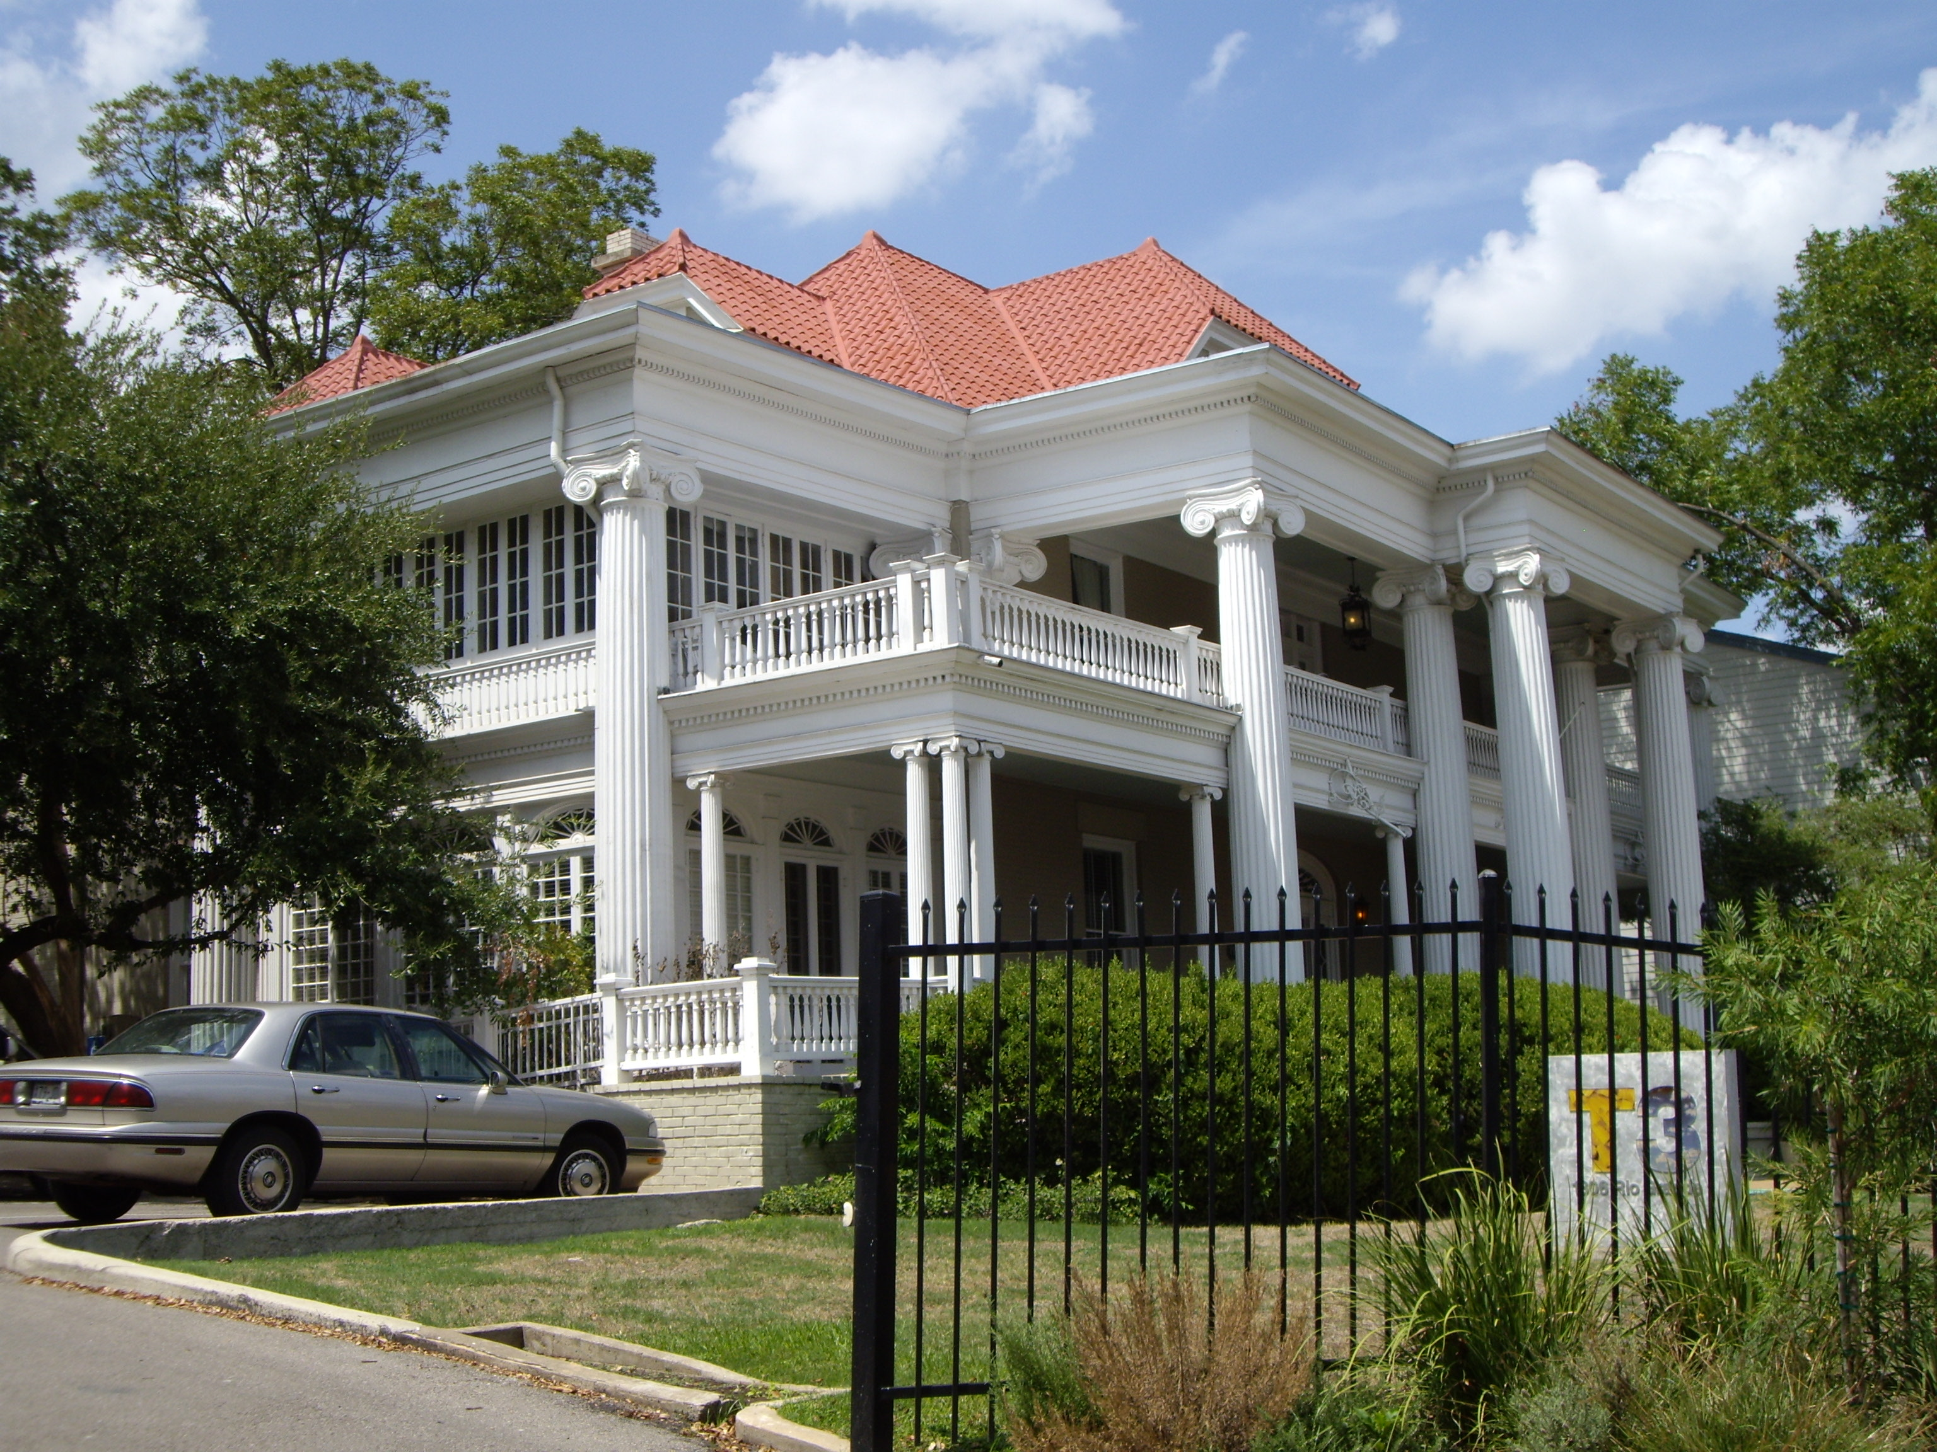
This despite abutting a historic landmark structure that is otherwise surrounded by MS2A and MS3A zoning. The DAP currently caps the height at 60 feet, rather than 120 feet. Zoning it CC-120 puts a development bullseye on a historic treasure surrounded by a home and structures zoned CC-40 and CC-60. It should be rezoned to a 60-foot height.

New problems to be addressed include:

- Some single family homes are now designated R4A, and townhomes are R4C, each allowing over 50 units per acre with density bonuses, or lots of just 2,500 square feet, all in contradiction to the recently approved DAP.
- Impervious cover limits are reduced on this slope over the chronic Shoal Creek/Lamar Blvd. flood plain, ignoring the lessons of Hurricane Harvey in unzoned Houston.

Again, we ask that the recent public process of the DAP be honored in our small, forested, historic corner of downtown alongside Pease Park. We have been assured by council members and the mayor that it is their intent to do so through an adjunct instrument, likely an overlay, upon which our support for CN will depend. Thorough staff implementation recommendations for the DAP were conveniently presented in 2014 (attached) and should form the basis for that overlay. We need confirmation that that document will govern CN in our area of downtown before we can begin to support the plan.

Please review the documents below to re-inform your decisions amid an overwhelming flow of information in the moving target that is CodeNEXT. Our community depends on it.

We thank you for your service to Austin.

Sincerely,

Jo Sue Howard
JHNA President

The Judges Hill Neighborhood Association update to its initial CodeNEXT Position Paper (Appendix A, pages 14-16) for the Judges Hill District (JHD) and adjacent Northwest District (NWD)
July 5th, 2017

The JHNA has voted unanimously to honor the DAP in CodeNEXT:

“Be it resolved that the Judges Hill Neighborhood Association asks that Commissioners and the Mayor, Mayor Pro Tem and City Council honor the DAP and its components in tailoring and approving CodeNEXT with regard to the JHD and the adjacent two blocks of the Northwest District and the University Neighborhood Overlay.”

Background:

After a years-long public process the DAP was approved by the Mayor and City Council at the end of 2011. During DAP development consultants and staff had informed us that a specific plan for our DAP roll-out overlay was to be delayed for budgetary reasons. They added that we’d been deemed appropriate for preservation, rather than development, so the plan was not urgent.

Had we been less understanding and insisted on that plan and Conditional Overlay (CO), it would have preserved existing zoning in CodeNEXT, as was done for the West University Neighborhood. They and we supported a large density bump in the adjacent University Neighborhood Overlay, across MLK from the JHD. We also supported a much larger density increment just 2 blocks from our homes, with heights of 400 feet to our east in the Uptown/Capitol District (UCD), and stepped up density and heights in the intervening NWD “panhandle”, a 2 block-wide strip between MLK and 15th.

Finally, in 2014 Staff issued Implementation Recommendations from the DAP in an overlay for the Judges Hill District (JHD) and the adjacent Northwest District (NWD). Here is a brief summary provided in that document:
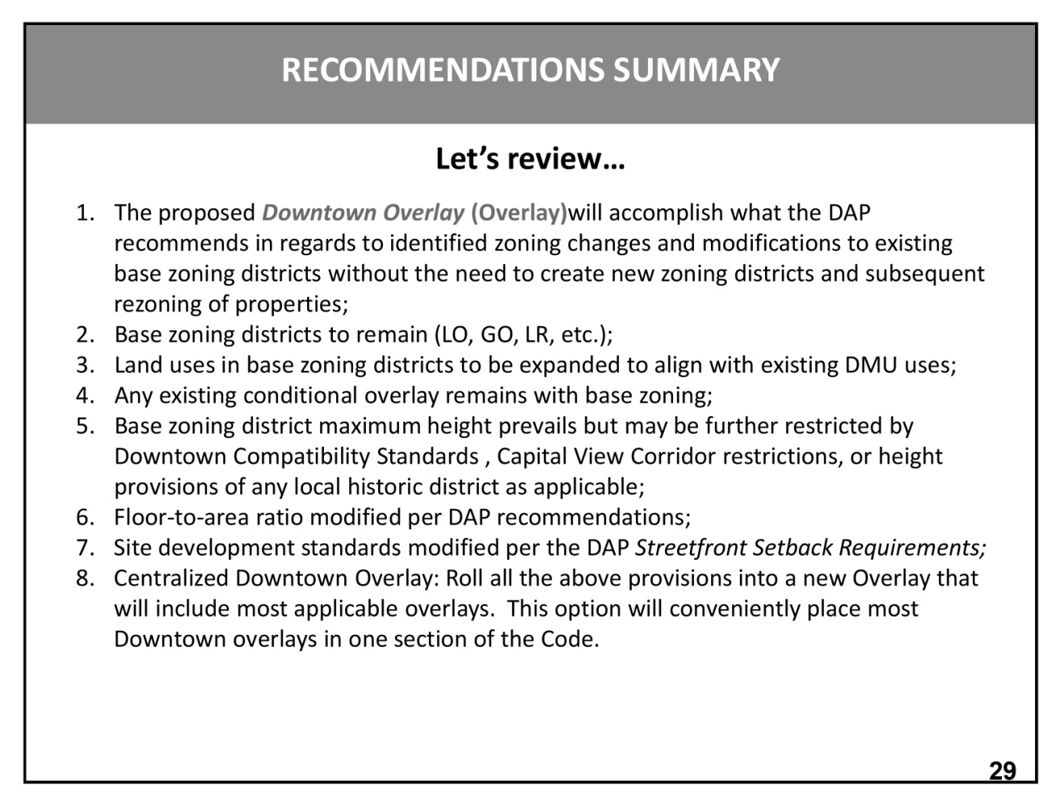

But that overlay was stonewalled as developers clamored for a new citywide plan, now called CodeNEXT.

The 2014 Staff DAP Overlay carries out DAP Council direction in all but a few cases. First, the overlay added increased heights beyond those in the adopted DAP within the new Compatibility Zones and the NWD panhandle. Secondly, the overlay allowed FAR density bonuses in areas where the DAP had deemed density bonuses inappropriate. But in general that staff overlay honors the letter and spirit of the DAP and should be implemented.

The Downtown Commission decided in 2017 that it made no sense to remap downtown for CodeNEXT after such recent work in the DAP rollout, and we agree. The current CodeNEXT draft ignores much of that direction. But we were pleased to hear Mayor Adler, in this year’s State of the City Address, declare:

“For starters, let’s agree we will not force density in the middle of neighborhoods. There’s no sense in showing density where it would ruin the character of the city we’re trying to save in the first place, where it’s not wanted by its neighbors, and where we would never get enough of the additional hosing supply we need anyway.”

The JHD is just 4 to 5 blocks across, with homes extending to some borders, and a single layer of offices, apartments or condominiums at others. The so-called “creamy yellow center” (homes on a zoning map) makes up the bulk of the neighborhood (see second map below, top of page 9). We are already extremely walkable to services along MLK or in the adjacent NWD which is, by DAP design, our “transition” to core density just 2 blocks away.

Mayor Pro Tem Tovo, in whose District 9 western downtown resides, and the Mayor have told us they agree with staff that the DAP should be honored by CodeNEXT. Staff note that to do otherwise would require new direction from the City Council, but that would conflict with the recent DAP.

How to integrate the DAP into CodeNEXT for the JHD and NWD:

The current CodeNEXT draft and map are antithetical to the goals and principles elucidated in the DAP in our area, namely preserving the character, history and tree canopy of the tiny, primarily single-family historic garden district that is the JHD, as well as the neighboring historic, treed NWD. The prior Mayor and Council walked our area before determining the goals, which are best shared through the following quotes from the DAP:

- “The DAP is the Downtown’s Neighborhood Plan, and like the other adopted Neighborhood Plans, will amend the much more general Comprehensive Plan, providing specificity about the particular geographic area of Downtown.”

- “The DAP is the result of a three-year dialogue with the general public and the Downtown community and stakeholders. It involved six Town Hall meetings and scores of smaller meetings and workshops, soliciting input on a wide range of issues and geographic subareas.”

- “The character of Downtown ranges from the skyscrapers of Congress Avenue to the single-family neighborhood of Judges Hill. This diversity gives Downtown an authentic sense of place -- a unique character that fosters district pride, enjoyment and investment, as well as visitor appeal.”

- “Compatibility Zones are proposed, each with specific height standards aimed at providing an appropriate scale transition to the Judges Hill and Old West Austin Neighborhoods”

- “Mixed Use: An appropriate mix of residential and non-residential uses should be allowed in all parts of Downtown, except for Judges Hill, which should generally be preserved as a single-family residential neighborhood.”

- “Downtown’s historic fabric is at risk of being demolished. More than 150 potentially significant historic properties, identified in Austin’s 1984 Cultural Resources Survey, have been demolished in Downtown over the past 35 years.”

- “The DAP recognizes the importance of the historic fabric of the original city and has identified nine individual “districts” that are generally cohesive in character, in terms of building form and scale, which is often a result of their historical development.”

- “Historic preservation is important if Downtown is to continue to develop in a way that is authentically and uniquely Austin - where the history of place is evident and celebrated. Downtown Austin’s sense of place is built to a great extent on its unique collection of historic buildings and landscapes.”

- “Preservation is also consistent with Austin’s value of sustainability. The conservation and improvement of existing built resources, including re-use of historic and existing buildings, greening of the existing building stock, and reinvestment in older and historic districts, are key elements of a sustainable downtown.”

Adapting CodeNEXT to conform to the DAP is no mean feat. Preserving history and tree canopy in Judges Hill is a very different task from promoting high rises in the nearby Uptown/Capitol District. Since a picture is worth a thousand words, we’ll start with the following maps that define the distributions of many important DAP parameters that must be respected to honor that process:

- Traditional Compatibility Standards in the western JHD consistent with the 2014 Pease Park Master Plan Council resolution
- DAP Compatibility Zones (less restrictive and more predictable) in the eastern JHD and NWD
- Density Bonuses (FARs of 3, 4 and 5, and heights of 90’, 100’ and 120’)
- Zoning changes/new Mixed Use (limited to the NWD: DMU-40 and DMU-60)
- Street setbacks.

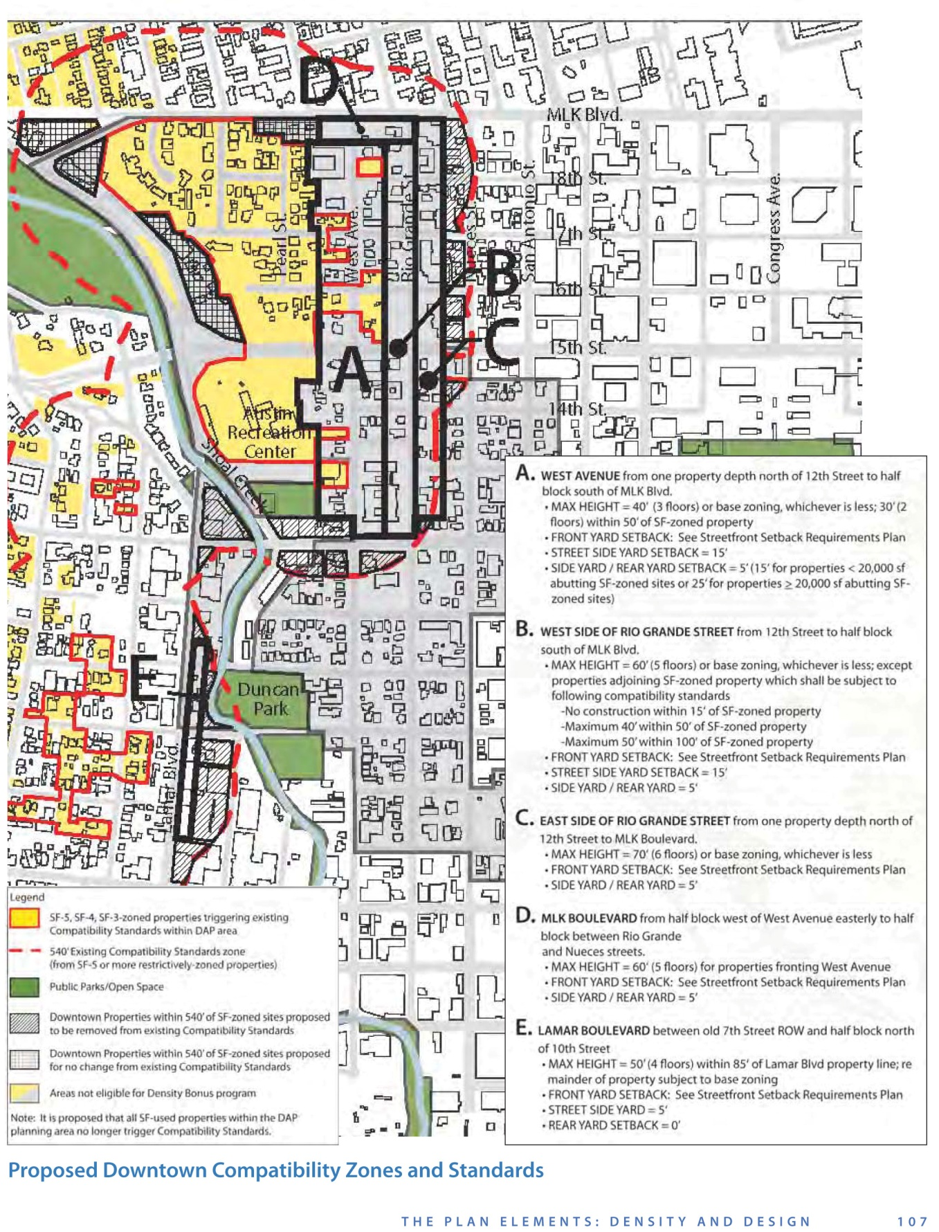
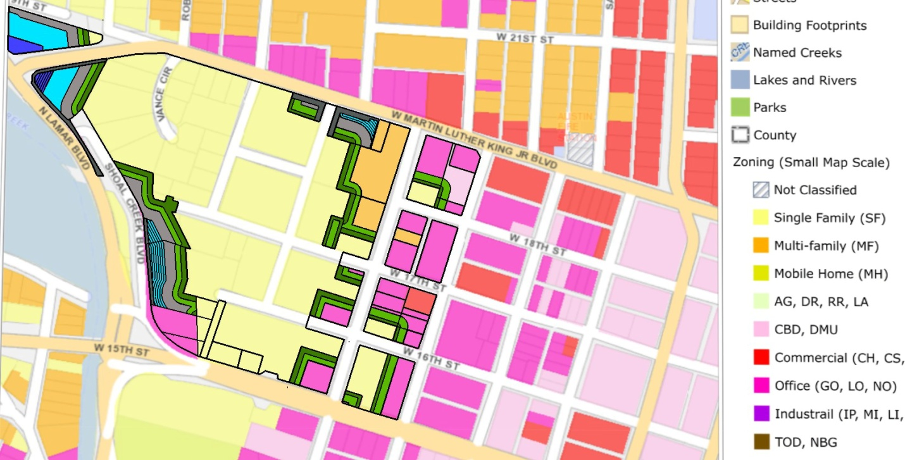
Addl. JHD Compatibility Effect per the DAP in the JHD & adj. NWD overlain on zoning: Yellow = SF-3, Pink = Office, Gold = Multifamily; Dk green = 15’/25’ setbacks from SF-3; Lt green = 30’ht; Gray = 40’ht; Lt blue = 40-50’ht in steps; Dk blue = 50’-56’ in steps (just 1 prop).

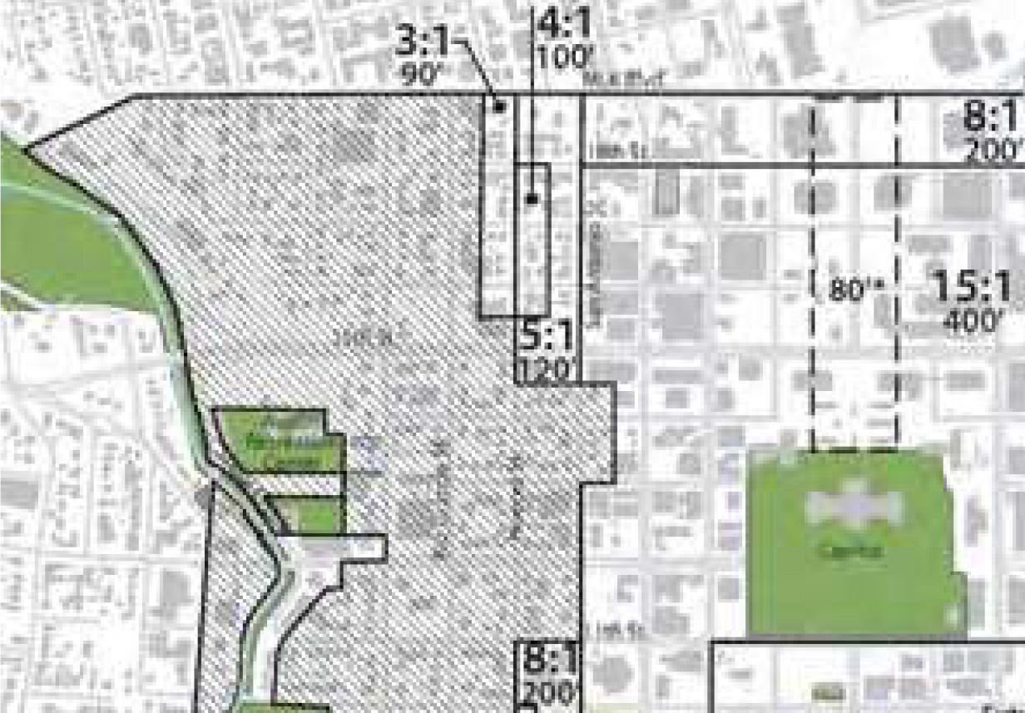
DAP Density Bonuses: In & beyond the eastern portion of the NWD Panhandle, Not in the JHD
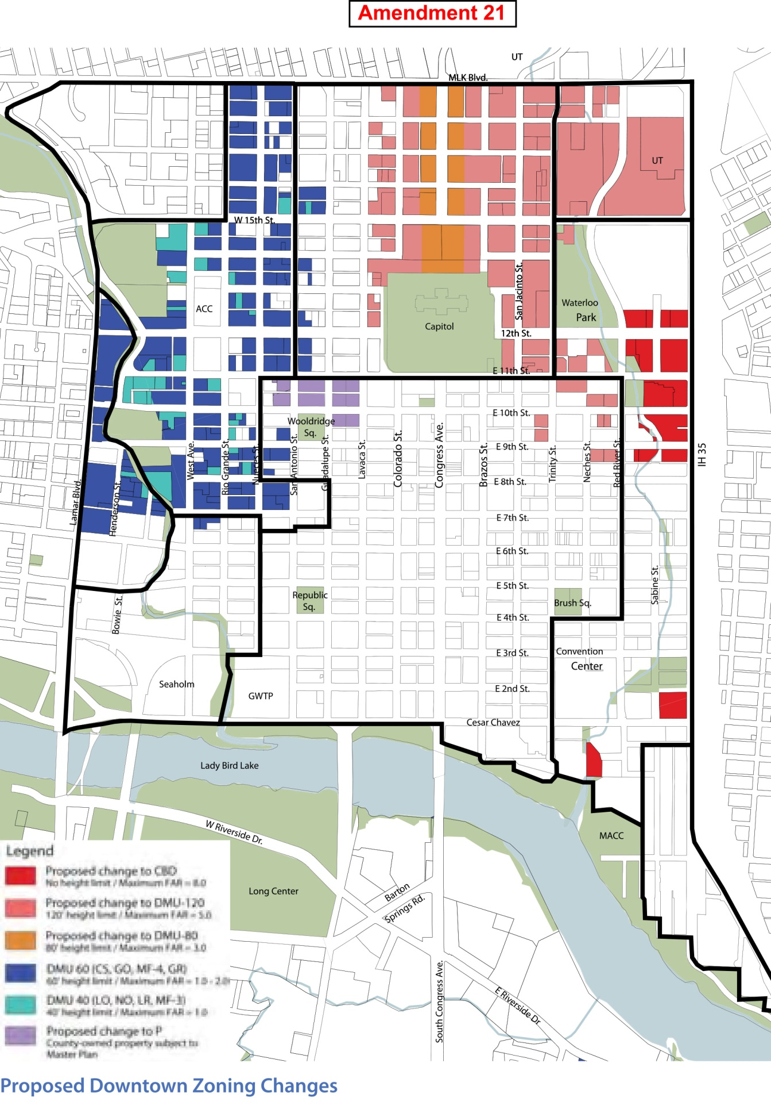
DAP: DMU-40 & DMU-60 in the NWD, but no new mixed use in the JHD
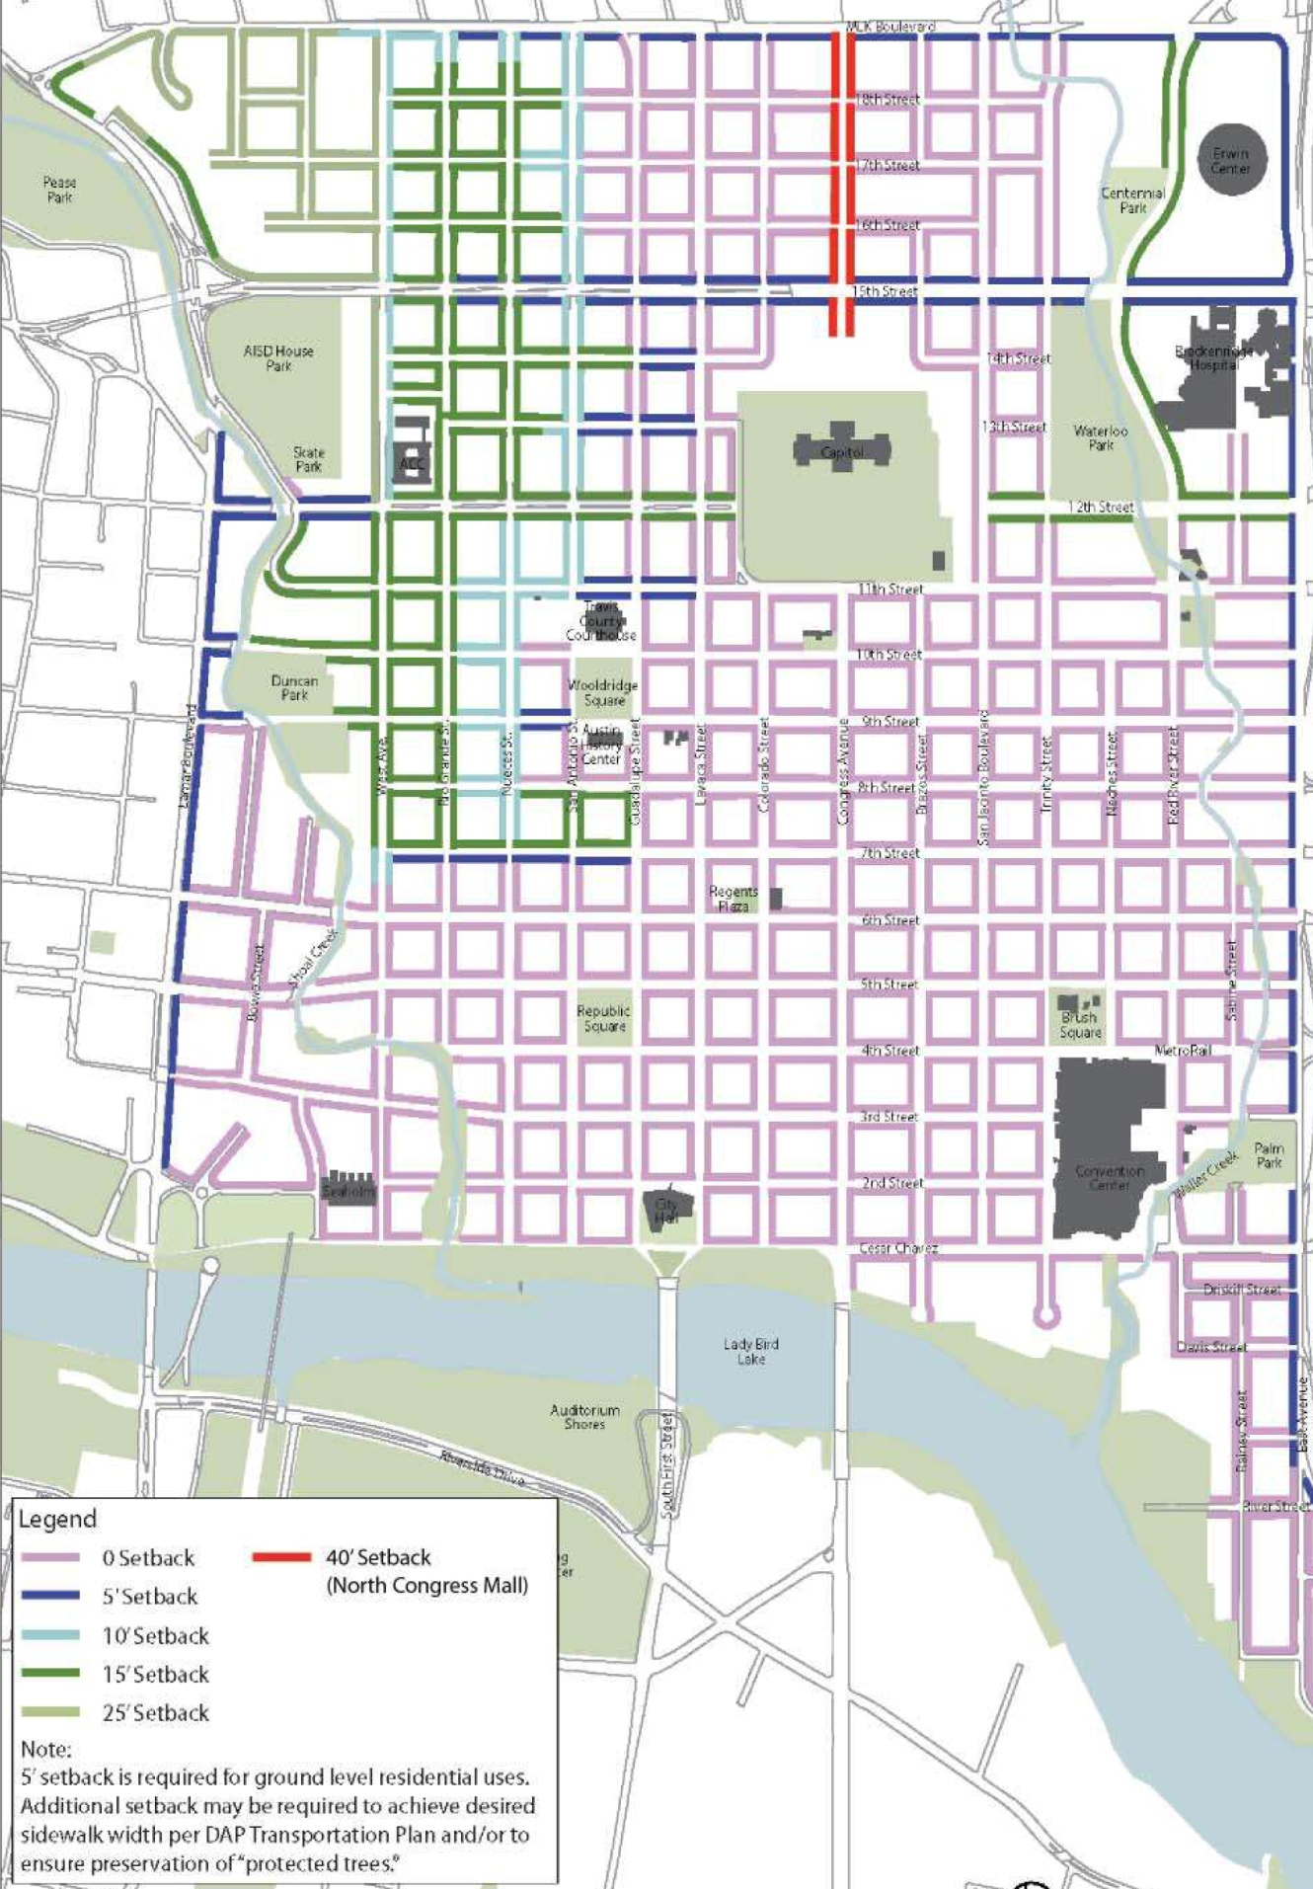
DAP Final Street Setbacks Map (JHD & adj. NWD upper left)
The following CodeNEXT Draft zones would best approximate the DAP if tailored with an overlay per the above maps and the other DAP parameters that follow in this paper:

- LMDR and T3 to become VLDR/R1A across the southern and western slopes to W. 16th Street, Shoal Creek Blvd. and N. Lamar Blvd., appropriate for large lots (here as large as 1.6 acres) with significant slopes and/or environmental features like the city’s critical one, canyon rimrock, documented by a geologist (Appendix B) as well as the more obvious one--its position above the chronic Shoal Creek/Lamar flood plain.
- Other LMDR, and T3 on lots over 10,000 square feet, to become LDR/R1B, appropriate for large lots that lack environmental features and/or have a significant slope. These lots are as large as 0.85 acres.
- T3 to become LMDR/R1C
- LMDR/R1C on lots under 10,000 square feet to be unchanged from the draft.
- Conditional Overlay properties (there are just 3) to be unchanged from the draft.
- T4MS-O from LO base zoning in the DAP becomes T4N.DS (compatible rowhouses rather than 55’-tall block forms).
- T4MS-O from GO base zoning to become T4N.IS (compatible rowhouses rather than 55’-tall block forms).
- CC to become T4MS with DMU-40 and DMU-60 parameters, plus density bonuses where appropriate per the DAP map above. (CC is a place marker for future Downtown Core, rather than the transition zone stepping up to the U/CD that was prescribed in the DAP).
9. Also, staff had advised us that the city-owned land now zoned LO and SF-3 at the southeast corner of the JHD was to be rezoned Public (along with House Park) in CodeNEXT. That is in accordance with the 1968 Council resolution which declared that the area would remain greenbelt in perpetuity in return for our accepting razing a historic Caswell House and contained in the deed of 1997 for the Max Bickler house (of 1911) 901 West 16th . That agreement allowed 15th Street to be cut through the neighborhood to Enfield and Lamar to facilitate traffic flow. In the current draft that was partially honored, but the portion of 2 such parcels that was zoned LO are still zoned T4MS-O in error and should be corrected.

We hope that CURE, and end-run around all zoning regulations, will cease with CodeNEXT. If not, it should exclude height and FAR, as it did in the DAP.

The following parameters from the DAP should be included in the overlay per the zoning districts in place at its adoption:

- Use limitations (including no new commercial uses in homes).
- Subdivision rules/hearing requirements.
- Council to not promote ordinances that undermine existing deed restrictions per that resolution in place at the time of the DAP.
- Minimum lot sizes.
- Variance rules.—no “director” as czar able to abrogate the need for public process.
- No ADUs in the JHD (only garage apts. were deemed appropriate in the DAP)
- Building height measurement per the DAP (average of max./min. structure perimeter height from most restrictive grade) to be retained, rather than the new method proposed for transects (and now R1,2,3) that would encourage tall buildings atop environmentally sensitive, unstable slopes, towering over homes (Appendix C).
- Parking requirements and the Residential Parking Program to be preserved in the JHD as was promised during the DAP per the massive nearby density increment and parking requirement decrement.
- No Minor Use Permits (not allowed in the DAP).
- No 10% “slop” in screening requirements, etc. (not allowed in the DAP).
- No blanket allowance for exceptions because a property has one or more heritage or protected trees (not allowed in the DAP).
- Impervious cover and building coverage limits and FAR in place at the time of the DAP to be maintained, for tree canopy preservation and drainage in an area above a chronic flood plain (water detention requirements should remain here) below the unstable Del Rio clay and Buda limestone slope.
- Right to valid petition maintained along with all hearing requirements from the time of the DAP.
In summary, we ask you to honor the recent Downtown Austin Plan within the Judges Hill District and the adjacent Northwest District. We feel the DAP goals are best met by retaining existing zoning, but this supplement outlines the next best alternative based on the ever-changing draft.

Sincerely,

Jo Sue Howard
President, Judges Hill Neighborhood Association

Appendix A

Position Paper of the Judges Hill Neighborhood Association:
Honor the Recent Downtown Austin Plan

Problem: The current CodeNEXT draft offers no mapping or text alternatives that would honor the Downtown Austin Plan (DAP). CodeNEXT fails to include the Judges Hill District (JHD) of the (DAP) ordinance and its adjacent two blocks south and east. Link to DAP: ftp://ftp.ci.austin.tx.us/DowntownAustinPlan/dap_approved_12-8-2011.pdf

Solution: Use the 2014 DAP Staff Implementation recommendations with existing zoning to map the JH District and adjacent.

Examples of Non-Compatibility

This diagram below shows that CodeNEXT draft Compatibility is not “baked in” for our area and uses McMansion as an example.

McMansion (current) - Grey T4MS 55’ tall on lot line (CodeNEXT) - Red

Current Compatibility Standards in DAP Overlay – White

55 feet tall -T4MS “row houses” with zero lot lines and flat roofs that allow nightclubs, restaurants and bars are non-compatible with adjacent homes in a historic area.

The Future of Judges Hill in Question

The DAP’s Judges Hill District (JHD), Austin oldest residential downtown neighborhood, a unique, forested, historic garden district, was found to be a concise amenity in the extreme northwest corner of downtown worth preserving. After visiting our area, Staff and officials agreed that the old growth tree canopy and historic cultural assets together provide a respite to the concrete canyons arising nearby, to be enjoyed by those residents, workers and visitors. The JHD relies upon the DAP to provide an orderly transition of increasing heights and density up to the mammoth increment in density of the Capitol Uptown District.

Tragic history will repeat itself. Prior mass “upzones” in our area resulted in numerous losses of magnificent trees and historic homes as detailed in the moving talk, “Ghosts of Judges Hill”. Pictured next is the unique shingle-style home of Col. E.M. House, after whom House Park was named:

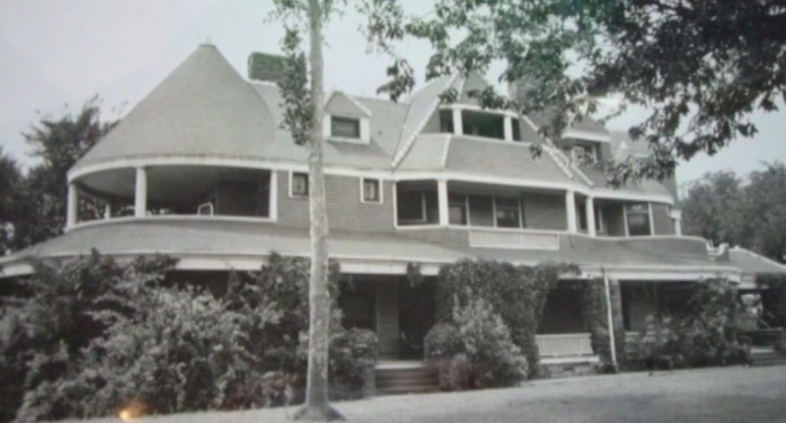

In its place now sits a historic plaque before a surface parking lot adjacent to 1970s condominiums. See the “Ghosts of JH Video” at: https://vimeo.com/user24073289

What does the DAP (a three-year dialogue) say about Judges Hill?

Quotes from that Council-approved ordinance:

- “. . . Judges Hill should generally be preserved as a single-family residential neighborhood.”
- “Downtown’s historic fabric is at risk of being demolished.”
- “Compatibility Zones are . . . aimed at providing an appropriate scale transition to Judges Hill”

Challenges with CodeNEXT

CodeNEXT zones in JHD would provide minimal additional density compared to the already council approved 75 million square feet of new density from the DAP. And here the “missing middle,” like other housing downtown, would not be affordable. The majority of properties would be made non-conforming under the proposed CodeNEXT.

Critical DAP parameters that must also be included in CodeNEXT: compatibility standards and zones; FAR caps; lot size; uses; heights and their method of measurement; density bonuses distribution; streetfront, side and rear setbacks, and City Public Lands and Greenbelt Designations.

Market Driven Displacement Pressure on Judges Hill

Since CodeNEXT discussions began, there’s been a particularly alarming change in our appraisals. Our land is increasing in value by as much as a third (33%), year after year, while many of our structures’ values remain flat and some drop. One sturdy, well-maintained 3,000+ square foot home’s structure market value dropped to $1,000 dollars for consecutive years, while its land skyrocketed by over $500K to $1.25 million. It’s a classic sign of the displacement pressure seen from measures like CodeNEXT in more expensive cities like Seattle, Portland and Denver, and TCAD recognizes that.

Commitment to DAP Overlay

Mayor Adler and Mayor Pro Tem Kathie Tovo, along with City Planning Staff, have assured us that DAP would be honored by CodeNEXT. An overlay must be applied rather than using current CodeNEXT zoning and mapping to achieve the protections of DAP.

Jo Sue Howard
President, Judges Hill Neighborhood Association
June 6, 2017

Appendix B
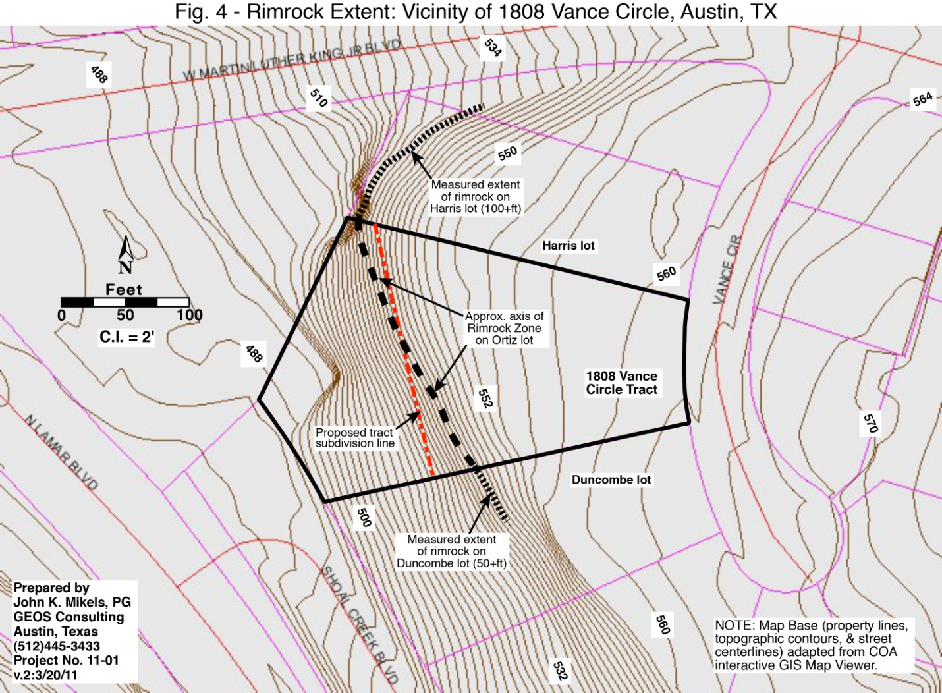

Appendix C

Transect height measurement method shown in red after equalizing setbacks of commercial structure in red vs. DAP and nontransect method in white. “Maxed out” McMansion home shown in gray above the slope.
